|  |  |
| --- | --- |
| 3GPP TR 22.856 V19.0.0 (2023-06) | |
| Technical Report | |
| 3rd Generation Partnership Project;  Technical Specification Group TSG SA;  Feasibility Study on Localized Mobile Metaverse Services  (Release 19) | |
|  | |
|  |  |
| The present document has been developed within the 3rd Generation Partnership Project (3GPP TM) and may be further elaborated for the purposes of 3GPP. The present document has not been subject to any approval process by the 3GPPOrganizational Partners and shall not be implemented. This Specification is provided for future development work within 3GPPonly. The Organizational Partners accept no liability for any use of this Specification. Specifications and Reports for implementation of the 3GPP TM system should be obtained via the 3GPP Organizational Partners' Publications Offices. | |

|  |
| --- |
|  |
| ***3GPP***  Postal address  3GPP support office address  650 Route des Lucioles - Sophia Antipolis  Valbonne - FRANCE  Tel.: +33 4 92 94 42 00 Fax: +33 4 93 65 47 16  Internet  http://www.3gpp.org |
| ***Copyright Notification***  No part may be reproduced except as authorized by written permission. The copyright and the foregoing restriction extend to reproduction in all media.  © 2023, 3GPP Organizational Partners (ARIB, ATIS, CCSA, ETSI, TSDSI, TTA, TTC).  All rights reserved.  UMTS™ is a Trade Mark of ETSI registered for the benefit of its members  3GPP™ is a Trade Mark of ETSI registered for the benefit of its Members and of the 3GPP Organizational Partners LTE™ is a Trade Mark of ETSI registered for the benefit of its Members and of the 3GPP Organizational Partners  GSM® and the GSM logo are registered and owned by the GSM Association |

Contents

Foreword 6

1 Scope 8

2 References 8

3 Definitions of terms, symbols and abbreviations 11

3.1 Terms 11

3.2 Symbols 13

3.3 Abbreviations 13

4 Overview 13

5 Use Cases 14

5.1 Use Case on Localized Mobile Metaverse Service 14

5.1.1 Description 14

5.1.2 Pre-conditions 15

5.1.3 Service Flows 16

5.1.4 Post-conditions 16

5.1.5 Existing feature partially or fully covering use case functionality 16

5.1.6 Potential New Requirements 17

5.2 Use Case on Mobile Metaverse for 5G-enabled Traffic Flow Simulation and Situational Awareness 17

5.2.1 Description 17

5.2.2 Pre-conditions 19

5.2.3 Service Flows 19

5.2.4 Post-conditions 20

5.2.5 Existing features partly or fully covering the use case functionality 20

5.2.6 Potential New Requirements needed to support the use case 20

5.3 Use Case on collaborative and concurrent engineering in product design using metaverse services 21

5.3.1 Description 21

5.3.2 Pre-conditions 22

5.3.3 Service Flows 23

5.3.4 Post-conditions 24

5.3.5 Existing features partly or fully covering the use case functionality 24

5.3.6 Potential New Requirements needed to support the use case 25

5.3.6.1 KPIs for the collaborative and concurrent engineering in product design 25

5.3.6.2 Service requirements for collaborative and concurrent engineering in product design 25

5.4 Use Case on Spatial Anchor Enabler 26

5.4.1 Description 26

5.4.2 Pre-conditions 27

5.4.3 Service Flows 27

5.4.4 Post-conditions 28

5.4.5 Existing feature partly or fully covering use case functionality 28

5.4.6 Potential New Requirements needed to support the use case 28

5.5 Use Case on Spatial Mapping and Localization Service Enabler 29

5.5.1 Description 29

5.5.2 Pre-conditions 30

5.5.5 Existing feature partially or fully covering use case functionality 32

5.5.6 Potential New Requirements needed to support the use case 32

5.5.6.1 Requirements for Spatial Mapping 32

5.5.6.2 Requirements for Localization 32

5.6 Use Case on Mobile Metaverse for Immersive Gaming and Live Shows 33

5.6.1 Description 33

5.6.2 Pre-conditions 33

5.6.3 Service Flows 34

5.6.4 Post-conditions 34

5.6.5 Existing features partly or fully covering the use case functionality 35

5.6.6 Potential New Requirements needed to support the use case 35

5.7 Use Case on AR Enabled Immersive Experience 35

5.7.1 Description 35

5.7.2 Pre-conditions 36

5.7.3 Service Flows 37

5.7.4 Post-conditions 37

5.7.5 Existing features partly or fully covering the use case functionality 37

5.7.6 Potential New Requirements needed to support the use case 37

5.8 Use Case on multi-service coordination in one mobile metaverse service 39

5.8.1 Description 39

5.8.2 Pre-conditions 40

5.8.3 Service Flows 40

5.8.4 Post-conditions 40

5.8.5 Existing features partly or fully covering the use case functionality 41

5.8.6 Potential New Requirements needed to support the use case 41

5.9 Use Case on Synchronized predictive avatars 41

5.9.1 Description 41

5.9.2 Pre-conditions 42

5.9.3 Service Flows 42

5.9.4 Post-conditions 43

5.9.5 Existing features partly or fully covering the use case functionality 43

5.9.6 Potential New Requirements needed to support the use case 43

5.10 Use Case on mobile metaverse for Critical HealthCare Services 43

5.10.1 Description 43

5.10.2 Pre-conditions 45

5.10.3 Service Flows 45

5.10.4 Post-conditions 46

5.10.5 Existing feature partly or fully covering use case functionality 46

5.10.6 Potential New Requirements needed to support the use case 46

5.11 Use case of IMS-based 3D Avatar Communication 46

5.11.1 Description 46

5.11.2 Pre-conditions 47

5.11.3 Service Flows 47

5.11.4 Post-conditions 49

5.11.5 Existing feature partly or fully covering use case functionality 49

5.11.6 Potential New Requirements needed to support the use case 50

5.12 Use Case on Virtual humans in metaverse 51

5.12.1 Description 51

5.12.2 Pre-conditions 52

5.12.3 Service Flows 52

5.12.4 Post-conditions 52

5.12.5 Existing features partly or fully covering the use case functionality 52

5.12.6 Potential New Requirements needed to support the use case 52

5.13 Use Case on digital asset container information access and certification 53

5.13.1 Description 53

5.13.2 Pre-conditions 53

5.13.3 Service Flows 53

5.13.4 Post-conditions 53

5.13.5 Existing features partly or fully covering the use case functionality 53

5.13.6 Potential New Requirements needed to support the use case 54

5.14 Use Case on interconnection of mobile metaverse services 54

5.14.1 Description 54

5.14.2 Pre-conditions 54

5.14.3 Service Flows 55

5.14.4 Post-conditions 55

5.14.5 Existing features partly or fully covering the use case functionality 55

5.14.6 Potential New Requirements needed to support the use case 55

5.15 Use Case on Access to avatars 55

5.15.1 Description 55

5.15.2 Pre-conditions 56

5.15.3 Service Flows 56

5.15.4 Post-conditions 56

5.15.5 Existing features partly or fully covering the use case functionality 57

5.15.6 Potential New Requirements needed to support the use case 57

5.16 Use Case on virtual store in a mobile metaverse marketplace 57

5.16.1 Description 57

5.16.2 Pre-conditions 57

5.16.3 Service Flows 58

5.16.4 Post-conditions 59

5.16.5 Existing features partly or fully covering the use case functionality 59

5.16.6 Potential New Requirements needed to support the use case 60

5.17 Use Case on Work delegation to autonomous virtual alter ego 60

5.17.1 Description 60

5.17.2 Pre-conditions 61

5.17.3 Service Flows 61

5.17.4 Post-conditions 62

5.17.5 Existing features partly or fully covering the use case functionality 62

5.17.6 Potential New Requirements needed to support the use case 62

5.18 Use Case on virtual meeting room in financial services 62

5.18.1 Description 62

5.18.2 Pre-conditions 63

5.18.3 Service Flows 63

5.18.4 Post-conditions 63

5.18.5 Existing features partly or fully covering the use case functionality 63

5.18.6 Potential New Requirements needed to support the use case 63

5.19 Use Case on Privacy-Aware Dynamic Network Exposure in Immersive Interactive Experiences 64

5.19.1 Description 64

5.19.2 Pre-conditions 64

5.19.3 Service Flows 64

5.19.4 Post-conditions 65

5.19.5 Existing feature partly or fully covering use case functionality 65

5.19.6 Potential New Requirements needed to support the use case 65

5.20 Use Case on Immersive Tele-Operated Driving in Hazardous Environment 65

5.20.1 Description 65

5.20.2 Pre-conditions 65

5.20.3 Service Flows 66

5.20.4 Post-conditions 66

5.20.5 Existing feature partly or fully covering use case functionality 66

5.20.6 Potential New Requirements needed to support the use case 66

5.21 Use Case on Virtual Emergency Drill over 5G Metaverse 67

5.21.1 Description 67

5.21.2 Pre-conditions 68

5.21.3 Service Flows 68

5.21.4 Post-conditions 69

5.21.5 Existing features partly or fully covering the use case functionality 69

5.21.6 Potential New Requirements needed to support the use case 69

5.22 Use case of Mobile Metaverse Live Concert 69

5.22.1 Description 69

5.22.2 Pre-conditions 69

5.22.3 Service Flows 69

5.22.4 Post-conditions 70

5.22.5 Existing feature partly or fully covering use case functionality 70

5.22.6 Potential New Requirements needed to support the use case 70

5.23 Use Case on cooperation between metaverse and network using interactive XR 70

5.23.1 Description 70

5.23.2 Pre-conditions 71

5.23.3 Service Flows 71

5.23.4 Post-conditions 71

5.23.5 Existing features partly or fully covering the use case functionality 71

5.23.6 Potential New Requirements needed to support the use case 71

5.24 Use Case on Authorization of Avatar Usage rights 71

5.24.1 Description 71

5.24.2 Pre-conditions 72

5.24.3 Service Flows 72

5.24.4 Post-conditions 72

5.24.5 Existing features partly or fully covering the use case functionality 72

5.24.6 Potential New Requirements needed to support the use case 72

5.25 Use Case on Enabling Metaverse services to users via multiple access connections 73

5.25.1 Description 73

5.25.2 Pre-conditions 73

5.25.3 Service Flows 73

5.25.4 Post-conditions 74

5.25.5 Existing features partly or fully covering the use case functionality 74

5.25.6 Potential New Requirements 74

5.26 Use Case on IMS-based 3D Avatar Call Support for Accessibility Use Case 74

5.26.1 Description 74

5.26.2 Pre-conditions 76

5.26.3 Service Flows 76

5.26.4 Post-conditions 77

5.26.5 Existing feature partially or fully covering use case functionality 77

5.26.6 Potential New Requirements 77

5.27 Use Case on Localized Mobile Metaverse Overload 78

5.27.1 Description 78

5.27.2 Pre-conditions 79

5.27.3 Service Flows 79

5.27.4 Post-conditions 79

5.27.5 Existing features partly or fully covering the use case functionality 79

5.27.6 Potential New Requirements needed to support the use case 80

5.28 Use Case on user identities in a digital asset container 80

5.28.1 Description 80

5.28.2 Pre-conditions 80

5.28.3 Service Flows 80

5.28.4 Post-conditions 81

5.28.5 Existing features partly or fully covering the use case functionality 81

5.28.6 Potential New Requirements needed to support the use case 81

6 Considerations 81

7 Consolidated potential requirements and KPIs 81

7.1 Consolidated potential requirements 81

7.1.1 Localized Mobile Metaverse Service Functionality 81

7.1.2 Digital representation of users and avatar functionality 82

7.1.3 Operational efficiency, exposure, and coordination of mobile metaverse services 83

7.1.4 Security and Privacy aspects of mobile metaverse services 84

7.1.5 Digital Asset Management 85

7.1.6 Charging requirements for mobile metaverse services 85

7.2 Consolidated potential KPIs 87

8 Conclusion and recommendations 89

Annex A (informative): Avatar Service Considerations 90

Annex B (informative): The EU Digital Identity Wallet Initiative 92

References 94

Annex C (Informative): Traffic Characteristics of Metaverse Media Communication 94

Annex D (informative): Change history 96

# Foreword

This Technical Report has been produced by the 3rd Generation Partnership Project (3GPP).

The contents of the present document are subject to continuing work within the TSG and may change following formal TSG approval. Should the TSG modify the contents of the present document, it will be re-released by the TSG with an identifying change of release date and an increase in version number as follows:

Version x.y.z

where:

x the first digit:

1 presented to TSG for information;

2 presented to TSG for approval;

3 or greater indicates TSG approved document under change control.

y the second digit is incremented for all changes of substance, i.e. technical enhancements, corrections, updates, etc.

z the third digit is incremented when editorial only changes have been incorporated in the document.

In the present document, modal verbs have the following meanings:

**shall** indicates a mandatory requirement to do something

**shall not** indicates an interdiction (prohibition) to do something

The constructions "shall" and "shall not" are confined to the context of normative provisions, and do not appear in Technical Reports.

The constructions "must" and "must not" are not used as substitutes for "shall" and "shall not". Their use is avoided insofar as possible, and they are not used in a normative context except in a direct citation from an external, referenced, non-3GPP document, or so as to maintain continuity of style when extending or modifying the provisions of such a referenced document.

**should** indicates a recommendation to do something

**should not** indicates a recommendation not to do something

**may** indicates permission to do something

**need not** indicates permission not to do something

The construction "may not" is ambiguous and is not used in normative elements. The unambiguous constructions "might not" or "shall not" are used instead, depending upon the meaning intended.

**can** indicates that something is possible

**cannot** indicates that something is impossible

The constructions "can" and "cannot" are not substitutes for "may" and "need not".

**will** indicates that something is certain or expected to happen as a result of action taken by an agency the behaviour of which is outside the scope of the present document

**will not** indicates that something is certain or expected not to happen as a result of action taken by an agency the behaviour of which is outside the scope of the present document

**might** indicates a likelihood that something will happen as a result of action taken by some agency the behaviour of which is outside the scope of the present document

**might not** indicates a likelihood that something will not happen as a result of action taken by some agency the behaviour of which is outside the scope of the present document

In addition:

**is** (or any other verb in the indicative mood) indicates a statement of fact

**is not** (or any other negative verb in the indicative mood) indicates a statement of fact

The constructions "is" and "is not" do not indicate requirements.

# 1 Scope

The present document investigates specific use cases and service requirements for 5GS support of enhanced XR-based services, (as XR-based services are an essential part of "Metaverse" services considered in this study,) as well as potentially other functionality, to offer shared and interactive user experience of local content and services, accessed either by users in the proximity or remotely. In particular, the following areas are studied:

- Support of interactive XR media shared among multiple users in a single location, including:

- performance (KPI) aspects; e.g. latency, throughput, connection density

- efficiency and scalability aspects, for large numbers of users in a single location.

- the combination of haptics type of XR media and other non-haptics types of XR media.

- Identification of users and other digital representations of entities interacting within the Metaverse service.

- Acquisition, use and exposure of local (physical and digital) information to enable Metaverse services, including:

- acquiring local spatial/environmental information and user/UE(s) information (including viewing angle, position and direction);

- exposing local acquired spatial, environmental and user/UE information to 3rd parties to enable Metaverse services.

- Other aspects, such as privacy, charging, public safety and security requirements.

The study also investigates gaps between the identified new potential requirements and the requirements already specified for the 5G system.

It is acknowledged that there are activities related to the topic Metaverse outside of 3GPP, such as the W3C Open Metaverse Interoperability Group (OMI). These activities may be considered in the form of use cases and related contributions to this study, but there is no specific objective for this study to consider or align with external standardization activities.

A difference between this study and TR 22.847 " Study on supporting tactile and multi-modality communication services" is that Metaverse services would involve coordination of input data from different devices/sensors from different users and coordination of output data to different devices at different destinations to support the same task or application.

# 2 References

The following documents contain provisions which, through reference in this text, constitute provisions of the present document.

- References are either specific (identified by date of publication, edition number, version number, etc.) or non‑specific.

- For a specific reference, subsequent revisions do not apply.

- For a non-specific reference, the latest version applies. In the case of a reference to a 3GPP document (including a GSM document), a non-specific reference implicitly refers to the latest version of that document *in the same Release as the present document*.

[1] 3GPP TR 21.905: "Vocabulary for 3GPP Specifications".

[2] 3GPP TS 22.228: "Service requirements for the Internet Protocol (IP) Multimedia core network Subsystem (IMS)".

[3] 3GPP TS 22.173: "IP Multimedia Core Network Subsystem (IMS) Multimedia Telephony Service and supplementary services".

[4] 3GPP TS 22.101: "Service principles".

[5] 3GPP TS 22.261: "Service requirements for the 5G system".

[6] Talaba D, Horvath I, Lee K H, "Special issue of Computer-Aided Design on virtual and augmented reality technologies in product design," Computer-Aided Design 42:361 - 363.

[7] Wang X, Tsai J J-H, "Collaborative Design in Virtual Environments," In: ISCA 48:1-2.

[8] Benford S, Greenhalgh C, Rodden T, "Collaborative virtual environments." Communications of the ACM 44: 79–85.

[9] M. Eid, J. Cha, and A. El Saddik, "Admux: An adaptive multiplexer for haptic-audio-visual data communication", IEEE Tran. Instrument. and Measurement, vol. 60, pp. 21–31, Jan 2011.

[10] K. Iwata, Y. Ishibashi, N. Fukushima, and S. Sugawara, "QoE assessment in haptic media, sound, and video transmission: Effect of playout buffering control", Comput. Entertain., vol. 8, pp. 12:1–12:14, Dec 2010.

[11] N. Suzuki and S. Katsura, "Evaluation of QoS in haptic communication based on bilateral control", in IEEE Int. Conf. on Mechatronics (ICM), Feb 2013, pp. 886–891.

[12] E. Isomura, S. Tasaka, and T. Nunome, "A multidimensional QoE monitoring system for audiovisual and haptic interactive IP communications", in IEEE Consumer Communications and Networking Conference (CCNC), Jan 2013, pp. 196–202.

[13] A. Hamam and A. El Saddik, "Toward a mathematical model for quality of experience evaluation of haptic applications", IEEE Tran. Instrument. and Measurement, vol. 62, pp. 3315–3322, Dec 2013.

[14] O. Holland et al., "The IEEE 1918.1 "Tactile Internet" Standards Working Group and its Standards," Proceedings of the IEEE, vol. 107, no. 2, Feb. 2019.

[15] Lee, Donghwan et. al., "Large-scale Localization Datasets in Crowded Indoor Spaces, " NAVER LABS, NAVER LABS Europe, CVPR 2021.

[16] 3GPP TR 22.837: " Study on Integrated Sensing and Communication."

[17] Alriksson, F., Kang, D.H., Phillips, C., Pradas, J.L. and Zaidi, A., 2021. XR and 5G: Extended reality at scale with time-critical communication. Ericsson Technology Review.

[18] 3GPP TR 26.928: "Extended Reality (XR) in 5G."

[19] Ge, Y., Wen, F., Kim, H., Zhu, M., Jiang, F., Kim, S., Svensson, L. and Wymeersch, H., 2020. 5G SLAM using the clustering and assignment approach with diffuse multipath. Sensors, 20(16), p.4656.

[20] Kim, H., Granström, K., Gao, L., Battistelli, G., Kim, S. and Wymeersch, H., 2020. 5G mmWave cooperative positioning and mapping using multi-model PHD filter and map fusion. IEEE Transactions on Wireless Communications, 19(6), pp.3782-3795.

[21] Liu, A., Huang, Z., Li, M., Wan, Y., Li, W., Han, T.X., Liu, C., Du, R., Tan, D.K.P., Lu, J. and Shen, Y., 2022. A survey on fundamental limits of integrated sensing and communication. IEEE Communications Surveys & Tutorials, 24(2), pp.994-1034.

[22] Dwivedi, S., Shreevastav, R., Munier, F., Nygren, J., Siomina, I., Lyazidi, Y., Shrestha, D., Lindmark, G., Ernström, P., Stare, E. and Razavi, S.M., 2021. Positioning in 5G networks. IEEE Communications Magazine, 59(11), pp.38-44.

[23] Suhr, C. "S.L.A.M. and Optical Tracking for XR", https://medium.com/desn325-emergentdesign/s-l-a-m-and-optical-tracking-for-xr-cfabb7dd536f <accessed 1.9.22>

[24] Kim, H., Granstrom, K., Svensson, L., Kim, S. and Wymeersch, H., 2022. PMBM-based SLAM Filters in 5G mmWave Vehicular Networks. IEEE Transactions on Vehicular Technology.

[25] 5GAA "C-V2X Use Cases Volume II: Examples and Service Level Requirements", 5G Automobile Assocaition White Paper, https://5gaa.org/wp-content/uploads/2020/10/5GAA_White-Paper_C-V2X-Use-Cases-Volume-II.pdf <accessed 02.09.22>

[26] A. Ebrahimzadeh, M. Maier and R. H. Glitho, "Trace-Driven Haptic Traffic Characterization for Tactile Internet Performance Evaluation," 2021 International Conference on Engineering and Emerging Technologies (ICEET), 2021, pp. 1-6.

[27] Lee, L.-H., Braud, T., Zhou, P., Wang, L., Xu, D., Lin, Z., Kumar, A., Bermejo, C., and Hui, P. All One Needs to Know about Metaverse: A Complete Survey on Technological Singularity, Virtual Ecosystem, and Research Agenda, 2021.

[28] Halbhuber, David & Henze, Niels & Schwind, Valentin. (2021). Increasing Player Performance and Game Experience in High Latency Systems. Proceedings of the ACM on Human-Computer Interaction. 5. 1-20. 10.1145/3474710.

[29] ITU-T Recommendation Y.3090 (02/22): "Digital twin network - Requirements and architecture" (https://www.itu.int/rec/T-REC-Y.3090-202202-I).

[30] Skalidis, I., Muller, O. and Fournier, S., 2022. CardioVerse: The Cardiovascular Medicine in the Era of Metaverse. Trends in Cardiovascular Medicine.

[31] Koo, H., 2021. Training in lung cancer surgery through the metaverse, including extended reality, in the smart operating room of Seoul National University Bundang Hospital, Korea. Journal of educational evaluation for health professions, 18.

[32] Mozumder, M.A.I., Sheeraz, M.M., Athar, A., Aich, S. and Kim, H.C., 2022, February. Overview: technology roadmap of the future trend of metaverse based on IoT, blockchain, AI technique, and medical domain metaverse activity. In 2022 24th International Conference on Advanced Communication Technology (ICACT) (pp. 256-261). IEEE.

[33] Ning, H., Wang, H., Lin, Y., Wang, W., Dhelim, S., Farha, F., Ding, J. and Daneshmand, M., 2021. A Survey on Metaverse: the State-of-the-art, Technologies, Applications, and Challenges. arXiv preprint arXiv:2111.09673.

[34] <https://www.xrtoday.com/virtual-reality/ukrainian-doctors-perform-first-vr-surgery/>

[35] <https://www.cryptotimes.io/surgeon-performed-surgery-remotely-through-metaverse/>

[36] Senk, S., Ulbricht, M., Tsokalo, I., Rischke, J., Li, S.C., Speidel, S., Nguyen, G.T., Seeling, P. and Fitzek, F.H., 2022. Healing Hands: The Tactile Internet in Future Tele-Healthcare. Sensors, 22(4), p.1404.

[37] Chen, D. and Zhang, R., 2022. Exploring Research Trends of Emerging Technologies in Health Metaverse: A Bibliometric Analysis. Available at SSRN 3998068.

[38] <https://www.yankodesign.com/2022/05/15/the-metaverse-has-the-power-to-improve-healthcare-and-it-has-already-begun/>

[39] 3GPP TS 23.501: "System architecture for the 5G System (5GS)".

[40] 3GPP TS 38.300: "NR; NR and NG-RAN Overall description; Stage-2".

[41] 3GPP TS 22.826: "Study on communication services for critical medical applications".

[42] Tataria, H., Shafi, M., Molisch, A.F., Dohler, M., Sjöland, H. and Tufvesson, F., 2021. 6G wireless systems: Vision, requirements, challenges, insights, and opportunities. Proceedings of the IEEE, 109(7), pp.1166-1199.

[43] 3GPP TS 23.682: "Architecture enhancements to facilitate communications with packet data networks and applications".

[44] 3GPP TS 23.273: "5G System (5GS) Location Services (LCS); Stage 2".

[45] "MPEG-4 Face and Body Animation", <https://visagetechnologies.com/mpeg-4-face-and-body-animation/> (accessed 2.11.22).

[46] 3GPP TS 22.105: "Services and service capabilities".

[47] Virtual humans: <https://en.wikipedia.org/wiki/Virtual_humans>

[48] Kwang Soon Kim, et al., "Ultrareliable and Low-Latency Communication Techniques for Tactile Internet Services", PROCEEDINGS OF THE IEEE, Vol. 107, No. 2, February 2019

[49] I.-J. Hirsh and C. E. J. Sherrick, "Perceived order in different sense modalities, " Journal of Experimental Psychology, vol. 62, no. 5, pp. 423–432, 1961.

[50] VESA Compression Codecs - vesa.org/vesa-display-compression-codecs

[51] 3GPP TR 23.700-80: "Study on 5G System Support for AI/ML-based Services".

[52] [EU data protection rules | European Commission (europa.eu)](https://ericsson-my.sharepoint.com/personal/peter_bleckert_ericsson_com/Documents/3GPP%20meetings/SA1%23100%20Toulouse%20November%202022/under%20construction/EU%20data%20protection%20rules%20|%20European%20Commission%20(europa.eu)) (<https://ec.europa.eu/info/law/law-topic/data-protection/eu-data-protection-rules_en>)

[53] [California Consumer Privacy Act (CCPA) | State of California - Department of Justice - Office of the Attorney General](https://oag.ca.gov/privacy/ccpa) (https://oag.ca.gov/privacy/ccpa)

[54] Y. Sun, Z. Chen, M. Tao, and H. Liu, "Communications, caching, and computing for mobile virtual reality: Modelingand trade off, " IEEE Trans. Commun., vol. 67, no. 11, pp. 7573–7586, Nov. 2019.

[55] Y. Cai, J. Llorca, A. M. Tulino and A. F. Molisch, "Compute- and Data-Intensive Networks: The Key to the Metaverse," 2022 1st International Conference on 6G Networking (6GNet), 2022.

[56] 3GPP TS 22.226: "Global Text Telephony"

[57] ITU-T SG16 "ITU-T SG 16 Work on Accessibility - How ITU is Pioneering Telecom Accessibility for All", https://www.itu.int/en/ITU-T/studygroups/com16/accessibility/Pages/telecom.aspx, accessed 30.1.23.

[58] Ankit Ojha, Ayush Pandey, Shubham Maurya, Abhishek Thakur, Dr. Dayananda P, "Sign Language to Text and Speech Translation in Real Time Using Convolutional Neural Network," INTERNATIONAL JOURNAL OF ENGINEERING RESEARCH & TECHNOLOGY (IJERT) NCAIT – 2020 (Volume 8 – Issue 15).

[59] R. Kazantsev and D. Vatolin, "Power Consumption of Video-Decoders on Various Android Devices," 2021 Picture Coding Symposium (PCS), Bristol, United Kingdom, 2021, pp. 1-5, doi: 10.1109/PCS50896.2021.9477481.

[60] glTF 2.0 specification, <https://registry.khronos.org/glTF/specs/2.0/glTF-2.0.html>, accessed 02/02/2023..

[61] B. Egger, W. A. P. Smith, A. Tewari, S. Wuhrer, M. Zollhoefer, T. Beeler, F. Bernard, T. Bolkart, A. Kortylewski, S. Romdhani, C. Theobalt, V. Blanz, and T. Vetter. "3D Morphable Face Models—Past, Present, and Future". ACM Trans. Graph. 39, 5, Article 157 (Jun 2020)

[62] M. Zollhöfer, J. Thies, P. Garrido, D. Bradley, T. Beeler, P. Pérez, M. Stamminger, M. Nießner, and C. Theobalt. "State of the Art on Monocular 3D Face Reconstruction, Tracking, and Applications". Computer Graphics Forum (2018).

[63] 3GPP TS 23.503, " Policy and charging control framework for the 5G System (5GS); Stage 2".

# 3 Definitions of terms, symbols and abbreviations

## 3.1 Terms

For the purposes of the present document, the terms given in 3GPP TR 21.905 [1] and the following apply. A term defined in the present document takes precedence over the definition of the same term, if any, in 3GPP TR 21.905 [1].

**avatar:** a digital representation specific to media that encodes facial (possibly body) position, motions and expressions of a person or some software generated entity.

**Conference**: An IP multimedia session with two or more participants. Each conference has a "conference focus". A conference can be uniquely identified by a user. Examples for a conference could be a Telepresence or a multimedia game, in which the conference focus is located in a game server.

NOTE 1: This definition was taken from TS 22.228 [2].

**Conference Focus**: The conference focus is an entity which has abilities to host conferences including their creation, maintenance, and manipulation of the media. A conference focus implements the conference policy (e.g. rules for talk burst control, assign priorities and participant’s rights).

NOTE 2: This definition was taken from TS 22.228 [2].

**digital asset**: digitally stored information that is uniquely identifiable and can be used to realize value according to their licensing conditions and applicable regulations. Examples of digital assets include digital image (avatar), software licenses, gift certificates and files (e.g. music files) that have been purchased under a license that allows resale.

**digital representation:** the mobile metaverse media associated with the presentation of a particular virtual or physical object. The digital representation could present the current state of the object. One example of a digital representation is an avatar, see Annex A.

**digital twin:** A real-time representation of physical assets in a digital world.

NOTE 3: This definition was taken from ITU-T Recommendation Y.3090 [29].

**gesture:** a change in the pose that is considered significant, i.e. as a discriminated interaction with a mobile metaverse service.

**immersive:** a characteristic of a service experience or AR/MR/VR media, seeming to surround the user, so that they feel completely involved.

**localization**: A known location in 3 dimensional space, including an orientation, e.g. defined as pitch, yaw and roll.

**location related service experience:** user interaction and information provided by a service to a user that is relevant to the physical location in which the user accesses the service.

**location agnostic service experience:** user interaction and information provided by a service to a user that has little or no relation to the physical location in which the user accesses the service. Rather the service provides interaction and information concerning either a distant or a non-existent physical location.

**mobile metaverse media:** media communicated or enabled using the 5G system including audio, video, XR (including haptic) media, and data from which media can be constructed (e.g. a 'point cloud' that could be used to generate XR media.)

**mobile metaverse:** the user experience enabled by the 5G system of interactive and/or immersive XR media, including haptic media.

**mobile metaverse server:** an application server that supports one or more mobile metaverse services to a user access by means of the 5G system.

**mobile metaverse service:** the service that provides a mobile metaverse experience to a user by means of the 5G system.

**pose:** the relative location, orientation and direction of the parts of a whole. The pose can refer the user, specifically used in terms of identifying the position of a user's body. The pose can also also refer to an entity or object (whose parts can adopt different locations, orientations, etc.) that the user interacts with by means of mobile metaverse services.

**service information**: this information is out of scope of standardization but could contain, e.g. a URL, media data, media access information, etc. This information is used by an application to access a service.

**spatial anchor**: an association between a location in space (three dimensions) and service information that can be used to identify and access services, e.g. information to access AR media content.

**spatial map**: A collection of information that corresponds to space, including information gathered from sensors concerning characteristics of the forms in that space, especially appearance information.

**spatial mapping service:** A service offered by a mobile network operator that gathers sensor data in order to create and maintain a Spatial Map that can be used to offer customers Spatial Localization Service.

**spatial localization service:** A service offered by a mobile network operator that can provide customers with Localization.

**User Identifier:** a piece of information used to identify one specific User Identity in one or more systems.

NOTE 4: This definition was taken from TS 22.101 [4].

**User Identity**: information representing a user in a specific context. A user can have several user identities, e.g. a User Identity in the context of his profession, or a private User Identity for some aspects of private life.

NOTE 5: This definition was taken from TS 22.101 [4].

**User Identity Profile:** A collection of information associated with the User Identities of a user.

NOTE 6: This definition was taken from TS 22.101 [4].

## 3.2 Symbols

Void.

## 3.3 Abbreviations

For the purposes of the present document, the abbreviations given in 3GPP TR 21.905 [1] and the following apply. An abbreviation defined in the present document takes precedence over the definition of the same abbreviation, if any, in 3GPP TR 21.905 [1].

AI Artificial Intelligence

CCTV ClosedCircuit TeleVision

DoF Degrees of Freedom

DVE Distributed Virtual Environment

FACS Facial Action Coding System

FOV Field Of View

LiDAR Light Detection And Ranging

VRU Vulnerable Road User

# 4 Overview

Mobile metaverse services are discussed in this technical report both in the abstract and concrete. Specific services mentioned in the TR include:

- Situational awareness for drivers, pedestrians, cyclists, to increase safety and efficiency of transport (see 5.2).

- XR enabled collaborative and concurrent engineering, to enable local and remote collaboration (see 5.3).

- Participatory in and passive observation of virtual reality events, e.g. basketball (see 5.6).

- Presentation of AR content, e.g. a feature length movie, on a virtual screen (see 5.7).

- Remote critical health care, including surgery and treatment (see 5.10).

The study also considers a number of use cases that feature new service enablers, including:

- Providing users with information and services that are of local relevance (see 5.1).

- Enhancements to IMS to support multiple users and multi-modal XR communication (see 5.3).

- Support for spatial anchors to link service information to specific locations (see 5.4).

- Support for spatial localization and mapping services, and enablers for them in the 5GS (see 5.5).

- Support for multi-service coordination for different input and output devices and diverse services (see 5.8).

- Support for synchronization of different data streams and predicted network conditions (especially latency) to enable immersive remote collaboration despite significant distance and therefore communication delay between participants (see 5.9).

# 5 Use Cases

## 5.1 Use Case on Localized Mobile Metaverse Service

### 5.1.1 Description

This use case will consider the potential service opportunities that arise when advanced location information is available to trigger AR based services.

A precursor to this use case is briefly considered: i-mode service, introduced by NTT DOCOMO in 1999. The discussion of i-mode serves as an inspiration. This service was extremely successful, was one of the early mobile services beyond messaging and voice, and has many potential similarities with metaverse services. This service in many ways preceded and foresaw mobile internet services that would arise 10 years later. Users could access data on-line concerning weather, traffic, etc. While there were many revolutionary aspects to i-mode, three are particularly relevant for this use case:

- **i-area** – a location information service that enabled the user to identify *locally relevant information* – concerning traffic, maps and retail store information for business in the user’s proximity.

- **i-channel** – *a distribution service of ‘latest information’* that the user could further investigate (through interaction) and *whose display was user configurable*.

- **a fully decentralized content and service creation framework** allowing third parties to easily provide content, especially relevant: *location specific content*. This made it possible for small businesses to provide information to potential customers in the proximity such as opening hours, special offers, etc. It was even possible for those in the same location to meet and join 'virtually,' e.g. to play a computer game with other passengers in the same train car or bus.

In this use case, analogously, services that are locally relevant can be accessed, with relevant information retried. The user will have the ability to selectively control which of this information to display. The content that is obtained comes from decentralized sources - in this case different individual merchants will provide this information.

The use case described in this clause does not rely on or recreate the i-mode service. Rather, some of the ideas in i-mode service are carried forward given the new opportunities enabled by localized 3D interactive media. Localized mobile metaverse services creates exciting new opportunities to receive locally relevant content and interact with services.

These capabilities taken to a much greater level will form the essence of the coming mobile metaverse user experience. What distinguishes this service most is that it will provide the user with information services *integrated into their ordinary experience.* Consider an example of a commuter navigating an underground passage. Diverse relevant information is integrated into the user's field of view, as shown in Figure 5.1.1-1 below.

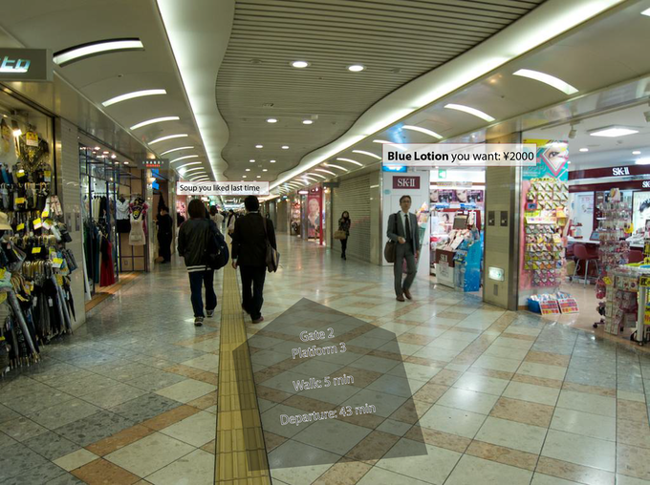

Figure 5.1.1-1: Localized Mobile Metaverse Services offering relevant information

Here, the AR annotation provides much more than an augmented map. The user is going to catch a train. (a) The path to the platform is shown without obstructing the user's perception of their proximity, where the contrast is good and no distractions appear. The (b) store on the right can provide content that may be relevant to the potential shopper, here the store's opening hours. Further along, (c) a restaurant provides a personalized message, reminding the user that they ate there in the past and ordered soup. These services are linked to the space that the user is in. See Figure 5.1.1-2, below.

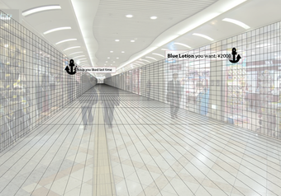

Figure 5.1.1-2: Services offering relevant information are anchored in space

The three information augmentations that are displayed are the result of different source of information. The path information (a) can be presented anywhere that it fits into the scene, where the information for (b) and (c) are anchored in space. The information depends on interaction between the user (or the user's preferences, application context, etc.): the content shown depends on the user's interest: (a) they are travelling, and the navigation app knows what information the user needs to see. (b) The user has sought Blue Lotion and it is available here - the user's 'persistent search' shows local results. (c) At this time of day, the user often eats, so the restaurant on the left's reminder is welcome.

The 5G system enables this 'access to local services' in a number of ways.

### 5.1.2 Pre-conditions

Ulysses uses his AR capable glasses while travelling. These are tethered to a UE that he carries. This UE receives 5G service from the mobile network operator he has a subscription with, M. Ulysses is interested in using his AR capable glasses to receive relevant information, so he has selected *which applications* are 'relevant.' These applications are therefore configured with the operator M to be 'active.' The purpose of this configuration will be described below.

Local services, that is services that are localized, have anchors that can be relevant to applications. A pre-condition of this use case is that such services exist and have *spatially defined* access. This is considered in this use case as an 'anchor.' The local service provider associates a service with an anchor, potentially as well as metadata concerning the service (e.g. 'is a restaurant'.) This information is available to M, either because the local services have been registered with M directly, or are available in maps, registries, or other information sources that M has access to (e.g. information that is provided by the UE).

### 5.1.3 Service Flows

Ulysses transfers at the Osaka train station. He has some time before he catches his connecting train. As he is hungry, he activates a 'persistent search' on his mobile device to inform him of opportunities to eat as he traverses the station. His mobile device begins to collect information about his surroundings. The collected information can include information that is obtained by interacting with nearby devices (e.g. sensors and other mobile devices). He also has a shopping list (a set of items of interest) from retail stores. He makes use of a navigation facility so that he will neither lose his way nor lose track of time.

This has the following consequences:

a) As a result of the applications activated by the user, and the user's preferences, the UE requests the 'localized mobile metaverse' service enabler offered by M, providing a list of 'persistent search' information and the information that was collected from the user’s surroundings.

b) M receiving the persistent search and the information that was collected from the user’s surroundings, engages localized service activation. The location of the UE is compared against the search criteria, the information that was collected from the user’s surroundings and information available to M of spatially defined access points.

c) M identifies a match - essentially a 'JOIN' of user preferences / application persistent search criteria "restaurants" AND location (in the user's field of view) AND local spatially defined access exists.

d) This match is provided to the UE, for further processing by the application.

Example 1: The application [service] associated with 'restaurants' has stored information the user has eaten there and indicated it was 'good.' Thus the annotation 'Soup you liked last time' is displayed.

Example 2: The application [service] associated with 'shopping' has stored a shopping list. When a local 'shopping service access point' has been identified, the shopping application queries the service provider directly. If there is success, the result is displayed. Here: "Blue Lotion you want ¥2000."

e) The UE is able to interact with the application to obtain information associated with the service.

### 5.1.4 Post-conditions

Spatial information has successfully been employed to allow a user to identify services. Please see 5.5 for further information on how spatial information is obtained.

The user's location has been applied.

The information output of different applications are integrated into the media that the user sees through the AR display device. The information associated with the services is displayed in the proper location in the user's field of view.

Ulysses may choose to eat soup or buy Blue Lotion.

M may charge Ulysses for this service, e.g. for the use of a persistent search and for each successful result provided.

### 5.1.5 Existing feature partially or fully covering use case functionality

Location based services exist, to identify the position of the UE.

The 5GS supports means to expose the UE's location to a 3rd party service provider.

Location Services for CIoT in 23.682, 4.5.19 [43], allow an LCS client to obtain the location of a CIoT UE location, either periodically or in a triggered manner, as well as the last known location of a UE that is unreachable for an extended time.

Location services, as specified in 23.273, 5.5 [44] support exposure to authorized third parties through a CAPIF API between NEF and the AF. The information that can be exposed includes the target UE identity and parameters for location events, e.g. the trigger (the UE enters, leaves or is within a target area), the time between reports if multiple reports are requested, and of course the precise location in three dimensions up to the maximum horizontal and vertical accuracy supported.

Effectively, there are also numerous 'over the top' mechanisms that essentially communicate GPS or other location information that can be accessed by the application from the mobile OS and terminal equipment. The client application on the UE supplies this location information to an AS 'opaque' to the 5G system (that is, in application traffic that is not visible to the 5G system.) In this sense, the 5G system supports location services in that it provides a UE with the mobile broadband services.

Using the location information obtained by any of these three mechanisms described above, a service provider can identify appropriate content for or interaction with the user, by means that are out of scope of 3GPP. This could include the services introduced in 5.1.1 in the example of i-mode. The application service can be configured or used in such a way that the user's interest is known, and location-relevant information can be 'pushed' to the client application.

There is a significant gap between this support and the functionality described in this use case. The Localized Mobile Metaverse Services unlike e.g. i-mode and similar location service enabled applications ***does not assume*** the use of a specific mediating application that organizes and delivers information. Rather, this use case features and motivates a service enabler that allows the user to ***discover*** different locally relevant services and content, so that any available application service can be accessed by the UE, e.g. through a web browser or other interactive-media capable general purpose application.

### 5.1.6 Potential New Requirements

[P.R.-5.1.6-1] The 5G system shall enable third parties to make known the availability of application services (i.e. provided by Application Servers) associated with a precise location.

[P.R.-5.1.6-2] The 5G system shall provide suitable exposure mechanisms for application services (i.e. provided by Application Servers) associated with a precise location available in the user's proximity (e.g. within line of sight), such that the mobile metaverse services can conform to specific service constraints.

NOTE: The term 'service constraints' implies that certain targets of service discovery are supported, e.g. to find 'restaurants.'

[P.R.-5.1.6-3] The 5G system shall provide suitable means to discover mobile metaverse services (i.e. provided by mobile metaverse servers) associated with a precise location available in the user's proximity.

[P.R.-5.1.6-4] The 5G system shall enable the rendering of diverse media, from one or more mobile metaverse services associated with a single location, to be combined to form a single location related service experience.

## 5.2 Use Case on Mobile Metaverse for 5G-enabled Traffic Flow Simulation and Situational Awareness

### 5.2.1 Description

Smart transport is a very important area for 5G system as well as an important mobile metaverse service. To reduce traffic jam and minimize traffic accident, 5G, including cellular based V2X technologies becomes more and more essential. The 5G system can be utilized to support real-time information & data delivery for the traffic participants including pedestrians, bicycle riders, and vehicles with or without autonomous driving mode. As shown in Figure 5.2.1-1, the physical objects including road infrastructure and vehicles including cars and trucks in each lanes, will have a corresponding digital twin in the virtual world, and the virtual and physical objects form the mobile metaverse. In this use case, there are virtual objects which actually represent the physical objects including vehicle, road and also pedestrians. This is the basis to enable smart transport applications like traffic flow simulation and situational awareness.

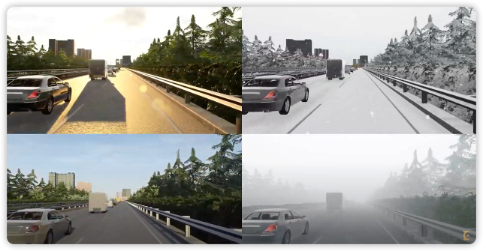

Figure 5.2.1-1 Example of Smart Transport Metaverse

With the support of 5GS, real-time information and data about the physical objects can be delivered and the virtual objects of the road infrastructure and traffic participants including vulnerable road users can form a smart transport mobile metaverse service as shown in Figure 5.2.1-2. Then real-time processing& computing can be conducted to support traffic simulation, situational awareness, and real time path guidance. Real-time safety or security alerts can be generated for vehicles as well as the driver and passengers.

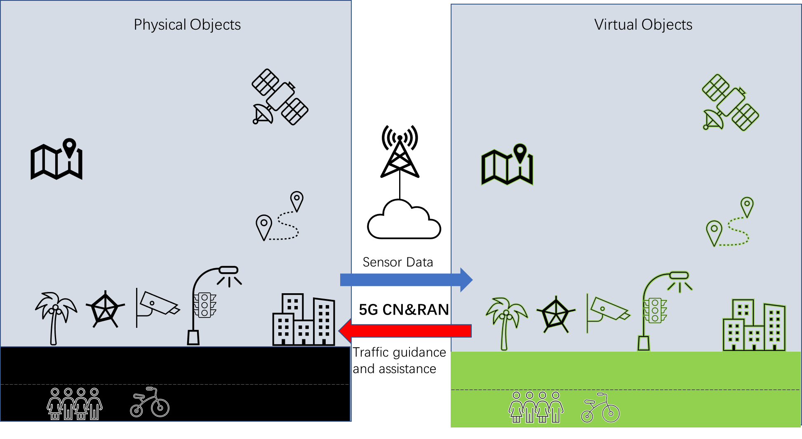

Figure 5.2.1-2 Scenario of 5G-enabled Traffic Flow Simulation and Situational Awareness

In order to support traffic flow simulation and situational awareness service, the 5G network need to provide low latency, high data rate and high reliability transmission, handover procedures that minimize service disruptions, and in addition, the 5G network may also need to be further enhanced to meet the service requirements for 5G-enabled traffic flow simulation and situation awareness. Meanwhile, in addition to the physical objects which may use UEs for telecommunication services, their corresponding virtual objects are also capable of interacting with each other and also interact with physical objects via 5GS.

This use case employs terminology defined in Table 5.2.1-1.

Table 5.2.1-1: Traffic Flow Simulation and Situational Awareness Terminology

|  |  |
| --- | --- |
| Situational Awareness | The ability to know and understand what is going on in the surroundings, e.g. the perception of environmental elements and events |

### 5.2.2 Pre-conditions

1. Traffic participants may or may not be equipped with 5G-enabled terminal equipment. The 5G-enabled terminal equipment can send and receive data via 5G network.

2. Computing and storage resources are provided for the mobile metaverse servers deployed locally or over the data network (in a centralized cloud) to allow real-time processing of huge amount of data produced by human, vehicle, camera, radar etc.

3. Wired or wireless communication resources are configured among the road infrastructure and mobile metaverse server so that the server has real time information of traffic participants perceived by these sensors. The road infrastructure include camera, radar/lidar and also other devices, e.g. for traffic control and guidance etc. The infrastructure equipment may have wired connection e.g. fiber or ethernet or any other wired connection if available. The cellular wireless network can be used to provide a more flexible way to obtain communication services, especially when a wired connection is not available.

### 5.2.3 Service Flows

1. Wired or wireless communication path are configured among the road infrastructure and mobile metaverse server so that the server has real time information of traffic participants perceived by these sensors.

2. Sensors deployed in roadside are initialized and enter normal working mode which means the sensors can start to capture the traffic participants.

3. Data connections between the vehicle driver’s UE and server are established with 5G UE module being registered with the server. Vehicles without driver are equipped with a 5G UE module.

4. The traffic participants including pedestrians, bicycle riders, and vehicles, send real-time information towards the server by means of 5G UEs. The real-time status information includes position, speed, direction, brake status etc. Other related status information can be, but is not limited to, sensors for XR (haptic, audio, video, etc) or smart transport (traffic light, camera, radar/LiDAR, etc). These traffic participants are physical objects in physical world which send their property and status information to the corresponding digital-twins objects, that is, virtual objects. This real-time information may include structured and unstructured data. Structured data normally means data which has been processed and thus formatted in a certain way, can be easily stored in database and when transmitted via 5G wireless network, normally less transmission resource (e.g. lower data rate) is needed. Unstructured data are not formatted in a certain and pre-defined way and is not easy to store in database and when transmitting over 5G network, more transmission resource would be needed.

5. Within the mobile metaverse service, for 5G-enabled traffic flow simulation and situation awareness, real-time information of the physical objects including the road infrastructure, the traffic participants as well as other information from traffic light signal, camera, radar, etc, are synchronized to the virtual objects and real-time simulation are conducted. The virtual objects can also interact with each other within virtual world and interact with physical objects via 5G system.

Having interaction among virtual and physical objects is essential and beneficial to support traffic simulation and situational awareness as the virtual objects can also have their intelligence which allow them to request telemetry from physical objects or other virtual objects. Thus, not only the physical but also virtual objects need to interact via 5G system and they need to be identified. Interaction means the physical objects deliver real-time status data to digital twin i.e. virtual objects in one direction, and the virtual objects can also send alert or other information to physical objects.

Such interaction needs to be realized via 5GS because the physical objects like vehicles or humans need to use a 5G UE to access the 5G system and use 5G resources to establish a connection with 5G system QoS support. Identification of these physical and virtual objects by 5GS and thus associating them is needed to support such interaction, meanwhile, from 5G system perspective, this make it easier for the 5G system, based on operator policy with 3rd party, to provide bearer services with corresponding QoS guarantee for both physical and virtual objects as they can be seen as UE for 5GS.

It is noted that physical objects may include static and dynamic. Some static objects deployed along road side like light poles may not move but their properties can be synchronized with their virtual objects if such properties may impact traffic simulation and situational awareness and also visualization processing of the physical world. Theses physical objects may or may not have dedicated UEs. Pedestrian and vehicles are equipped with UEs but the sensors like camera, LiDAR and radar may share a common communication module to establish connection with mobile metaverse services. The communication module can be wired node or wireless UE.

6. Traffic flow simulation is conducted which can predict whether there will be traffic jam and which path is optimal for a certain vehicle. The simulation can generate traffic assistance or guidance in a real-time manner towards the traffic participants.

7. The mobile metaverse server sends the traffic assistance or guidance information to the UE which serves the pedestrian, bicycle rider, vehicle driver or autonomous vehicle.

### 5.2.4 Post-conditions

1. The mobile metaverse server conducts big data analysis to further refine the accuracy of traffic flow simulation and situation awareness.

2. Both UEs serving (e.g. providing sensing data for) the physical objects and digital twins objects can be identified by the 5G system.

### 5.2.5 Existing features partly or fully covering the use case functionality

The QoS framework of 5G system supports low latency, high reliability or high data rate transmission of data traffic.

### 5.2.6 Potential New Requirements needed to support the use case

[PR 2.1.6-1] The 5G system shall be able to support the following KPIs for transmission for traffic between a large number of UEs and application server (e.g. mobile metaverse server).

| **Use Cases** | **Characteristic parameter (KPI)** | | | | **Influence quantity** | | |
| --- | --- | --- | --- | --- | --- | --- | --- |
| **Max allowed end-to-end latency** | **Service bit rate: user-experienced data rate** | **Reliability** | **Area Traffic capacity** | **Message Data Volume** | **Transfer Interval** | **Service Area** |
| 5G-enabled Traffic Flow Simulation and Situational Awareness | [5-20] ms (NOTE 1) | [10~100 Mbit/s] [25](NOTE 6) | > 99.9% | [~39.6 Tbit/s/km2 ]  (NOTE 5) | Typical data:  Camera: 10M bits/s per sensor (unstructured)  LiDAR: 90M bits/s per sensor (unstructured)  Radar: 10M per sensor (unstructured)  Real-time Status information including Telemetry data:  [< 50K bits/s] per sensor/vehicle/VRU  (structured)  (NOTE 2) | 20-100 ms  (NOTE 3) | City or Country wide  (NOTE 4) |
| NOTE 1: The mobile metaverse server receives the data from various sensors, performs data processing, rendering and provide feedback to the vehicles and user s. The end-to-end latency refers to the transmission delay between a UE and the mobile metaverse server. Exact value is FFS  NOTE 2: To support at least 80 vehicles and 1600 users present at the same location (e.g. in an area of 40m*250m) to actively enjoy immersive metaverse services for traffic simulation and traffic awareness, the area traffic capacity is calculated considering 2 cameras, 2 Radars, 2 LiDARs on road side, 1600 user’s smart phones and 80 vehicles with 7 cameras, 4 radar and 2 LiDAR for each vehicle. These application layer message data need to be segmented for network transport thus doesn’t mean packet size. The real-time status information including telemetry data may be structured.  NOTE 3: The frequency considers different sensor types such as Radar/LiDAR (10Hz) and Camera (10~50Hz).  NOTE 4: The service area for traffic flow simulation and situational awareness depends on the actual deployment, for example, it can be deployed for a city or a district within a city or even countrywide. In some cases a local approach (e.g. the application servers are hosted at the network edge) is preferred in order to satisfy the requirements of low latency and high reliability.  NOTE 5: The calculation is this table is done per one 5G network, in case of N 5G networks to be involved for such use case in the same area, this value can be divided by N. Exact value is FFS.  NOTE 6: User experienced data rate refers to the data rate needed for the vehicle or human, the value is observed from industrial practice and exact value is FFS. | | | | | | | |

## 5.3 Use Case on collaborative and concurrent engineering in product design using metaverse services

### 5.3.1 Description

Since the industrial age, engineering design has become an extremely demanding activity. Collaborative and concurrent engineering occur as a concept and methodology at the end of the last century and was defined as a systematic approach to integrated and co-design of products and their related processes. The diversity and complexity of actual products, requires collaboration of engineers from different geographic locations to share the ideas and solutions with customer and to evaluate products development. VR and AR technologies have found their ways into critical applications in industrial sectors such as aerospace engineering, automotive engineering, medical engineering, and also in the fields of education and entertainment. The range of technologies include Cave Automatic Virtual Environment (better known by the recursive acronym CAVE) environments, reality theatres, power walls, holographic workbenches, individual immersive systems, head mounted displays, tactile sensing interfaces, haptic feedback devices, multi-sensational devices, speech interfaces, and mixed reality systems [6].

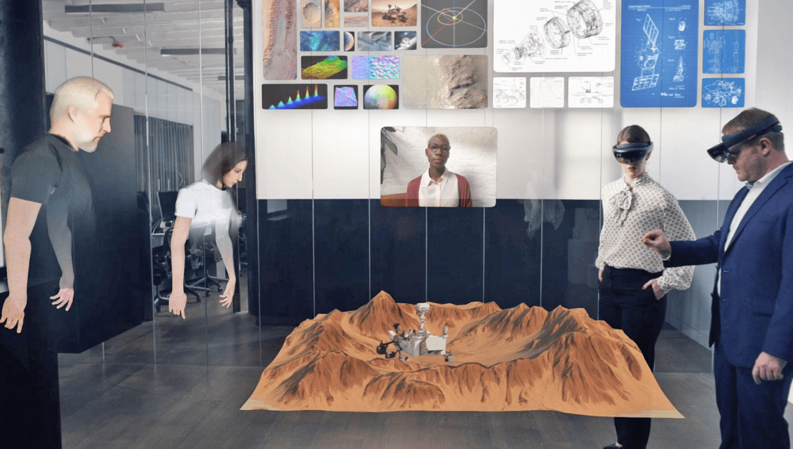

Figure 5.3.1-1: XR enabled collaborative and concurrent engineering in product design   
(Source: https://vrtech.wiki/)

One of the key challenges is to how to enable a distributed virtual environment (DVE) allowing multiple users from different geographical locations (some of them are present at the same location) to interact over a network. A DVEs is defined as multi-user virtual reality that actively support communication, collaboration, and coordination [7], 3D place-like environment in which participants are provided with graphical embodiments called avatars that convey their identity, presence, location, and activities to others [8]. A DVE is the simultaneous existence of multiple users in the same virtual space represented as avatars, their communication, the shared exploration of 3D visualizations, and the collaborative construction of new content. This avatar representation is essential for every user knows about the actual perceptions of other users. The users can communicate with each other. They can interact with other users and with the virtual environment. A DVE in the terms of this study is a location agnostic service experience.

To support DVEs for collaborative and concurrent engineering, the 5G system needs to fulfil certain KPIs, such as latency, data rate, reliability. Moreover the 5G system (with mobile metaverse services) is expected to support the fundamental features including:

- mobile metaverse media support among multiple users;

- User Identity management;

- data security.

### 5.3.2 Pre-conditions

Novitas, an innovative start-up company, has set up a distributed virtual environment (with the corresponding 5G communication subscriptions provided by GreenMobile) for collaborative and concurrent engineering in their product design with engineers participating locally and remotely. They have been granted a contract to work together with several partner companies to design and produce a new model of aeroplane engine.

In the current phase, Novitas need to collaborate closely with Nyhet, a partner company, to design the key parts of the engine. As part of the agreement, they use the distributed virtual environment to carry out some of the design that requires interaction among engineers. Some engineers use mobile phones or computers (as well as the necessary XR devices), with the corresponding 5G communication subscriptions, to attend such engineering meetings. To protect the sensitive business information, strict security requirements for user identity management and data security are crucial.

The service flows below illustrate how engineers interact with each other using services provided by 5G system.

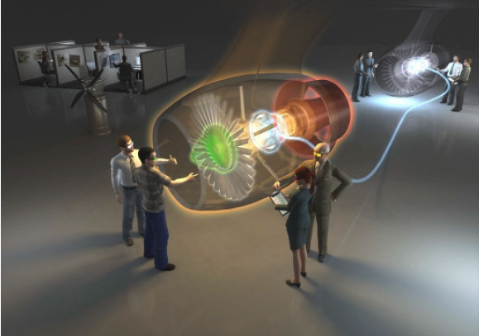

Figure 5.3.2-1: Illustration of Collaborative Workspace (Source: ESI-Icido GmbH)

### 5.3.3 Service Flows

1. Archimedes, Isambard, Leonardo and George have scheduled an XR design meeting, and Archimedes, Isambard, Leonardo attend from offices while George attends from the factory. Each participant needs to be authenticated before being admitted to the meeting. Due to the strict security requirements, typically participants need to be authenticated using bio information (e.g. finger print, facial image) at the terminal side. The result (not the original bio information) of the terminal side authentication can be forwarded to the corresponding application server of the enterprise. The final result of the network level authentication (can also include the context information, e.g. location information of the participants) is also forwarded to the corresponding application server of the enterprise. Such information helps the enterprise to decide what information (e.g. levels of confidentiality) can be disclosed to which participants during the meeting.

2. Having completed the authentication of the participants, the multimedia communication session/sessions are set up among multiple users as well as the associated devices in the mixed reality systems (e.g. head mounted displays, tactile sensing interfaces, haptic feedback devices, multi-sensational devices). This can be done by means of the IMS (including IMS CN with Data Channel capability) or via OTT applications.

3. When a session starts, multiple streams are established over the 5G network between the corresponding devices that carry multiple modalities data. Table 5.3.3-1 depicts the typical QoS requirements that have to be fulfilled in order for the users’ QoE to be satisfactory.

Table 5.3.3-1 Typical QoS requirements for multi-modal streams [9] [10] [11] [12] [13]

|  |  |  |  |
| --- | --- | --- | --- |
|  | **Haptics** | **Video** | **Audio** |
| Jitter (ms) | ≤ 2 | ≤ 30 | ≤ 30 |
| Delay (ms) | ≤ 50 | ≤ 400 | ≤ 150 |
| Packet loss (%) | ≤ 10 | ≤ 1 | ≤ 1 |
| Update rate (Hz) | ≥ 1000 | ≥ 30 | ≥ 50 |
| Packet size (bytes) | 64-128 | ≤ MTU | 160-320 |
| Throughput (kbit/s) | 512-1024 | 2500 - 40000 | 64-128 |

4. The haptic information, video and voice are generated at one party and distributed to all other parties continuously. Note that based on the company security policy, some information is shielded before being distributed to certain participants. For example, George joins the meeting from the factory, which is considered less secure according to the company policy. Consequently some sensitive information is filtered before being distributed to George. Information filtering is typically done at the conference centre (i.e. conference focus).

5. George travels back to office while staying connected on the conference. The connection quality of George’s devices has deteriorated sharply, and the 5G network triggers the codec re-negotiation to maintain the reasonable quality of experience for all participants.

### 5.3.4 Post-conditions

The 5G system enables efficient communication, with enhanced security and identity management, in support of DVEs for the collaborative and concurrent engineering.

### 5.3.5 Existing features partly or fully covering the use case functionality

The service requirements on the support of multimedia communication among multiple users have been captured in TS 22.228 [2] with the following key definitions:

***Conference:*** *An IP multimedia session with two or more participants. Each conference has a "conference focus". A conference can be uniquely identified by a user. Examples for a conference could be a Telepresence or a multimedia game, in which the conference focus is located in a game server.*

***Telepresence:*** *A conference with interactive audio-visual communications experience between remote locations, where the users enjoy a strong sense of realism and presence between all participants by optimizing a variety of attributes such as audio and video quality, eye contact, body language, spatial audio, coordinated environments and natural image size.*

***Telepresence System:*** *A set of functions, devices and network elements which are able to capture, deliver, manage and render multiple high quality interactive audio and video signals in a Telepresence conference. An appropriate number of devices (e.g. cameras, screens, loudspeakers, microphones, codecs) and environmental characteristics are used to establish Telepresence.*

***Conference Focus:*** *The conference focus is an entity which has abilities to host conferences including their creation, maintenance, and manipulation of the media. A conference focus implements the conference policy (e.g. rules for talk burst control, assign priorities and participant’s rights).*

Support of Multi-device and Multi-Identity in IMS MMTEL service is captured in TS 22.173 clause 4.6 [3]:

*The support of multiple devices is inherent in IMS. In addition, a service provider may allow a user to use any public user identities for its outgoing and incoming calls. The added identities can but do not have to belong to the served user. Identities may be part of different subscriptions and different operators.*

In addition, TS 22.101 [4] has specified in clause 26a a set of service requirements on User Identity:

*Identifying distinguished user identities of the user (provided by some external party or by the operator) in the operator network enables an operator to provide an enhanced user experience and optimized performance as well as to offer services to devices that are not part of a 3GPP network. The user to be identified could be an individual human user, using a UE with a certain subscription, or an application running on or connecting via a UE, or a device (“thing”) behind a gateway UE.*

*Network settings can be adapted and services offered to users according to their needs, independent of the subscription that is used to establish the connection. By acting as an identity provider, the operator can take additional information from the network into account to provide a higher level of security for the authentication of a user.*

*The 3GPP System shall support to authenticate a User Identity to a service with a User Identifier.*

The functional requirement and performance KPIs in support of XR applications are mainly captured in TS 22.261:

- clause 7.6.1 AR/VR;

- clause 6.43 Tactile and multi-modal communication service

- clause 7.11 KPIs for tactile and multi-modal communication service

Clause 8 of TS 22.261 specifies the security related requirements covering aspects such as authentication and authorization, identity management, and data security and privacy.

Additional consideration need to be given to allow multiple users from different geographical locations to interact using XR techniques.

### 5.3.6 Potential New Requirements needed to support the use case

#### 5.3.6.1 KPIs for the collaborative and concurrent engineering in product design

[PR 5.3.6.1-1] The 5G System shall provide the appropriate connectivity KPIs for the use case of collaborative and concurrent engineering in product design, see table 5.3.6.1-1.

**Table 5.3.6.1-1 – Potential key performance requirements for collaborative and concurrent engineering in product design**

| **Use Cases** | **Characteristic parameter (KPI)** | | | | **Influence quantity** | | |
| --- | --- | --- | --- | --- | --- | --- | --- |
| **Max allowed end-to-end latency** | **Service bit rate: user-experienced data rate** | **Reliability** | **Area Traffic capacity** | **Message size (byte)** | **UE Speed** | **Service Area** |
| Collaborative and concurrent engineering | [≤10] ms  Typical haptic data: [5] ms  (note 1) | [1-100] Mbit/s  ([14]) | [> 99.9%] ([14])  Typically for Haptic: [> 99.9%] (without compression)  Typically for Haptic: [> 99.999%] (with compression (note 4))  [26] | [3.804] Tbit/s/km2  (note 2) | Typical haptic data:  1 DoF: 2-8  3 DoFs: 6-24  6 DoFs: 12-48  Video: 1500  Audio: 100  ([14]) | Stationary or Pedestrian | typically  < 100 km2  (note 3) |
| NOTE 1: The network based conference focus is assumed, which receives data from all the participants, performs rendering (image synthesis), and then distributes the results to all participants. The latency refers to the transmission delay between a UE and the application server.  NOTE 2: To support at least 15 users present at the same location (e.g. in an area of 20m*20m) to actively enjoy immersive Metaverse service concurrently, the area traffic capacity is calculated considering per user consuming non-haptic XR media (e.g. for video per stream up to 40000 kbit/s) and concurrently 60 haptic sensors (per haptic sensor generates data up to 1024 kbit/s).  NOTE 3: In practice, the service area depends on the actual deployment. In some cases a local approach (e.g. the application servers are hosted at the network edge) is preferred in order to satisfy the requirements of low latency and high reliability.  NOTE 4: The arrival interval of compressed haptic data usually follow some statistical distributions, such as generalized Pareto distribution, and Exponential distribution [26]. | | | | | | | |

#### 5.3.6.2 Service requirements for collaborative and concurrent engineering in product design

[PR 5.3.6.2-1] The 5G system shall enhance the interaction between IMS CN and 5G CN to allow 5G CN to provide the IMS CN with real-time feedback in support of XR communication among multiple users simultaneously.

NOTE: The feedback can include information such as network condition, achieved QoS. Such information can be used by the IMS CN, for example, to trigger the codec negotiation.

[PR 5.3.6.2-2] Subject to regulatory requirements, operator policies and user consent, the 5G system shall be able to support mechanisms to expose to a trusted third party (e.g. the conference focus) the result of authenticating a user identity to a UE.

NOTE: Authenticating a user identity to a UE at the terminal side is out of 3GPP scope.

[PR 5.3.6.2-3] The 5G system shall be able to collect charging information per UE or per application for the use of IMS based conferencing services.

[PR 5.3.6.2-4] The 5G system shall provide a means to synchronize multiple data flows from multiple UEs associated with one user.

## 5.4 Use Case on Spatial Anchor Enabler

### 5.4.1 Description

In use case 5.1 "Localized Mobile Metaverse Service Use Case," we introduced the term spatial anchor to describe an association between space and service information. This use case elaborates the concept of the spatial anchor to enable diverse mobile metaverse services, including those described in use case 5.1. This use case focuses on the creation, management and use of spatial anchors.

The overall purpose of this enabler is to make it possible to create AR content and share it with others. The 'spatial anchor producer' determines what to share and its location, and any constraints (e.g. who to share the spatial anchor with) and additional information, most importantly the 'resource' associated with the anchor (e.g. AR media, mobile metaverse service to access, etc.).

The 'spatial anchor consumer' is able to recognize anchors associated with locations, and use the spatial anchor to obtain the associated information.

Functionally, a spatial anchor has the following model:

- **Spatial Anchor**: information that can be provided by a content producer to a content consumer. How this is done is out of scope of this use case.

- **Precise spatial location information**: where the produced content is located, including the content's extent, orientation, etc.

- **Service information**: this information is out of scope of standardization but could contain, e.g. a URL, media data, media access information, etc. This information is used by an application to access a service.

The spatial anchor enabler will benefit retail environments. Here, a cheese seller has extensive information about her wares that she will share with customers.

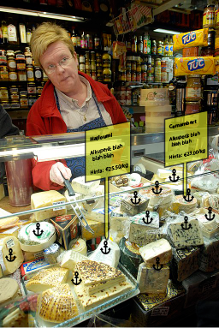

Figure 5.4.1: Spatial Anchors - created by a user to share with other users

In this use case there are several actors that are relevant.

- Leka the cheese seller is the content producer. She creates content and also anchors them to her wares. (She is very adept at putting the cheese back in the same places, and moving the anchors when this is not possible.)

- I am the customer.

- Warez is the mobile metaverse service provider stores that updates Leka's content, generates its presentation (that is, the AR content that is presented to customers), supports any interactive features, etc.

- FineNet is the network operator that enables anchored services for any content producer, customer and mobile metaverse service provider.

### 5.4.2 Pre-conditions

Leka makes use of a UE that has a subscription with FineNet. She has a sensor that can be used in combination with the UE to indicate precise locations. In figure 5.4.1-1, the sensor can identify the location of the tip of the cheese fork she holds.

Leka obtains services from Warez, where she stores information related to her inventory. She also has arranged in advance what information to display to customers and in what format.

I wear glasses that provide AR experience and communicate by means of my UE. I have a mobile subscription with FineNet also.

### 5.4.3 Service Flows

Leka places wares on display. She indicates the location of wares that are associated with inventory information so that the association of location (listed below as 'pose' including position in 3 dimensional space, orientation and possibly more spatial data) and service information are captured by the 5GS. This inventory information is captured also by the mobile network operator as **spatial anchors**. This is shown on the top half of Figure 5.4.3-1.

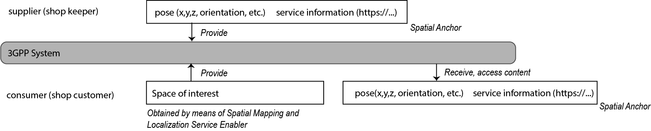

Figure 5.4.3-1: Spatial Anchor Enabler Service Flow

NOTE: The text in parentheses in the figure above are examples.

**1. Creating, modifying, removing spatial anchors**

To add new wares to display, Leka captures the location of the item with her cheese for (which includes sensors.) She associates a new spatial anchor with this location and product information (e.g. by scanning the bar code on the cheese). The Warez inventory management system also generates AR content on demand (mobile metaverse media): this application is *external* to 3GPP standards. Leka's UE accesses the mobile metaverse service that establishes the association that comprises the spatial anchor, the physical location and the service information.

When Leka moves wares, Leka can adjust the spatial location of items or remove them entirely (e.g. when the cheese has been sold) by registering the new location or removal with the Warez inventory management system. The 'location' and 'service information' can be updated over time.

Leka can also update the information that will be displayed as AR (mobile metaverse media) to the customer by the mobile metaverse server offered by the Warez inventory management system, for example the description of the cheese, its price, etc. This interaction is out of scope of 3GPP standards.

**2. Accessing and using Spatial Anchors**

I enter the store and examine what is on display. I capture the scene with sensors and share this information with the Spatial Mapping and Localization Service Enabler (5.5). This allows me to identify my localization information, including orientation, precisely.

I put on (activating) my AR glasses. By means of my UE with access over FineNet, share the location and orientation information (the area of interest) with the 5G system.

The 5G system uses the localization information to identify all applicable spatial anchors in the area of interest. These are returned to the UE and the AR glasses. This function is illustrated in the lower half of Figure 5.4.3-1.

The service information suffices to access the media server offered by Warez. The location information indicates the location of each spatial anchor.

I now perceive the spatial anchors as shown in Figure 5.4.1.

As Leka indicates the Halloumi in her counter, and my gaze focuses on that location (known to a very high degree of precision), the AR glasses use the service information associated with the spatial anchor to activate the Halloumi cheese media.

I now perceive the AR information panel associated with the Halloumi cheese.

### 5.4.4 Post-conditions

I am able to observe the AR content (mobile metaverse media) associated with the wares on display, as shown in Figure 5.4.1-1. As wares are moved or removed from the display, the content shifts as well. The display of AR content is the result of the service information (i.e. how to access the media) and the localization information (i.e. where the media is placed, oriented, etc.)

At any time Leka can add new wares and associated AR content, update the content that is displayed, etc.

I perceive AR content associated with the items in the shop and happily buy the cheese that meets my needs.

### 5.4.5 Existing feature partly or fully covering use case functionality

### 5.4.6 Potential New Requirements needed to support the use case

[PR-5.4.6-1] Subject to operator policy, the 5G system shall enable an authorized third party to establish an association between a physical location (in three dimensional space, an orientation, etc.) and service information, where the service information is provided to the 5G system and the spatial anchor is either provided or determined by the 5G system.

[PR-5.4.6-2] Subject to operator policy, the 5G system shall be able to establish an association between a physical location (in three dimensional space, an orientation, etc.) and service information, where the service information is provided to the 5G system and the spatial anchor is either provided or determined by the 5G system.

[PR-5.4.6-3] Subject to operator policy, the 5G system shall enable an authorized third party to obtain all of the spatial anchors located in a given three dimensional area.

NOTE 1: How the authorized third party identifies which three dimensional area to request spatial anchors in is not in scope of the 3GPP standard. Spatial localization and mapping information could be used to identify areas of interest.

[PR-5.4.6-4] Subject to operator policy, the 5G system shall enable a third party to request the service information associated with the precise location of a specific spatial anchor. Making use of this service and location information, the third party can access a mobile metaverse server to obtain AR media.

NOTE 2: How the service and location information is used by the third party to access a mobile metaverse server and the AR media itself is out of scope of this requirement.

[PR-5.4.6-5] Subject to operator policy, the 5G system shall provide an authorized third party a means to manage the spatial anchor(s), e.g. add, remove or modify spatial anchors, determine privacy and security aspects, and specifically to enable the third party to define which spatial anchors they manage have restricted access conditions.

[P.R.-5.4.6-6] The 5G system shall be able to collect charging information for the establishment or management of an association between a physical location and service information, where a third party creates, deletes or changes a spatial anchor or associated service information.

[P.R.-5.4.6-7] The 5G system shall be able to collect charging information associated with the network operator exposure of spatial anchors to authorized third parties, and of service information associated with spatial anchors.

NOTE: The preceding requirements assumes that exposure of network anchors and associated service information can be a service provided by a network operator to third parties.

## 5.5 Use Case on Spatial Mapping and Localization Service Enabler

### 5.5.1 Description

Spatial mapping is constructing or updating a map of an unknown location and localization is tracking an object to identify its location and orientation over time.

For the localized mobile metaverse use case 5.1, the service provider or operator needs to provide and use spatial map information, i.e. a 3D map of indoor or outdoor environment. This use case considers how a spatial map can be created and employed, both as service enablers. The creation and maintenance of the spatial map is referred to as Spatial Mapping Service and the employment of the map to identify the customer's Localization is termed Spatial Localization Service.

Spatial mapping will classify objects into modelling and tracking of stationary and moving objects. For stationary object, spatial mapping has to estimate the number of objects, type of object and position. Whereas for moving objects, spatial mapping has to determine the position, type of object, direction, speed. Once the spatial mapping service has sufficient information, it has to map all the stationary and moving objects related to UE’s environment. This information can be provided to the UE, service providers and surrounding subscribed users as well [17,19,24]

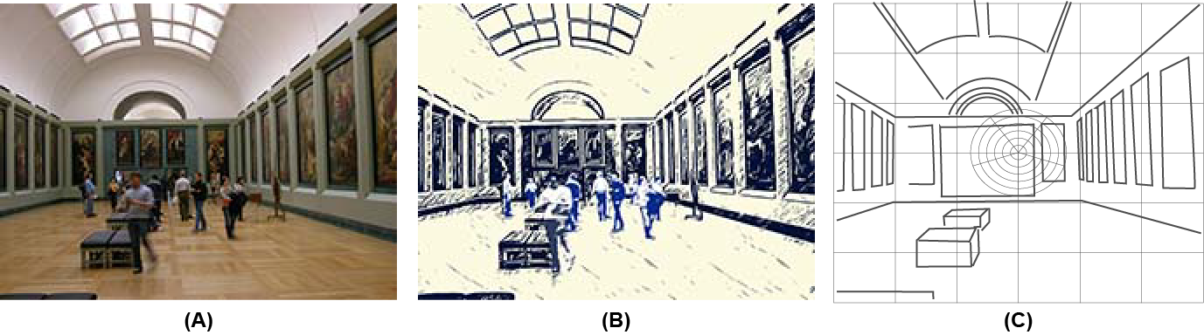

Figure 5.5.1-1: Spatial Location Services Enabler

Specifically, this use case proposes two spatial localization service enablers.

1) Spatial Mapping

Sensing data gathered transparently is processed in order to identify the static and transient forms. For example, in Figure 5.5.1-1

(A), the Rubens room in the Louvre, sensing data captures information.

(B) This information is processed to identify the static and transient information, to establish an up-to-date spatial map.

(C) In combination with location information (for the sensors) and other information (e.g. architectural specifications of the Louvre), a spatial map can be achieved in which not only the forms but also their locations in 3D space are known.

2) Localization

Given that a spatial mapping exists,

(A) sensing data for a user (from devices communicating by means of a UE) can be captured,

(B) compared with the spatial map,

(C) used to identify in 3D space the position, viewing direction, angle, etc. of the user.

**Spatial Mapping Considerations**

Examples when spatial mapping could be useful:

- A government conducting a digital city project can build a 3D spatial map of outdoor environment of an entire city or public spaces such as outdoor parks or indoor offices of their government building.

- A navigation service provider (or Spatial Localization Service) can build a 3D spatial map of outdoor environment of entire roads or public spaces. An operator’s partner or operator also can build a 3D spatial map of outdoor environment.

- A customer wanting mapping of their indoor environment, e.g. the interior of a commercial space such as the cheese shop as described in 5.4.

It is a hard task to perform the mapping of the entire city using a vehicle by traversing various roads and spaces. It also requires lots of time and effort (for data conversion, etc.) if the work is performed in offline. If the multiple capturing devices are used in parallel, the spatial map data in the same location could be synthesized over the different cameras and input devices to generate the spatial map.

The mobile capturing device, vehicle or robot equipped with multiple stereo/mono RGB cameras and multiple LiDAR to capture various qualities of images and depth information of the environments. As an example in [15], a mobile indoor robot is equipped with two LiDARs, 6 industrial cameras and 4 smartphone cameras. Based on the example, we can derive the uplink bandwidth requirements for one mobile indoor mapping robot. There is a corresponding use case for 'transparent sensing' in TR 22.837.

**Localization Considerations**

The environment mapping can be used for providing a visual positioning service, for enhancing the accuracy of location service or for helping the metaverse contents management system for spatial internet.

In this use case, the UE provides uplink sensor information that can be interpreted, along with a spatial map, to identify Localization. This is analogous to the process used by the UE to provide sensor data that the 5G system can use to determine UE location for Location Services.

### 5.5.2 Pre-conditions

**For Spatial Mapping**

Mobile operator or service provider can determine the target area for the spatial mapping. The target area can be divided into multiple areas where each can be mapped with multiple capturing devices (e.g. capturing indoor robot, vehicles).

Each capturing device is equipped with multiple sensors, e.g. mono or stereo RGB camera or one or more multiple LiDAR cameras. The intrinsic parameter of cameras equipped with the device are pre-configured in the device.

Each capturing device has a capability with high resolution positioning system, the positioning technique also can derive the altitude information.

An indoor robot can be equipped with non-3GPP based high resolution positioning system such as UWB. To derive the exact the position of the capturing device, each capturing device also can utilize the structure-from-motion technologies.

The capturing devices communicate via a UE that can access the mobile network of the MNO that supports spatial mapping. The capturing devices can either sense the spatial area to be mapped, or move about sufficiently that the capturing devices can be used to acquire sensing data corresponding to the area.

**For Localization**

A set of sensors are accessible by a UE. These could be built into the terminal equipment or communicate with it in some way that is out of scope of this use case, e.g. using a cable, a personal area network, etc.

The UE can access a mobile network of MNO M that offers localization services.

In 3GPP-R16, bistatic localization is performed on both downlink and uplink using time-difference-of-arrival (TDoA), angle-of-arrival (AoA), and angle-of-departure (AoD) measurements both at the base station. Both bistatic and monostatic have limitation with their accuracies, with the advent of high BW mmWave brings high resolution in both time-delay and angle domains. The spatial mapping problem can be divided into front and a back-end problem. In front-end, the problem is to determine the data association - between landmarks and measurement directions. The back-end problem is to find the probabilistic SLAM density for a given data association- determined in the front end. Most of the back-end algorithms are Kalman filter (EKF), Fast-SLAM and Graph-SLAM, which are based on Bayesian method [21, 22, 23].

5.5.3 Service Flows

**For Spatial Mapping**

1. A capturing mobile device attaches to the mobile network and becomes authorized to deliver sensing data for the purposes of spatial mapping.

2. The capturing mobile device starts the mapping operation.

a. The capturing mobile device arranges for its sensors to provide information as needed by the 5G system. This could require some configuration of the capturing mobile device, e.g. the sensors or to control the uplink communication of sensing data.

3. The capturing mobile device navigates, e.g. with a pre-defined route, within the selected target region in order to provide a sufficiently complete set of sensor information for the space to be mapped.

4. The capturing mobile device uploads the captured RGB camera images and LIDAR depth images to the 5G system with the positioning information of the mobile device.

5. The mapping server collects and analyzes the information provided to cumulative create or update a spatial map.

**For Localization**

1. A mobile device requiring localization attaches to a mobile network and becomes authorized to obtain Localization services.

2. The mobile device uses sensors to capture information corresponding to the point and direction that has to be localized.

3. The mobile device sends via uplink communication the sensing data to the 5G system.

4. The 5G system uses the sensing data and a spatial map to determine the localization, that is, the corresponding positioning information and sensor pose.

5.5.4 Post-conditions

**For Spatial Mapping**

The spatial mapping enabler re-structures the data provided by mobile capture devices to create a spatial map. This information could be combined with other information available, e.g. floor plans of buildings, survey data, satellite images, etc. Over time sufficient information will be captured to allow the spatial mapping enabler to distinguish between static and dynamic objects in the environment.

**For Localization**

The result of the localization service is available as a service enabler. This could be provided to the UE for use by applications or exposed to a third party by means of an API by the 5GS. This information can be used for many purposes, especially for media based applications that require localization to control the rendering of AR or MR content. Localization can be done over time, e.g. to track a user's movement.

The localization enabler can enhance location services as it can identify with some degree of precision a location by means of diverse sensors compared with known location data in the spatial map.

### 5.5.5 Existing feature partially or fully covering use case functionality

Location Services provide location information which can be used to support services that are triggered or informed by the user's location. This information is not at the degree of accuracy needed for some applications, e.g. AR. Location Services also do not work in all environments, e.g. indoor.

The 5GS supports uplink media and uplink sensor data communication.

In clause 4.1.4 of TR 26.928 [18] - XR spatial mapping and localization - has been proposed. This use case specifies the key areas of XR and AR are spatial mapping, which is creating a map of the surrounding areas, and localization - positioning the user in that map. This use case depends on multiple external sensors such as monocular/stereo/depth cameras, radio beacons, GPS, inertial sensors, etc., There is no requirement on how 5G sensing can be used for spatial mapping and localization services.

Positioning in 5G Networks been proposed in 3GPP release-16, it specifies positioning signals and measurements for the 5G NR. In release-16, 5G Positioning architecture extends 4G positioning architecture by adding Location Management Function (LMF) and Transmission reception points (TRP). 5G- along with enables- provides new positioning methods based on multi-cell round-trip time measurements, multiple antenna beam measurements, multiple to enable downlink angle of departure (DL-AoD) and uplink angle of arrival (UL-AoA) [M, 21, 22]. Current 5G system supports positioning of the device-based but not device-free – Objects that do not radiate EM signals. We propose to add new requirement in section- 5.5.6 to extend this architecture to support spatial mapping and localization service enablers.

### 5.5.6 Potential New Requirements needed to support the use case

#### 5.5.6.1 Requirements for Spatial Mapping

[PR5.5.6.1-1] Subject to operator policy and relevant regional and national regulation, the 5GS shall support mechanisms for an authorized UE to provide sensing data that can be used to produce or modify a spatial map.

[PR5.5.6.1-2] Subject to operator policy, user consent and relevant regional and national regulation, the 5GS shall support mechanisms to receive and process sensing data to produce or modify a spatial map.

[PR5.5.6.1-3] Subject to operator policy and relevant regional and national regulation, the 5GS shall support mechanisms to expose a spatial map or derived localization information from that map to authorized third parties.

NOTE 1: The spatial map and derived localization information supports services that produce AR and MR media, e.g. as described in clause 5.1.

NOTE 2: The precision of spatial positioning of sensors that provide sensing data used to create or modify the spatial map is not specified. This could be revisited in future as more experience accumulates with spatial mapping services.

[PR5.5.6.1-4] The 5G system shall support the collection of charging information associated with the exposure of a spatial map or derived localization information to authorized third parties.

[PR5.5.6.1-5] The 5G system shall support the collection of charging information associated with the production or modification of a spatial map on behalf of an authorized third party.

#### 5.5.6.2 Requirements for Localization

[PR5.5.6.2-1] Subject to operator policy and relevant regional and national regulation, the 5GS shall support mechanisms to authorize Spatial Localization Service.

[PR5.5.6.2-2] Subject to operator policy and relevant regional and national regulation, the 5GS shall support mechanisms for an authorized UE to provide sensor data that can be used to for Spatial Localization Service.

[PR5.5.6.2-3] Subject to operator policy and relevant regional and national regulation, the 5GS shall support mechanisms to expose Spatial Localization Service information to authorized third parties.

NOTE 2: The Spatial Localization Service information supports services that produce AR and MR media, e.g. as described in clause 5.1.

[PR5.5.6.2-4] The 5G system shall support the collection of charging information associated with exposing spatial location service information to authorized third parties.

## 5.6 Use Case on Mobile Metaverse for Immersive Gaming and Live Shows

### 5.6.1 Description

The mobile metaverse combines the physical and digital world. Mobile metaverse services have already gained significant attention and will benefit multiple areas, such as gaming, social, medical, industry, transport, and so on [27]. Mobile metaverse services will bring more immersive user experience, which will bring more potential requirements to 5G systems. Among these fields, gaming is considered a pioneer in the development of mobile metaverse services. This use case aims to discuss mobile metaverse services for immersive gaming and live shows.

With the support of 5GS, game players can interact with each other on the cloud or edge server, which may form a digital world we term a mobile metaverse. Figure 5.6.1-1 shows the general idea of this use case. The mobile metaverse service may be deployed at the cloud or edge server for immersive gaming and live shows. When the players are playing a basketball game, they may achieve an immersive experience with their avatars, and the avatars can interact with each other, whether the players are in proximity or non-proximity. Meanwhile, other players in the metaverse can join in this digital world as spectators to watch the live show.

The sensor data obtained by the cloud or edge server may perform coding and rendering to generate the digital representation for immersive gaming and live shows, which may be displayed (as if) on a big screen, and the interactive service data could be exchanged among the players, avatars. Here, sensing data include the physical pose and gestures including movement. For a basketball game, the court and surrounding facilities also can have sensor. The sensor data obtained from these sensors is useful for the metaverse to determine how to perform 3D digital representation of the participants and setting. An immersive user experience could be provided for the players and their audience. The major impact on 3GPP is whether and how 5GS can be used to better utilize the sensor data and achieve immersive experiences of the multiple players.

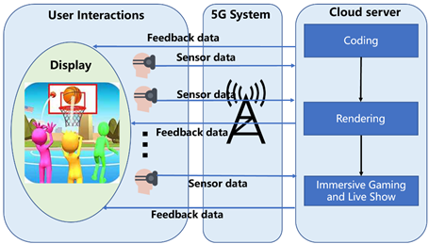

Fig 5.6.1-1 Mobile Metaverse for Immersive Gaming and Live Shows

### 5.6.2 Pre-conditions

The following are pre-conditions for this use case:

1) The computing resource used for game design and real-time processing such as game development library and rendering tools could be provided for mobile metaverse on the cloud or edge server.

2) 5GS is capable of transporting the uplink/downlink service data.

The VR/AR/MR/Cloud Gaming mobile devices, such as mobile headsets or other haptic mobile devices, could be connected to the cloud or edge server for supporting the mobile metaverse immersive game and live show via 5GS.

### 5.6.3 Service Flows

The following are service flows for this use case:

1) Player A (a lady who is a fan of the gaming mobile metaverse service) configures her smartphone (a UE.) One path is established between the cloud or edge server and the UE. The UE sends a request to the 5GS, and the 5GS authorizes the request and exposes the capability of mobile metaverse game production and game development (e.g. expose APIs) to the UE. Player A controls her avatar and performs game production and game development based on the rules made by her and the game development or material library stored on the cloud or edge server. She creates a basketball game venue, game rules, NFT characters (with player attributes), supermarkets, etc., all stored and run on the cloud or edge server.

NOTE: The edge may be a burden when it comes to long-term services, such as mobile metaverse service data storage and large-scale computing. In such a case, cloud service is essential for being a centralized node to maintaining shared space for thousands or even millions of concurrent users in such a large scale mobile metaverse service, and cloud-edge interaction via 5GS is necessary.

2) Player A invites seven players (B, C, D, E, F, G, H) who are participating in the mobile metaverse service to join the game venue created by herself. These players form two teams to play a 3v3 basketball game match. Among them, B, C, and D are one group, E, F, and G are another group, and H is the game referee. Each member of each group chooses their own digital representatoin. Then, player A publishes the game match information, and other players as spectators in the metaverse can enter the game venue to watch the match.

NOTE: Players A, B, C, D, E, F, G, and H can be located in different areas in the physical world.

3) The game starts. When the players are playing in a venue realized as a mobile metaverse service. 3D positioning accuracy is required for the digital representations (avatars) that represent the players’ location and also gestures in a basketball game. The team members in the physical world control the (digital representation of the) basketball through 5GS in the uplink direction by means of a typical mobile input device, e.g., VR headset, VR glasses. At the same time, the players can interact with each other and pass the basketball, etc.; though the player has no actual contact with a basketball in the physical world, he can get some haptic experience of the basketball. The team members both in the physical world and digital representation can interact with each other via 5GS anytime, anywhere for an immersive experience.

4) Spectators can watch the game match through 5G system by a typical mobile device. At the same time, the spectators can view diverse content such as the game attributes, including game rules and player information, by switching the viewing direction. Multiple mobile metaverse media can be provided to spectators an immersive live show experience through 5G system. The spectators can interact with each other via 5G system for an immersive experience.

NOTE: During the running of the game, UE can access mobile metaverse services with low power consumption to reduce the metaverse game interruption. The cloud or edge server is used for coding, rendering, and generating the mobile metaverse media for immersive gaming and live show mobile metaverse services.

5) Player A terminates the game application.

### 5.6.4 Post-conditions

The following are post-conditions for this use case:

The players in the game match achieved an immersive game experience by means of a mobile metaverse serivce enabled by 5GS.

The spectators in the game match had an immersive live show.

The 5GS can address and meet the mobile metaverse service game requirements with the cloud or edge side.

Players A, B, C, D, E, F, G, and H may earn money from the game, a mobile metaverse service.

### 5.6.5 Existing features partly or fully covering the use case functionality

In clause 6.43.2 of 3GPP TS 22.261, there are the following requirements:

The 5G system shall enable an authorized 3rd party to provide policy(ies) for flows associated with an application. The policy may contain e.g. the set of UEs and data flows, the expected QoS handling and associated triggering events, and other coordination information.

The 5G system shall support a means to apply 3rd party provided policy(ies) for flows associated with an application. The policy may contain e.g. the set of UEs and data flows, the expected QoS handling and associated triggering events, and other coordination information.

NOTE: The policy can be used by a 3rd party application for the coordination of the transmission of multiple UEs’ flows (e.g., haptic, audio, and video) of a multi-modal communication session.

5.6.6 Potential New Requirements needed to support the use case [PR 5.6.6-1] The 5G System shall support the transmission of uplink sensor data transmission and downlink feedback information with stringent requirements on packet delay and bandwidth for real-time interaction.

[PR.5.6.6-2] The 5G System shall support a mechanism to obtain the location and gestures of the players with stringent requirements on 3D positioning accuracy.

KPI requirements related to the potential requirements:

**Table 5.6.6-1 – Potential key performance requirements for immersive gaming and live shows**

| **Use Case** | **Characteristic parameter (KPI)** | | | |
| --- | --- | --- | --- | --- |
| **End-to-end latency** | **Service bit rate: user-experienced data rate** | **Reliability** | **Positioning accuracy** |
| Mobile Metaverse for immersive gaming and live shows | [5~20] ms | [1~1000] Mbit/s | [>99.99%] | [<1] m |

## 5.7 Use Case on AR Enabled Immersive Experience

### 5.7.1 Description

In addition to watching movies at the cinema, people will also choose to watch a movie on their mobile phones, laptops or TVs when they don’t have time to go to the cinema, e.g. when travelling or at home. However, by watching through these terminals, users will feel more or less uncomfortable in the neck or cervical spine because the users always keep their necks down. Moreover, the screen is relatively small; if users want to see more realistic screen details or watch an immersive 3D movie, using these terminals is not feasible.

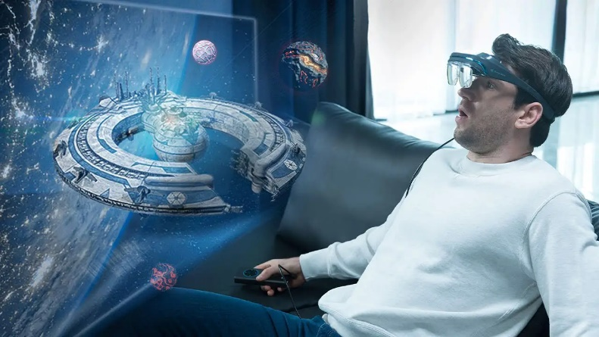

Figure 5.7.1-1: AR Enabled Immersive Experience (image source: www.indiegogo.com)

In this use case, users can get an immersive location agnostic service experience of watching movies in certain circumstances, such as at home or on the train. They can even invite some of their friends to watch a movie at different place simultaneously by wearing a wearable device, such as AR glasses. A large screen like a movie theatre will be presented in the field of vision (FOV) of the wearable device, which not only provides an immersive watching experience like private cinema but also has very low demands on the environment and space of the user's location, 3D cinematic effects can also be easily rendered in the device.

To achieve an immersive experience location agnostic service through AR glasses, the 5G system is required to provide a reliable transmission of uplink and downlink data and a way for users to synchronize their experience and interact together. In mobility scenarios, e.g., when a user is travelling on the train, the continuity of data transmission also needs to be guaranteed. Moreover, when AR glasses are wireless, the power supply relies on the battery integrated inside the AR glasses. This use case investigates how the 5G system (through direct device connection or NG-RAN) can be used to support UE to establish data connection with the mobile metaverse server. The 5G system can provides services to AR glasses so as to minimize energy consumption in the overall system.

The service dataflows and requirements may differ depending on whether the AR glasses are accessing the service through a direct device connection or NG-RAN.

### 5.7.2 Pre-conditions

Bob wants to watch an AR movie with friends to relax while travelling by train. So he wears wearable equipment such as AR glasses that can access into the 5G network (through direct device connection or NG-RAN) to access metaverse services.

Bob has subscribed to an immersive movie service as a mobile metaverse service that he can access via AR glasses. The service gives Bob access to a large movie catalog (2D/3D). The battery capacity of the AR glasses is enough to watch a two-hour movie. Before starting the movie, Bob can invite some friends to join him. If people join Bob, their avatars are also placed into his FOV and Bob can interact with them (speech or text).

Considering the wearing comfort of users, mainstream AR glasses should not be too heavy (normally less than 150 grams). The maximum capacity of the battery (50 grams) is about 1000mAh. Usually, 25% of the battery capacity of AR glasses is allocated to the mobile termination module.

When a user watches a 4K movie, some video compression techniques are usually used to reduce the amount of data transmitted while maintaining the image quality.

In general, a large compression ratio will cause a delay increase. Considering the overall factors of delay and energy consumption, using AR glasses with a direct device connection would require a low compression ratio, for instance, 3:1 [50]. However, some advanced AR glasses SoC embeds hardware video decoders (e.g., AVC, HEVC, and VVC) and can render viewport efficiently.

A study on energy consumption of hardware video decoders [59] shows that a typical HEVC hardware decoder embedded on an Android device is spending 40-50mA per hour of video playback (decoding only). The usage of hardware decoders seems reasonable, given the 1000mAh battery capacity assumption made in the current description. For the NG-RAN case, it is reasonable to think that AR glasses can decode and render efficiently with low energy consumption.

### 5.7.3 Service Flows

1. Data connections are set up between AR glasses and the Metaverse server, which can provide immersive location agnostic service experience of a movie service. The 5G module can be connected to the 5G network either via direct device connection or NG-RAN.

2. The mobile metaverse server provides movie access to the client AR glasses through the downlink data stream.

3. The mobile metaverse server manages communications between clients (friends), e.g., including video, avatar, speech, and text.

4. The mobile metaverse server manages synchronization between the clients (e.g., the various AR glasses) of the friends.

### 5.7.4 Post-conditions

Bob is able to watch an immersive movie with friends while travelling, obtaining a good user experience. The battery capacity of the AR glasses is enough to watch a two-hour movie.

Bob is able to communicate with them in a synchronized manner. Bob’s friends (or avatars) can be visible in his FOV.

The 5G system is able to support communication for immersive location agnostic AR services, providing a reliable transmission, a continuity of service and a synchronized experience across users sharing a viewing experience.

### 5.7.5 Existing features partly or fully covering the use case functionality

The performance requirements for high data rate AR services have been captured in TS 22.261 clause 7.6. The performance requirements for UE to network relaying in 5G systems have been captured in TS 22.261 clause 7.7. The functional and performance requirements for tactile and multi-modal communication services have been captured in TS 22.261 clauses 6.43 and 7.11, respectively.

However, existing requirements still need to consider the power consumption of the 5G UE onboard AR terminals.

### 5.7.6 Potential New Requirements needed to support the use case

[PR 5.7.6-1] Subject to operator policy, the 5G system shall support a means to provide high data rate transmission to a UE during an extended period of time, including when in high-speed mobility.

NOTE 1: Metaverse service experience over an extended period of time (e.g. 2h) requires significant power consumption by the UE. In some cases, a device with no external power supply cannot sustain downloading and rendering of media over a long interval, e.g. for the duration of an entire feature film or athletic event.

[PR 5.7.6-2] Subject to operator policy, the 5G system shall support a mechanism that enables flexible adjustment of communication services based on the type of devices (e.g., wearables), such that the services can be operated with reduced energy utilization.

[PR 5.7.6-3] Subject to operator policy, the 5G system shall support a means to enable interactive immersive multiparty communications in the metaverse service.

NOTE 2: The multiparty immersive communication (e.g. amongst multiple friends) could be location related or location agnostic.

Table 5.7.6-1 – Potential key performance requirements for Immersive AR interactive experience: tethered link

|  | Characteristic parameter (KPI) | | | Influence quantity | | |
| --- | --- | --- | --- | --- | --- | --- |
| Max allowed end-to-end latency | Service bit rate: user-experienced data rate | Reliability | # of UEs | UE Speed | Service Area |
| Viewports streaming from rendering device to AR glasses through direct device connection  (tethered/relaying case)  (note 1) | 10 ms (i.e., UL+DL between AR Glasses display and the rendering UE) (note 2) | [200-2000] Mbit/s | 99,9 % (note 2) | 1-2 | Stationary or pedestrian |  |
| Pose information from AR glasses to rendering device through direct device connection  (tethered/relaying case)  (note 1) | 5 ms (note 2) | [100-400] Kbit/s (note 2) | 99,99 % (note 2) | 1-2 | Stationary or pedestrian |  |
| Note 1: These KPIs are only valid for cases where the viewport rendering is done in the tethered device and streamed down to the AR glasses. In the case of rendering capable AR glasses, these KPIs are not valid.  Note 2: These values are aligned with the tactile and multi-modal communication KPI table in TS 22.261 [5], cl 7.11 | | | | | | |

Table 5.7.6-2 – Potential key performance requirements for Immersive AR interactive experience: NG-RAN multimodal communication link

|  | Characteristic parameter (KPI) | | | Influence quantity | | |
| --- | --- | --- | --- | --- | --- | --- |
| Max allowed end-to-end latency | Service bit rate: user-experienced data rate | Reliability | # of UEs | UE Speed | Service Area |
| Movie streaming from metaverse server to the rendering device  (note 2) | Only relevant for live streaming.  [1-5] s in case of live streaming | [0,1-50] Mbit/s (i.e., covering a complete OTT ladder from low resolution to 3D-8K)  (note 1) | 99,9 % | 1 to [10] | [up to 500 km/h] | - |
| Avatar information streaming between remote UEs (end to end)  (note 3) | 20 ms (i.e., UL between UE and the interface to metaverse server + DL back to the other UE) | [0,1-30] Mbit/s | 99,9 % | 1 to [10] | [up to 500 km/h] | - |
| Interactive data exchange: voice and text between remote UEs (end to end)  (note 4) | 20 ms (i.e., UL between UE and the interface to metaverse server + DL back to the other UE) | [0,1-0,5] Mbit/s | 99,9 % | 1 to [10] | [up to 500 km/h] | - |
| Note 1: These values are aligned with “high-speed train” DL KPI from TS 22.261 [5] cl 7.1  Note 2: To leverage existing streaming assets and delivery ecosystem, it is assumed that the legacy streaming data are delivered to the rendering device, which incrusts this in the virtual screen prior to rendering. For a live streaming event, the user-experience end-to-end latency is expected to be competitive with traditional live TV services, typically [1-5] seconds.  Note 3: For example, the glTF format [60] can be used to deliver avatar representation and animation metadata in a standardized manner. Based on this format, the required bitrate for transmitting such data is highly dependent on avatar’s complexity (e.g., basic model versus photorealistic).  Note 4: These values are aligned with “immersive multi-modal VR” KPIs in TS 22.261 [5], cl 7.11. End-to-end latency in this table is calculated as twice the value of the DL “immersive multi-modal VR” latency in TS 22.261 [5], cl 7.11. | | | | | | |

## 5.8 Use Case on multi-service coordination in one mobile metaverse service

### 5.8.1 Description

There’s a major difference between a metaverse service and traditional multi-media service. A mobile metaverse service provides a platform which supports different applications to complete a task such as gaming, online-working, online-education, etc. Users will have no limitations on the terminals they use. In existing XR applications, specific brand of VR glasses or gloves are required to be used in a game, different brands of VR glasses and gloves will be very hard to map and coordinate in a same game. But in mobile metaverse services, the nature of the standard will support the coordination between different equipment belonging to different applications or brands.

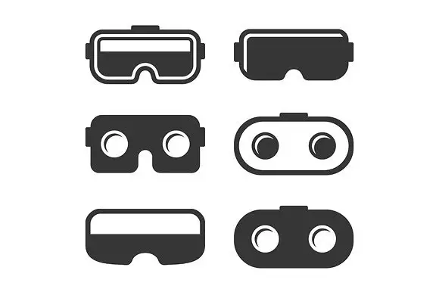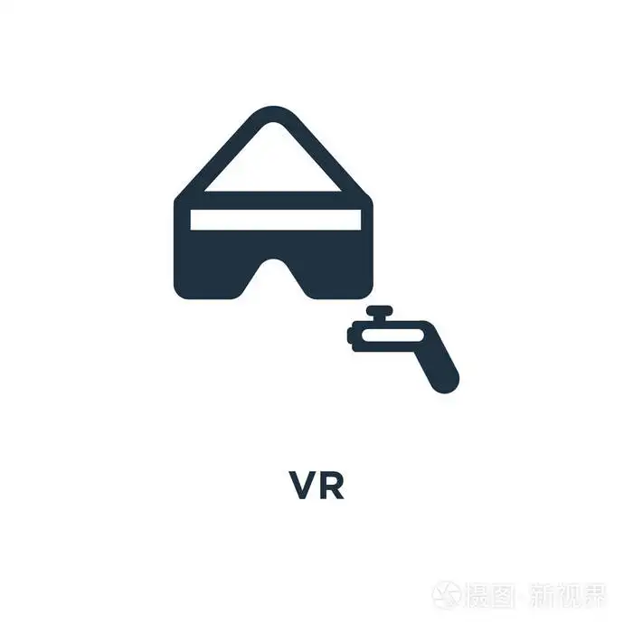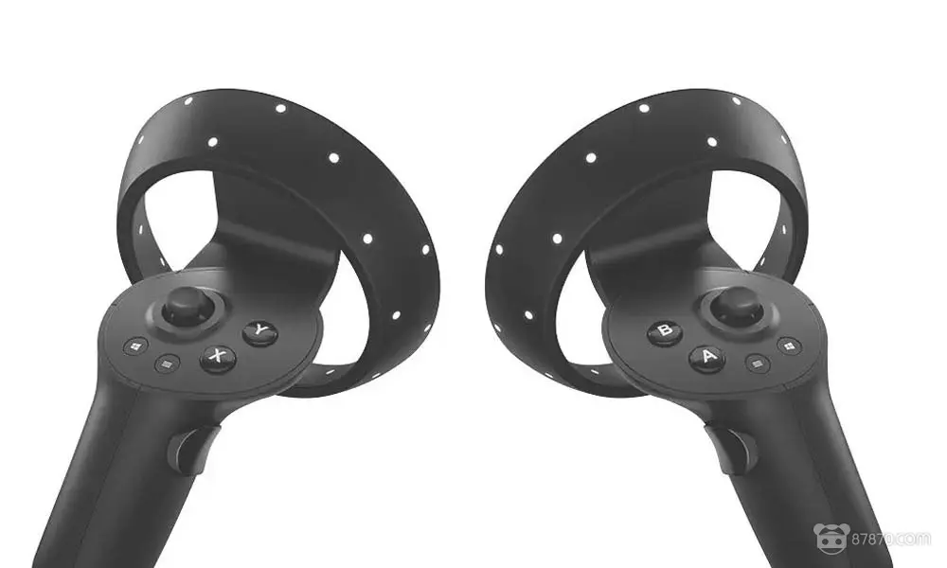

metaverse

Figure 5.8.1-1: multi-service coordination in one mobile metaverse service

### 5.8.2 Pre-conditions

John has a pair of VR glasses and a pair of tactile gloves. Usually, he uses VR glasses for VR games and tactile gloves for vertical painting where he can feel the brushstrokes. These two activities were running on two different network slices. As the VR glasses was bought to play VR games, the VR game application has a network slice A which is better support the game service. Tactile gloves belong to Brand B which has another network slice B.

In the mobile metaverse, there are many different types of services such as games, concerts, education, etc. And the mobile metaverse services has subscribed different network slice for these different types of service, and different QoS for different flows accordingly for better user experience.

### 5.8.3 Service Flows

1. John opens a mobile metaverse service, in which both VR glasses and tactile gloves are needed, and he would like to draw a picture with tactile gloves and see a live music show at the same time.

2. In the subscription between mobile metaverse service (which can be hosted by operators or other companies) and network, the video flow, audio flow in live music condition were subscribes to QoS 1 and QoS2 in slice A, the video flow and tactile flow in painting condition were subscribes to QoS 3 and QoS4 in slice B in art painting.

3. In John’s VR glasses he can see the singer and other listeners and at the same time. At the same time, he can see his painting on a virtual easel and use a virtual brush to paint, while he can feel the brushstrokes with the tactile feedback.

4. In this case, the mobile metaverse service will have a policy to use a same QoS level for the video flows in live music condition and painting condition and inform network on this decision.

5. As John is painting and enjoying the live show at the same time, the coordination between video flow, audio flow in live music mobile metaverse service and the video flow and tactile flow in painting mobile metaverse service need to be coordinated. This coordination information need to be share with the network for policy modification.

6. Network will do this dynamic policy modification for John.

### 5.8.4 Post-conditions

John used both the VR glasses and the tactile gloves in distinct mobile metaverse services with very good user combined experience.

### 5.8.5 Existing features partly or fully covering the use case functionality

The 5G system can support different communication performance policies for services and provides some support for resolving conflicts between the policies of different services.

There is however no way to for the 5G system to coordinate the communication performance delivered so that divergence in communication performance is reduced for distinct services (i.e. from different service providers).

3GPP TS 23.503 [63] clause 4.3.1 includes the following general requirement "The PCC framework shall allow the resolution of conflicts which would otherwise cause a subscriber's Subscribed Guaranteed Bandwidth QoS to be exceeded.".

3GPP TS 23.503 [63] clause 6.1.3.7 explains that "Service pre-emption priority enables the PCF to resolve conflicts where the activation of all requested active PCC rules for services would result in a cumulative authorized QoS which exceeds the Subscribed Guaranteed bandwidth QoS.".

Editor's Note: A note in 3GPP TS 23.503 [63] clause 6.1.3.7 includes the following sentence: "Normative PCF requirements for conflict handling are not defined."

### 5.8.6 Potential New Requirements needed to support the use case

[PR 5.8.6-1] The 5G system shall provide the capability of reducing the differences between different mobile metaverse services communication performance for a given UE to prevent inconsistency of experience due to XR media with divergent or conflicting characteristics, e.g., resolution, latency or packet loss.

NOTE: The UE can provide communication services for more than one terminal equipment.

## 5.9 Use Case on Synchronized predictive avatars

### 5.9.1 Description

In this first use case, three users are using the 5GS to join an immersive mobile metaverse activity. The users Bob, Lukas, and Yong are located in the USA, Germany and China, respectively. Each of the users is served by a local mobile metaverse service edge computing server (MECS) hosted in the 5GS, each of the mobile metaverse servers is located close to the user it is serving. When a user joins a mobile metaverse activity, such as a joint game or teleconference, the avatar of the user is loaded in the MECS of the other users. For instance, the MECS close to Bob hosts the avatars of Yong and Lukas.

The distance between the users, e.g., the distance between USA and China is around 11640 Km, determines minimum communication latency, e.g., 11640/c = 38 msec. This latency might also be higher due to different causes such as, e.g., hardware processing. This latency might also be variable due to multiple reasons, such as, e.g., congestion or delays introduced by (variable processing time of) hardware components such as sensors or rendering devices. Since this value maybe too high and variable for a truly immersive joint location agnostic metaverse service experience, each of the deployed avatars includes one or more predictive models of the person it represents and that allow rendering in the local edge server a synchronized predicted (current) digital representation (i.e. avatar) of the remote users. Similar techniques have been proposed for example in [28].

Figure 5.9.1-1 shows an exemplary scenario in which a MECS at location 3 (USA) runs the predictive models of remote users (Yong and Lukas) and takes as input the received sensed data from all users (Yong, Lukas, and Bob) as well as the current end-to-end communication parameters (e.g., latency) and generates a synchronized predicted (current) avatar digital representation (i.e. avatar) of the users to be rendered in local rendering devices of Bob. A particular example of such scenario might be about gaming: Yong, Lukas, and Bob are playing baseball in an immersive mobile metaverse activity , and it is Yong’s turn to hit the ball that is going to be thrown by Lukas. If Yong hits the ball, then Bob can continue running since Yong and Bob are playing in the same team. In this example, the digital representation (e.g. avatar) predictive models of Lukas and Yong (deployed at the MECS close to Bob) will allow creating a combined synchronized prediction at Location 3 of Lukas throwing the ball and Yong reacting to the ball and hitting the ball so that Bob can start running without delays and can enjoy a great immersive mobile metaverse experience.

This example aims at illustrating how predictive models can improve the location agnostic service experience in a similar was as in [28]. Synchronized predictive digital representation (e.g. avatars) are however not limited to the gaming industry and can play a relevant role in other metaverse services, e.g., immersive healthcare or teleconferencing use cases. This scenario involving synchronized predictive digital representation (e.g. avatars) assumes to require synchronization of user experiences to a single clock.



Figure 5.9.1-1: Example of a joint metaverse experience with synchronized predicted avatar representation.

### 5.9.2 Pre-conditions

The following pre-conditions and assumptions apply to this use case:

1. Up to three different MNOs operate the 5GS providing access to mobile metaverse services.

2. The users, Bob, Lukas, and Yong have subscribed to the mobile metaverse services.

3. Each of the users, e.g., Bob, decide to join the immersive mobile metaverse service activity.

### 5.9.3 Service Flows

The following service flows need to be provided for each of the users:

1. Each of the users, e.g., Bob, decide to join the immersive mobile metaverse service activity and give consent to the deployment of their avatars.

2. Sensors at each user sample the current representation of each of the users where sampling is done as required by the sensing modalities. The sampled representation of each of the users is distributed to the metaverse edge computing servers of the other users in the metaverse activity.

3. Each of the edge computing servers applies the incoming data stream representing each of the far located users to the corresponding digital representation (e.g. avatar) predictive models – taking into account the current communication parameters/performance, e.g., latency – to create a combined, synchronized, and current digital representation of the remote users that is provided as input to rendering devices in the local environment.

The service flows for the other users (i.e., Yong in China and Lukas in Germany) are the mirrored equivalent. For instance, even if not shown in Figure 5.9.1-1, the local edge computing server associated to Lukas will run the digital representation (e.g. avatar) predictive models of Yong and Bob and consume the data streams coming from those users.

### 5.9.4 Post-conditions

The main post-condition is that each of the users enjoy an immersive metaverse service activity.

### 5.9.5 Existing features partly or fully covering the use case functionality

TS 22.261 includes in Clause 6.40.2 the following requirement related to AI/ML model transfer in 5GS:

*“Based on operator policy, 5G system shall be able to provide means to predict and expose predicted network condition changes (i.e. bitrate, latency, reliability) per UE, to an authorized third party.”*

This requirement is related to requirement [PR 5.9.6.2], but not exactly the same since the usage of predictive digital representation (e.g. avatar) models requires the knowledge of the end-to-end network conditions, in particular, latency.

### 5.9.6 Potential New Requirements needed to support the use case

[PR 5.9.6.1] the 5G system shall provide a means to synchronize the incoming data streams of multiple (sensor and rendering) devices associated to different users at different locations.

[PR 5.9.6.2] the 5G system shall provide a means to expose predicted network conditions, in particular, latency, between remote users.

[PR 5.9.6.3] The 5G system shall provide a means to support the distribution, configuration, and execution of a predictive model associated to a remote user in a local service hosting environment.

## 5.10 Use Case on mobile metaverse for Critical HealthCare Services

### 5.10.1 Description

**Mobile metaverse for Critical HealthCare Services.** Immersive interactive mobile services encompass multiple services such as gaming, education, healthcare, shopping, recreation etc. Healthcare is a lifesaving critical service, which will benefit the most from mobile metaverse services. Remote surgery and surgeon training are already emerging examples, for geographically spread specialized surgeons, students and patients. Healthcare making use of mobile metaverse services can save lives by providing healthcare services at the earliest, train students better and free surgeons/doctors from being physically present at patient’s location. This area will encompass services such as surgery, medical student training, surgeon training. It will enable remote physician and patient examination. Mobile metaverse services can be characterized as a typical class of application that involves a server and a client device. This class of application will typically exchange haptic signals (forces, torques, position, velocity, vibration etc.), video and audio signals. Mobile metaverse services largely depend on low latency, highly reliable, secure wireless communication networks. [14, 32, 33, 36, 37]

**Mobile metaverse-Surgeries.** Normally, surgeons have to be physically present at hospital to perform their surgeries. Surgeons and patients may have to travel a great distance for surgeries, which is resource intensive and burdensome. The outbreak of coronavirus has further proves the case for remote surgeries. At present, there are increasingly more surgical rooms adapted with advanced surgical robots and doctors can remotely operate on the patients by controlling these surgical robots as shown in Figure-5.10.1-1b [35]. Mobile metaverse services can bring doctors and patients closer virtually, which further improves the accuracy and surgery flexibility. It can also facilitate consultation to provide suggestions and domain knowledge to reduce risks in actual operation. Recently, a real time remote breast cancer surgery was performed using private 5G network and head mounted display. Dr. G, physically present in the operating room, wore a head mounted display and could see the crucial information displayed by the goggles and performed breast cancer surgery remotely. Dr. G received constant advice from Dr. A, who was seated on the stage at the congress of Spanish association of Breast Surgeons, 900 km away from the surgery room [34, 35].

**Mobile metaverse Physician Consultation.** With the outbreak of COVID**, v**irtual consultation through audio and video conference calls has gained considerable momentum. Mobile metaverse services enabled by tactile sensors along with video and audio media can provide a rich and successful experience to both physician and patient. The ability to perform mobile metaverse service consultation without the need for the doctors and patient to be physically co-located is an extremely efficient prospect. Doctors can potentially use mobile metaverse services to examine and interact with representations of aspects and views of the patient, and benefit from a plethora of medical advice database as shown in Figure-5.10.1-1.c. 5G communication is one the key factors to enable mobile metaverse service based physician consolation. Doctors and patients both need high throughput, ultra-reliable and low latency 5G communication for these services to succeed. [30, 32].

**Mobile metaverse Body scan and vitals.** Mobile metaverse services can significantly improve and change the way current body scan diagnostics and vital statistics are gathered. Mobile metaverse services can be utilized to see the real-time diagnostic data of the patient such as body temperature, heart rate, blood pressure, breathing rate along with MRI, CT and 3D scans as show in Figure-5.10.1-1.d. Medical challenges such as vein detection for IV, shots etc., can easily be resolved using mobile metaverse services. These will help medical professionals to detect, diagnose and treat a patient [30, 32].

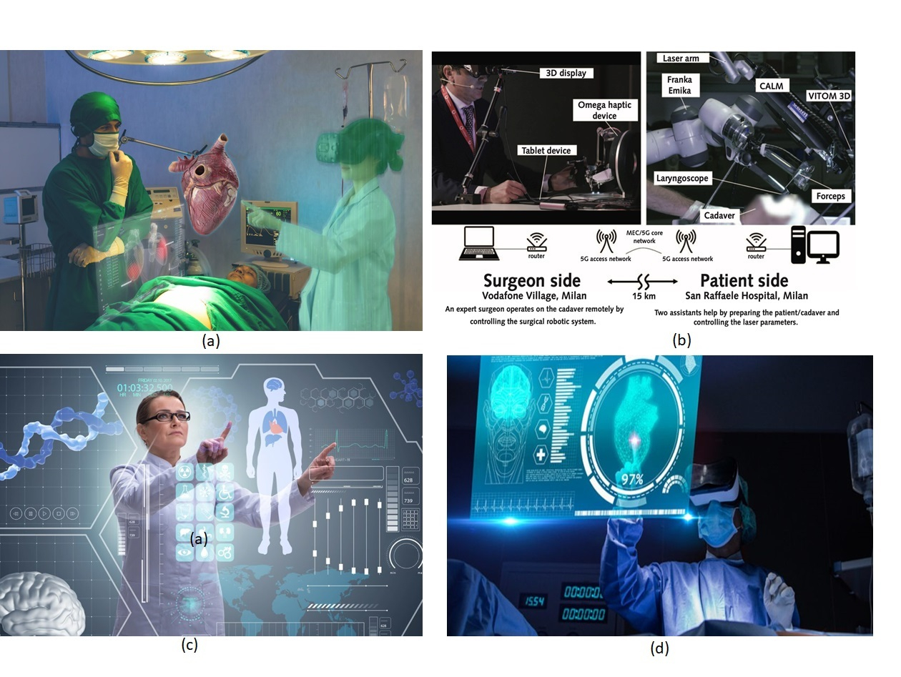

Figure-5.10.1-1: Mobile metaverse service examples

The examples in Figure 5.10.1-1 feature the use of mobile metaverse services for a) Training Surgeons, b) remote surgery, c) physician consultation d) remote medical diagnostics. (Image source: healthcareoutlook.net, courthousenews.com, gmw3.com, ourplnt.com)

**Mobile metaverse Training Medical Students.** Surgeries performed by surgeons all over the world can be used to train students using mobile metaverse services. Students can observe a live surgery with almost all the important vital and view on display, as they would be displayed to a surgeon. Further, the students can view the live surgery from different viewing perspectives, hear surgeon’s instruction, display of suggestions and domain knowledge as show in Figure-5.10.1-1.a. In May 2021, a live lung surgery was performed using an extended reality (XR) technology platform. More than 200 thoracic surgeons from Asian countries attended the outreach program and received training. The participants wore a head-mounted display (HMD) at their respective locations and participated in the program virtually represented by a digital representation (e.g. an avatar). They participants viewed the live lung surgery with lecture and 360deg high resolution surgical scenes as show in Figure-5.10.1-2 [31].

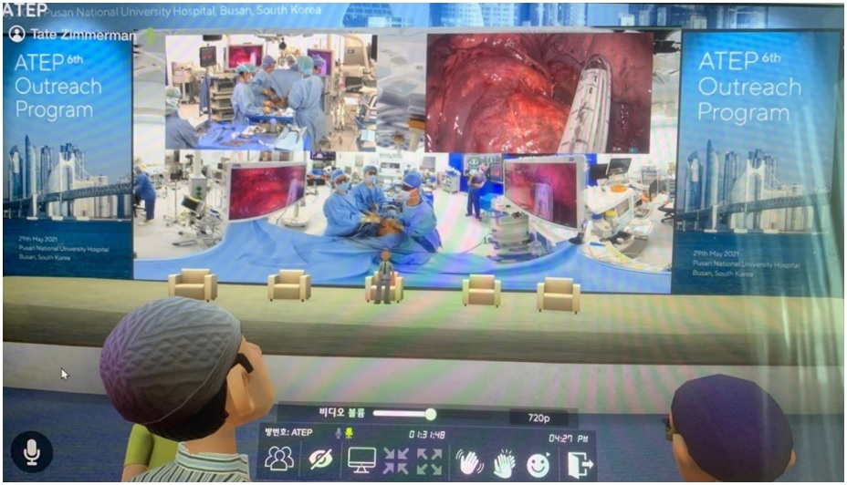

Figure-5.10.1-2: Live lung surgery training through metaverse

The source of figure 5.10.1-2 is [31] (Image source: Journal of Educational Evaluation for Health Professions (Jeehp))

### 5.10.2 Pre-conditions

Hospital Y has an enterprise subscription with MNO X, with which MNO provides the hospital and its staff with fault-tolerant and ultra-high reliable 5G communication as well as mobile metaverse services. Dr. Alex and Dr. Bob are renowned surgeons of Hospital Y, who are also trained to perform surgeries using immersive interactive mobile healthcare services.

Dr. Alex and Dr. Bob both have 5G based head mounted device (HMDs) and tactile gloves, which can communicate with those in the hospital surgery room virtually using digital representation of themselves (an avatar). The doctors are able to make remote use of actuators in operating room, though remote. The service requires extremely high reliability as a patient's life is at risk. 5G allocates sufficient communications resources, e.g. through the use of GBR QoS policy, to both the surgeons communications for the entire duration of the surgery.

### 5.10.3 Service Flows

1) Dr. Alex and Dr, Bob are surgeons and senior surgeons of a renowned hospital. Dr. Alex is on a vacation with the family and Dr. Bob is attending a conference 300 miles away from Madrid, Spain.

2) A patient, David, has had an accident and has been rushed to the emergency room of a local hospital. David has a bad head injury and needs an urgent brain surgery.

3) The hospital requests that the surgeons Dr. Alex and Dr. Bob perform the surgery.

4) Dr. Alex and Dr. Bob wear HMDs and tactile gloves and connect to the hospital surgery room virtually making use of the 5G system.

5) David is in an operating room of the hospital equipped with advanced surgical robots and attended by the local doctors and nurse.

6) The vital diagnostic information such as heart rate, BP reading, ECG etc., are virtually displayed to both the surgeons. The surgeons are able to view the surgery room and able to see each other using digital representations (e.g. avatars.)

7) Dr. Alex and Dr. Bob perform the surgery remotely with the assistance of the robots and doctors and nurses at the hospital.

8) The surgery successfully ends, after three hours of surgery and remote treatment without an interruption in the 5G connections.

9) After the surgery, the patient is shifted from the surgery bed to an Intensive Care Unit (ICU) by the doctors and nurses in the hospital. Dr. Alex and Dr. Bob return to their vacation and conference respectively.

### 5.10.4 Post-conditions

After the surgery, the doctors and surgeons stay connected virtually to read the vitals of the patients. Once the patient’s condition has stabilized, Dr. Alex and Dr. Bob disconnect their devices. The 5G system then releases dedicated communication resources (GBR QoS policy) from the devices used for surgery using 5GS.

### 5.10.5 Existing feature partly or fully covering use case functionality

1) URLLC system design in clause 5.33 of 23.501 [39] has proposed dual redundant system to achieve ultrahigh reliability. Though - in this system design- there are dual RAN connections, PDU session established, SMF and UPF but has a common DN and AMF nodes, which is a single point failure in the system architecture. URLLC system design is ultrareliable but not end to end ultra-reliable and fault tolerant. It also relies on the upper layer protocol such as IEEE 802.1 TSN (Time sensitive Network) FRER (Frame replication & elimination for reliability), to manage dual redundant systems such as replication and elimination of redundant packets or frames. A typical fault-tolerant system should not have single point of failures and manage system flow. Moreover, the use of FRER implies that the content is exchanged over both paths continuously, thus doubling the resources used over the radio.

2) Redundant user plane paths based on multiple UEs per device has been proposed in Annex F of 23.501[39]. In this system design, the device is expected to have two UE(s) and they independently connect to their RAN and have their own PDU sessions with a common DN. This system is not End-to-End fault tolerant since it has a common DN – a single point of failure- and requires dual UE(s) to achieve ultrahigh reliability. This architecture too assumes that some upper layer protocol (e.g. FRER) is used for replication and frame elimination, thus doubling the resources used over the radio.

3) As per Multimedia Priority Service (MPS), mentioned in clause 5.16.5 of TS 23.501[39], allows service users priority access to the system resources under congestion, creating the ability to deliver or complete session of a high priority nature. Service users are priority users such as government officials, authorized users. Currently there are no requirements to identify mission critical users and its priorities such as emergency (under surgeries), surgeon training, scans and physician consultation.

4) RRC controls the scheduling of user data in the uplink by associating each logical channel with a logical channel priority, a prioritised bit rate (PBR), and a buffer size duration (BSD), mentioned in clause 10.5 of TS 38.300 [40]. We can extend this to allocate logical channels for mission critical services such as metaverse for Critical-HealthCare services.

5) The existing CMED in TR 22.826 specifies various possible healthcare support using ultra high-definition videos, tactile sensors and audio. Though this TR specifies the reliability of 99.999% but does not specify the fault tolerant end-to-end reliability, and also does not specify for metaverse, which is an interactive VR 360˚ streaming [41].

### 5.10.6 Potential New Requirements needed to support the use case

[PR 5.10.6-1] The 5G system shall provide a means to synchronize multiple service data flows (e.g., heart rate, video, audio) of multiple UEs associated with Critical HealthCare services.

## 5.11 Use case of IMS-based 3D Avatar Communication

### 5.11.1 Description

This use case identifies two fundamental scenarios and one sub-scenario for 3D Avatar Communication by means of the IMS. The intention of the proposal is to fully specify this system in 3GPP, to provide a standard for a new form of media to be used in telecommunication by mobile users. In the terminology of this use case, the avatar is a digital representation of a user, and this digital representation is exchanged (with other media, notably audio), with one or more users as mobile metaverse media.

An Avatar Call is similar to a Video Call in that both are visual, interactive, provide live feedback to participants regarding their emotions, attentiveness and other social information. They differ in that an Avatar call can be more private - neither revealing the environment where the caller is, nor their actual appearance. An avatar may be preferable to display to one's own face in a call for a number of reasons - a user may not feel presentable, may want to make a specific impression, or may have to communicate when only limited data communication is possible. The key difference between an Avatar Call and a Video Call is that the Avatar Call requires only a very constrained data rate, e.g. 5 kbps, to support.

This use case is timely because the key enabling technologies have reached a sufficient maturity. The key avatar technologies are the means to (1) capture facial and calculate values according to a model, (2) efficiently send both media and model components through a communication channel, both initially and over time, (3) produce media for presentation to a user for the duration of the communication. We anticipate services will be increasingly available in the coming months and years. The current approaches under development are effectively proprietary and they are not integrated with the IMS.

The scenarios considered in this use case are:

1(a). IMS users initiate an avatar call.

1(b). An IMS users initiate a video call, but one (or both) users decide instead to provide Avatar Call representation instead of video representation.

For both 1(a) and 1(b) the goal is to capture sensing data of the communicating users (especially facial data) to create an animated user digital representation (avatar). This media is provided to communicating users as a new teleservice user experience enabled by the IMS.

2. A user interacts with a computer-generated system. Avatar communication is used to generate an appearance for a simulated entity with whom the user communicates.

### 5.11.2 Pre-conditions

Users Adonis and Aphrodite are 3GPP subscribers. Both have terminal equipment sufficient to capture their facial expression and movements adequately for computing avatar modeling information. The terminal equipment also includes a display, e.g. a screen, to display visual media. The terminal equipment is capable of initiating and terminating the IMS multimedia application 'avatar call.' The terminal equipment is also capable of capturing the facial appearance and movements sufficiently to produce data required by a Facial Action Coding System (FACS).

A network accessible service is capable of initiating and terminating an IMS session and the IMS multimedia application 'avatar call.'

### 5.11.3 Service Flows

1(a). Avatar Call

i. Adonis is on a business trip and filthy after a day servicing industrial equipment. He calls Aphrodite, who is several time zones away and reading in bed after an exhausting day.

ii. Adonis doesn't want to initiate a video call since he hasn't had a chance to clean up and is still at work, surrounded by ugly machines. He initiates an 'avatar call' explicitly with his terminal equipment interface.

iii. Aphrodite, several time zones away, reading in bed after an exhausting day, is alerted of an incoming call. She sees it is from Adonis and that it is an avatar call. She accepts the call, pleased that she will be presented on the call as an avatar.

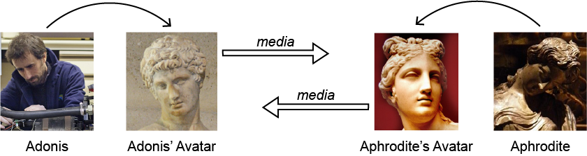

Figure 5.11.3-1: Avatar media prepared for an avatar call

In more detail, the media that is provided uplink is generated on each terminal. This is analogous to the way in which speech and video codecs operate today.

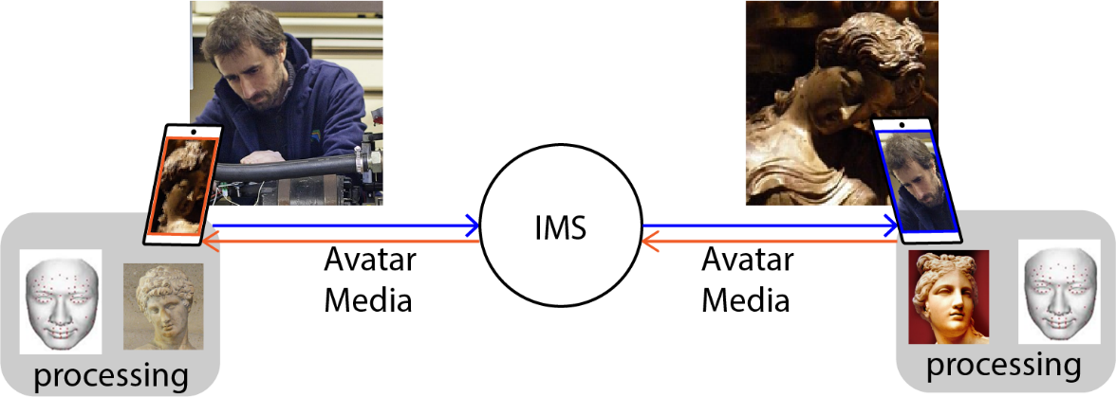

Figure 5.11.3-2: Avatar generation on each UE

Once the avatar call is established the communicating parties provide information uplink. The terminal (a) captures facial information of the call participants and (b) locally determines an encoding that captures the facial information (e.g. consisting of data points, colouring and other metadata.) This information is transmitted as a form of media uplink, and provided by the IMS to the other participant(s) in the avatar call. When (c) the media is received by a participant, the media is rendered as a two (or three) dimensional digital representation, shown above as the 'comic figure' on the right.

In this use case, the UE performs processing of the data acquired by the UE to generate the avatar codec. It is possible to send the acquired data, e.g. video data from more than one camera, uplink so that the avatar codec could be rendered by the 5G network. It is however advantageous from a *service perspective* to support this capability on the UE. First, the uplink data requirement is greatly reduced. Second, the confidentiality of the captured data could prevent the user from being willing to expose it to the network. Third, the avatar may not be based on sensor data at all, if it is a 'software generated' avatar (as by a game or other application, etc.) and in this case there is no sensor data to send uplink to be rendered.

1(b). Video call falls back to an Avatar call

i. Adonis is striking as can be, and standing at an awe-inspiring vista on mount Olympus. He initiates a video call with Aphrodite.

ii. Unfortunately, Adonis has forgotten to consider the time zone difference. For Aphrodite, it is the middle of the night. What's more, Aphrodite has been up for several hours in the middle of the night to clean up a mess made by her sick cat. While she wants to take the call from Adonis, she prefers to be presented by an avatar, and not to take the call as a video call from her side. She explicitly requests an 'avatar presentation' instead of a 'video presentation' and picks up Adonis' call.

iii. The call between Adonis and Aphrodite is established. Adonis sees Aphrodite's avatar representation. Aphrodite sees Adonis in the video media received as part of the call.

iv. Adonis walks further along the mountain trail while still speaking to Aphrodite. The coverage gets worse and worse until it is no longer possible to transmit video uplink adequately. Rather than switching to a voice-only call, Adonis activates 'avatar call' representation. This requires very little data throughput.

v. Adonis and Aphrodite enjoy the rest of their avatar call.

2. Aphrodite calls automated customer service. Aphrodite calls a customer service of company "Inhabitabilis" to initiate a video call.

ii. Inhabitabilis customer service employs a 'receptionist' named Nemo, who is actually not a person at all. He is a software construct. There is an artificial intelligence algorithm that generates his utterances. At the same time, an appearance is generated as a set of code points using a FACS system, corresponding to the dialog and interaction between Aphrodite and Nemo.

iii. Aphrodite is able to get answers to her questions and thanks Nemo. In all the above scenarios, the following applies.

3. Aphrodite uses a terminal device without cameras, or whose cameras are insufficient and/or Adonis uses a terminal device without avatar codec support

In this scenario, the UE used by either calling party is not able to support an IMS 3D avatar call. Through the use of transcoding, this lack of support can be overcome. In the service flow shown below, as an example, Aphrodite's UE cannot capture her visually so as to generate an avatar encoding, so she expresses herself in text.

i. Aphrodite calls Adonis and wants to share an avatar call. She cannot however be captured via FACS due to a lack of sufficient camera support on her UE. Instead she uses *text-based avatar media*.

ii. The text-based avatar media is transported to the point at which this media is *rendered* as a 3D avatar media codec.

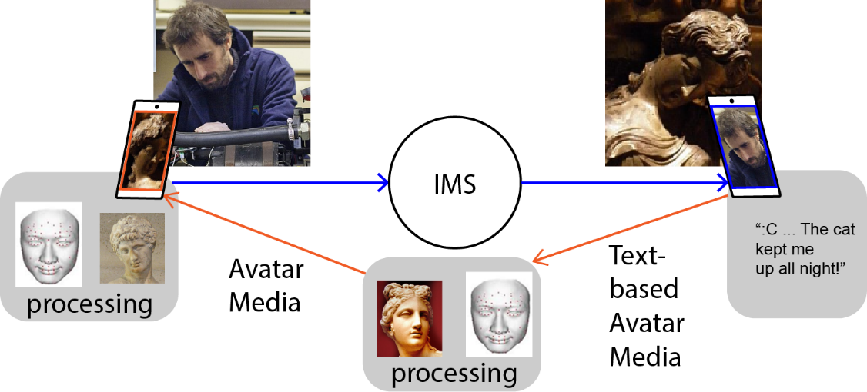

Figure 5.11.3-3: Example of a text-based Avatar Media enables avatar call without camera, etc. support on a UE

The transcoding rendering of the avatar media to 3D avatar media could be at any point in the system - Aphrodite's UE, the network, or Adonis' UE.

iii. Adonis' UE is able to display an avatar version of Aphrodite and hear it speak (text to voice.) To the extent that the avatar configuration and voice generation configuration is well associated with Aphrodite, Adonis can hear and see her speaking, though Aphrodite only provides text as input to the conversation.

Other examples (not further described here) could, for example, transcode the media provided by Aphrodite (e.g. text, binary, avatar encoding, etc.) and transcode it to video for presentation to Adonis. This would be useful if Adonis' UE did not have support for avatar encoding.

### 5.11.4 Post-conditions

In each of the scenarios above, avatar media provides an acceptable interactive choice for a video call experience. The advantages are privacy, efficiency and ease of integration with computer software to animate a simulated conversational partner.

### 5.11.5 Existing feature partly or fully covering use case functionality

TS 22.228 define the service requirements for IMS. IMS supports different IMS multimedia applications. IMS supports a wide range of services, notably voice and video calls. There is extensive support for services, tightly integrated with the 3GPP system, with extensive support for roaming and integration with both PSTN and ISDN telephony, emergency services and more. The requirements for a 3D avatar application are largely covered by existing requirements in the 5G standard for IMS.

TS 22.173 defines the media handling capabilities of the IMS Multimedia Telephony service

The specific gaps that are addressed in 5.A.6 include: extended feature negotiation, enabling the user to decide whether to present video or avatar communication, the ability to support Avatar communication and content efficiently, the ability to support standardized Avatar media in the 5G system.

The following KPIs are easily supported by the 5G system. They are included in order to contrast the requirements of an avatar call with a video call.

| **Use Case** | **Characteristic parameter (KPI)** | |
| --- | --- | --- |
| **End-to-end latency** | **Service bit rate: user-experienced data rate** |
| Avatar call | [NOTE1] | <5 kbps [45] |
| Video call | < 150 msec preferred  <400 msec limit  Lip-synch: < 100 msec [46] | 32-384 kb/s [46] |
| NOTE1: The latency requirement for real time immersive service experience would be the same as the video call below. For some user experiences (smaller devices or an embedded icon-sized representation in other application, etc.) the latency tolerance could be greater.  NOTE2: The video call KPIs are from TS 22.105 and have not changed since Rel-99. Actual transactional video call parameters may be higher now. | | |

### 5.11.6 Potential New Requirements needed to support the use case

[P.R. 5.11.6-1] The IMS shall allow multimedia conversational communications between two or more users providing real time conversational transfer of animated user digital representation and speech data.

[P.R. 5.11.6-2] The 5G system shall support a means for UEs to produce 3D avatar media to be sent uplink, and to receive this media downlink.

NOTE 1: In some scenarios, avatar media transmission entails a significantly lower data transfer rate than video.

[P.R. 5.11.6-3] The 5G system shall support a means for the production of 3D avatar media to be accomplished on a UE to support confidentiality of the data used to produce the 3D avatar (e.g. from the UE cameras, etc.)

[P.R. 5.11.6-4] Subject to user consent, the 5G system shall support a means to provide bidirectional transitioning between video and avatar media for parties of an IMS call.

NOTE 2: An example where an IMS call could transition to an IMS based 3D avatar call is where the communication performance of one or more parties declines to the extent that video is no longer of sufficient quality or even possibility. In this case, an avatar call between the same parties can replace the video call.

[P.R. 5.11.6-5] The 5G system shall support a means to enable locally generated media (e.g. text or video) of a party to be transcoded before it is rendered for the receiving party.

NOTE 3: The locally generated media could allow a party to control the appearance of its avatar, e.g. to express behavior, movement, affect, emotions, etc.

NOTE 4: The transcoding of media enables 3D avatar communication to be supported in scenarios in which UE participating in the IMS call does not support e.g. FACS, encoding avatar media, presenting avatar media, etc.

[P.R. 5.11.6-6] The 5G system shall support collection of charging information associated with initiating and terminating an IMS-based 3D avatar call.

## 5.12 Use Case on Virtual humans in metaverse

### 5.12.1 Description

Virtual humans (or digital representations of humans, also referred to as 'avatars' in this use case) are simulations of human beings on computers [47]. There is a wide range of applications, such as games, film and TV productions, financial industry (smart adviser), telecommunications (avatars), etc.

In the coming era, the technology of virtual humans is one of foundations of mobile metaverse service. A virtual human can be a digital representation of a natural person in a mobile metaverse service, which is driven by the natural person. Or a virtual human also can be a digital representation of a digital assistant driven by AI model.

Mobile metaverse services offer an important opportunity for socialization and entertainment, where user experience of the virtual world and the real world combine. This use case focuses on the scenario of a natural person's digital embodiment in a metaverse as a location agnostic service experience. A virtual human is customized according to a user's personal characteristics and shape preferences. Users wear motion capture devices, vibrating backpacks, haptic gloves, VR glasses to drive the virtual human in a meta-universe space for semi-open exploration. The devices mentioned above are 5G UEs, which need to collaborate with each other to complete the actions of user and get real-time feedback.

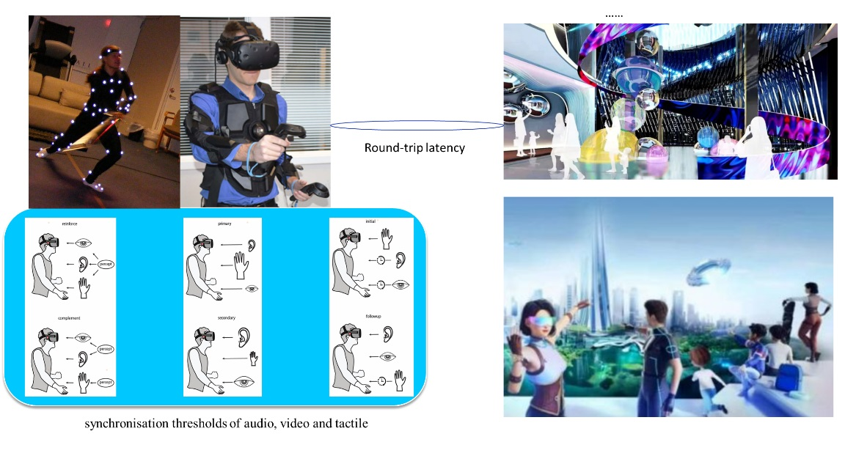

Figure 5.12.1-1: Virtual humans in metaverse (Source: <https://vr.baidu.com/product/xirang>, https://en.wikipedia.org/wiki/Virtual_humans)

For smooth experience, the motion-to-photon latency should be less than 20ms [48]. The motion-to-photon latency requires that the latency between the moment that players do one movement and the corresponding new videos shown in VR glasses and tactile from vibrating backpacks or haptic gloves should be less than 20ms. As the asynchrony between different modalities increases, users’ experience will decrease because uses are able to detect asynchronies. Therefore, the synchronisation among audio, visual and tactile is also very important. The synchronisation thresholds regarding audio, visual and tactile modalities measured by Hirsh and Sherrick are described as follows [49]. The obtained results vary, depending on the kind of stimuli, biasing effects of stimulus range, the psychometric methods employed, etc.

- audio-tactile stimuli: 12 ms when the audio comes first and 25 ms when the tactile comes first to be perceived as being synchronous.

- visual-tactile stimuli: 30 ms when the video comes first and 20 ms when the tactile comes first to be perceived as being synchronous.

- audio-visual stimuli: 20 ms when the audio comes first and 20 ms when the video comes first to be perceived as being synchronous.

NOTE 1: Taking audio-tactile stimuli as an example, when the audio comes first, users are not able to detect asynchronies if the tactile comes within 12ms. Accordingly, when the tactile comes first, users are not able to detect asynchronies if the audio comes within 25ms.

### 5.12.2 Pre-conditions

Alice’s virtual human exists as a digital representation in a mobile metaverse service. Alice’s virtual human wants to explore a newly opened area, including both natural environment and the humanities environment. The equipment Alice wears are all connected to 5G network. The mobile metaverse service interacts with 5G network to provide QoS requirements. The network provides the pre-agreed policy between the mobile metaverse service provider and operator on QoS requirements appropriate to each mobile metaverse media data flow.

### 5.12.3 Service Flows

1. Alice’s virtual human digital representation exists as part of the mobile metaverse service.
2. Alice’s virtual human digital representation can interact with other virtual humans. These could correspond to virtual humans representing other players or to machine generated virtual humans. Interactions could include a handshake, shopping, visiting an exhibition together, etc.
3. When someone or something touches Alice’s virtual human (e.g. Alice's virtual human's hand or back touches some virtual object or human in the mobile metaverse service), Alice can see the object and feel the temperature and weight of the object at the same time. For example, when a virtual leaf falls on the hand of Alice’s virtual human, Alice should see the leaf fall on her hand and sense the presence of a leaf at the same time. It means that the tactile impression from haptic gloves should come within 30ms after the video in VR glasses (assuming the video media precedes the haptic media.) Or, the video in VR glasses should come within 20ms if the tactile impression resulting from tactile media presented by the haptic gloves, if the tactile media precedes the video media.

### 5.12.4 Post-conditions

Alice can physically experience what is represented in mobile metaverse services. The experience is very realistic and consistent.

### 5.12.5 Existing features partly or fully covering the use case functionality

3GPP TS 22.261 [6] specifies KPIs for high data rate and low latency interactive services including Cloud/Edge/Split Rendering, Gaming or Interactive Data Exchanging, Consumption of VR content via tethered VR headset, and audio-video synchronization thresholds.

Support of audio-video synchronization thresholds has been captured in TS 22.261:

Due to the separate handling of the audio and video component, the 5G system will have to cater for the VR audio-video synchronisation in order to avoid having a negative impact on the user experience (i.e. viewers detecting lack of synchronization). To support VR environments, the 5G system shall support audio-video synchronisation thresholds:

- in the range of [125 ms to 5 ms] for audio delayed and

- in the range of [45 ms to 5 ms] for audio advanced.

Existing synchronization requirements in current SA1 specification are only for data transmission of one UE. Existing specifications do not contain requirements for coordination of synchronization transmission of data packet for multiple UEs.

### 5.12.6 Potential New Requirements needed to support the use case

[PR 5.12.6-1] The 5G system shall provide a mechanism to support coordination and synchronization of multiple data flows transmitted via one UE or different UEs, e.g., subject to synchronization thresholds provided by 3rd party.

[PR 5.12.6-2] The 5G system shall provide means to achieve low end-to-end round-trip latency (e.g., [20ms]).

## 5.13 Use Case on digital asset container information access and certification

### 5.13.1 Description

The network operators offer the digital asset management services for the users, with which some information (e.g. IDs) can be certified by the operator. The digital asset management services can also include

- The management of the digital asset container is performed according to the applicable regulations.

- The digital asset container has security properties (cannot be spoofed, access control with a policy determined by the user, etc.).

In the case of immersive XR media services, the user can choose, in the digital asset container, his/her digital representation and the related information, for example, the digital representation of the user (e.g. avatar), electronic money and associated financial services, identity, purchased items (the format of this information is at application layer and is not studied in 3GPP). This information can be used when accessing immersive XR media services or for real life services as the presentation of the identity.

### 5.13.2 Pre-conditions

Alice has a service subscription with the operator. As part of the service, the network operator provides

- The digital asset container management according to the future applicable regulations;

- Security protection options of the digital asset container (e.g. cannot be spoofed, access control with a policy determined by the user, etc.).

### 5.13.3 Service Flows

1. Alice accesses the digital asset container data services. The digital asset container is initiated with Alice information (digital representation (e.g. avatar) profile, IDs ...). The digital assets are completed and modified over time. The service (allowing to store and update information) can be provided by the network operator or by a third party using an operator’s trusted API.

2. Alice wants to dispose of old paint and solvent at a local dump. She has to identify herself as being a local resident, authorized to use the dump. She has to provide payment information, to pay the fee to dispose of toxic waste. She interacts with the dump (services) and the ID and payment information is shared with the service. The authorities that run the facility now allowing Alice to put down the paint and solvent.

Alice access to her digital asset container to select the list of information (local resident, payment information, ID) that she has already configured and saved (e.g. her digital representation (e.g. avatar) and other information like her electronic money and associated financial services, ID, purchased items,…). The choice of information can be automated (without action on the part of the user).

3. She then connects to the digital service, e.g. mobile metaverse service, with the information she authorises to share for the successful provision of the service.

### 5.13.4 Post-conditions

Alice is authorized to access and use the dump.

### 5.13.5 Existing features partly or fully covering the use case functionality

This feature is currently not documented in the 3GPP specifications.

Concerning the user identity related aspects, the features described in the document TR 22.904 [X] can be applied.

### 5.13.6 Potential New Requirements needed to support the use case

[PR 5.13.6-1] The 5G system shall support allow a user to securely manage a digital asset container (e.g. store and update the information associated with this user).

[PR 5.13.6-2] The 5G system shall support mechanisms to retrieve the information of a digital asset container associated with a user by an authorized third party.

[PR 5.13.6-3] According to the service invoked when a user accesses an application platform, the 5G system shall support mechanisms to provide the information associated with the user to a third party.

[PR 5.13.6-4] The 5G system shall support mechanisms to certify the authenticity of the information of a digital asset container associated with a user.

[PR 5.13.6-5] The 5G system shall protect against spoofing attacks of the customer’s digital asset container.

## 5.14 Use Case on interconnection of mobile metaverse services

### 5.14.1 Description

The concept "mobile metaverse" and "metaverse" became popular during the coronavirus pandemic as lockdown measures and work-from-home policies pushed more people online for both business and pleasure, increasing demand for ways to make online interaction more lifelike. The term covers a wide variety of location agnostic service experiences, from workplace tools to games and community platforms. It generally refers to shared and immersive digital service experiences (i.e. mobile metaverse services) that people can experience by means of using XR devices. By 2026, 25% of people are estimated to spend at least one hour a day using services that provide immersive XR media for work, shopping, education, social media and/or entertainment, according to the latest study by Gartner, Inc. (a U.S.-based technology research and consulting company).

Mobile metaverse service technologies are still in the early stages of being adopted. Currently there are already many digital environments (i.e. mobile metaverse services that offer location agnostic and location related service experiences), which typically run in silos and are not interconnected. From end users’ view point, there are several basic requirements to be addressed:

- Depending on the immersive XR media service the user wants to connect to, he/she can choose his/her digital representation and the related information when needed: avatar (one or more), e-money (e.g. financial services as payment, his/her means of payment), ID, purchased items…

- A user is able to transition between immersive mobile metaverse services using the similar digital representation seamlessly and taking into account the constraints of the mobile metaverse services accessed. The transfer of information via the operator's network ensures the semantic compatibility – possibly through abstraction - between the origin and the destination. This also ensures, if necessary, the confidentiality of the origin and the destination.

In the following use case, Alice uses an immersive mobile metaverse service of a travel company, and a trip interests her. She would like to verify if she has enough money to buy the trip. She needs to link the immersive mobile metaverse service of her bank with the current immersive mobile metaverse service of the travel company so that her profile is automatically shared between these two services (she has previously given authorisation).

In this use case 'digital representations' are expected to interwork with specific services. The use case does not propose to define a new 'standard' for digital representations (avatars, electronic money and financial service, IDs, purchased items.) Rather personal information is stored and retrieved to improve service delivery and to assure privacy and security. If some formats, etc. are shared between different service providers, this would present an opportunity for consistency and continuity for the user of those two services, enabled by this use case.

### 5.14.2 Pre-conditions

Alice has a service subscription with the network operator M4Mobile, which is for communication services. When visiting immersive mobile metaverse service Alice uses digital representation which contains her avatars and other information like her electronic money and associated financial services, IDs, purchased items …

Alice has chosen a profile (a subset of her digital representation) for her session to access universes. The choice of information can be automated (without action on the part of the user) depending on the universe visited or already visited, the user configurations, privacy options, etc.

### 5.14.3 Service Flows

1. Alice would like to buy a travel using mobile metaverse service.

2. Alice connects to the immersive mobile metaverse service A of a travel company with the information she authorises to share for the successful provision of the service (the purchase of the travel).

3. During her session Alice is interested in buying a trip, for which she needs to interact with the mobile metaverse service B of her bank.

4. When moving between these immersive mobile metaverse services A and B, the network operator provides the same user information (for instance regarding the digital representation used to connect to the original mobile metaverse service…) in accordance with the configurations and the rights granted by the user.

5. Information may be coded differently in the immersive mobile metaverse service A and in the immersive mobile metaverse service B (e.g. the level of graphical accuracy of an avatar). In this case, a negotiation by the network operator may be necessary to adapt the information received from A to B.

### 5.14.4 Post-conditions

Alice appears in the universe with the digital information chosen in her wallet (with some certified via the network operator). She keeps that information as she travels from universe to universe.

### 5.14.5 Existing features partly or fully covering the use case functionality

This feature is currently not documented in the 3GPP specifications.

Concerning the user identity related aspects, the features described in the document TR 22.904 [X] can be applied.

### 5.14.6 Potential New Requirements needed to support the use case

[PR 5.14.6-1] The 5G system shall support suitable APIs to securely provide information of a user to an immersive mobile metaverse service when the user accesses the service.

[PR 5.14.6-2] The 5G system shall support mechanisms to adapt the user assets and information stored by one immersive mobile metaverse service with the information needed, or requested, by another immersive XR media service.

## 5.15 Use Case on Access to avatars

### 5.15.1 Description

Mobile metaverse services often involve the use of digital representation (e.g. avatars, which are discussed throughout this use case.) Given different use cases, the data associated with the avatars of a user are generated and stored in different mobile metaverse servers. For example, a user uses life-like avatars for e-commerce and cartoonish avatars for gaming. Network operators enabling users to obtain diverse mobile metaverse services should support avatar management. For example, network operators can leverage their existing connections to extensive mobile metaverse servers and provide access to avatars across these servers acting as a proxy. Compared to the model where two mobile metaverse servers define direct access APIs, the interconnect model described in the use case can utilise the 5G system capability of authenticating and authorizing the third-party entities.

The advantage of having a central storage of the information related to avatars is that the same avatar could potentially be used in different mobile metaverse services. The information exposed by the central point, i.e. the 5G system, to different mobile metaverse services helps them share and use the same avatar for a user. Users would therefore benefit from using their UE/ mobile access for metaverse services because there are enablers (like this one) that provide consistency between different metaverse services.

It is noted that the storage location of avatars is subject to service agreement between the operator and the third-party entities, and hence it is out of scope of 3GPP.

### 5.15.2 Pre-conditions

ClothingA and ClothingB are two small clothing companies that both have virtual stores and provide avatar-based shopping services. Online shoppers can use immersive real-time technology to virtually try-on apparel, accessories, or full looks on the digital representation of themselves, i.e. avatars. Their avatars are stored in mobile metaverse servers, and interoperable data formats between these servers are used for avatars.

T is a mobile network operator. Based on its service level agreements with ClothingA and ClothingB, it provides multimedia communication services to enable virtual shopping. Moreover, T behaves like a proxy and supports the exchange of avatars stored in the databases of ClothingA, ClothingB, and any other companies that have agreements with T.

Shaun, an online shopper, has used the virtual try-on service provided by ClothingA several times. His avatar–a 3D actual visual representation of himself is stored in the ClothingA database.

### 5.15.3 Service Flows

1. ClothingA and ClothingB register with the operator T. Shaun registers with T by a UE that has a subscription with T.

2. Shaun visits the ClothingA virtual store using his avatar stored in the ClothingA database. He is authenticated by T and ClothingA, and a multimedia communication session is established between Shaun, a shop assistant, and associated devices (e.g. AR glasses). Shaun tries on some products and sees 3D digital clothing automatically appear on himself.

3. Shaun terminates the session with ClothingA. His user profile on T’s system is updated with the information that an avatar is stored in the ClothingA database. Parameters linked to this avatar in the user profile may include

- last access time. This could potentially help a user select which avatar to use and help the 5G system determine if the avatar is still available;

- authorised mobile metaverse services;

- address (e.g. IP address). This could potentially help a trusted third party retrieve the avatar.

4. Having authenticated by T and ClothingB, Shaun visits the ClothingB virtual store for the first time. Since it is his first visit, Shaun has no avatars available in ClothingB. ClothingB requests the 5G system for the avatar-related information of Shaun.

5. The 5G system accepts the request and exposes the selected avatar-related information in Shaun’s user profile to ClothingB. The decision of what information to be exposed is subject to user consent and service agreement between third parties and T. As pre-agreed by ClothingA, the information related to the avatar stored in its database is exposed to ClothingB. The information is then provided to Shaun, based on which Shaun decides to reuse the avatar stored in the ClothingA database.

6. ClothingB sends a request for Shaun’s avatar to the 5G system. The 5G system authorises the request and provides ClothingB with the IP address of the avatar.

7. ClothingB retrieves the avatar from the ClothingA database using the given IP address.

### 5.15.4 Post-conditions

Shaun tries on products in the ClothingB virtual store with his avatar.

Shaun’s user profile on T’s system is updated to record the use of his avatar in the ClothingB virtual store.

T charges ClothingA, ClothingB, and Shaun for supporting virtual shopping sessions.

### 5.15.5 Existing features partly or fully covering the use case functionality

The functional requirements for user identity are captured in TS 22.101 clause 26a [4].

### 5.15.6 Potential New Requirements needed to support the use case

[PR 5.15.6-1] Subject to user consent, operator policy, and regulatory requirements, the 5G system shall be able to store and update the information related to digital representations for a user (e.g. last access time and address).

[PR 5.15.6-2] Subject to user consent, operator policy, and regulatory requirements, the 5G system shall support mechanisms to expose the information related to the digital representations of a user to a trusted third party.

[PR 5.15.6-3] Subject to user consent and operator policy, the 5G system shall be able to authorise a trusted third party to use the digital representations of a user.

## 5.16 Use Case on virtual store in a mobile metaverse marketplace

### 5.16.1 Description

5G technologies especially the XR communication technologies make it possible to run business online (with or without physical offices/stores) to offer various services. Examples include fashion store online, drop-shipping business, virtual real estate agency, virtual assistants, teaching an online course, and online fitness training. Running a business online is particularly attractive for start-ups and small even medium sized businesses. For end consumers, visiting a market is a real feast for the senses. It is a multisensory experience that combines tradition with human contact and involves a series of decisions about which products to choose for the shopping basket.

Mobile metaverse services are expected to help to transfer a world so rich in sensations to the virtual sphere, which offer rich XR enabled multimedia communication services together with security mechanisms for data protection, user identity/profile management as well as digital asset management and protection. IMS based avatar calls are among these new features/services, where AI avatar can be used to help facilitate social interactions. An AI avatar [61] [62] is a digital character powered by artificial intelligence, which lives in a virtual setting, like a game, social network or online world. More frequently avatars are designed as human-like bots that can be controlled by real human using AI technologies and can easily engage with real humans and maintain relationship - to varying degrees - with them.

### 5.16.2 Pre-conditions

Magnificent Muggles, a niche fashion company, has set up virtual stores in a metaverse marketplace (a mobile metaverse service) provided by GreenMobile. The corresponding 5G communication subscriptions provided by GreenMobile include the XR enabled multimedia communication services, including IMS based avatar calls) which enable the efficient near-real life interaction between the virtual shop assistant and the online shoppers, an immersive location agnostic service experience. As a fashion retailer, Magnificent Muggles expect to provide similar if not better experience to their online shoppers in their virtual stores. To enable this, they have their shop assistants equipped with XR devices to interact with online buyers. In their virtual stores, the end consumers can “see” the products as if they were buying them face-to-face and they can interact live with the people selling them.

As part of the service level agreement, GreenMobile provides storage and communication services to Magnificent Muggles:

- to store the digital representations (e.g. avatars) for the virtual shop assistance;

- to assist the authentication of their employees to use the digital representations (e.g. avatars) in the XR communication when assisting online buyers;

- to render the digital representations (e.g. avatars) based on the voice, facial expression or body motion of a human user.

The service flows below illustrate how the virtual shop assistant and an online shopper interact with each other using services provided by 3GPP system.

### 5.16.3 Service Flows

0.1 Magnificent Muggles register with GreenMobile (the provider of 5G communication services and the mobile metaverse service) the digital representation (e.g. avatar) to be used by the virtual shop assistants. Subject to regulatory requirements, the digital representation are then certified to be legally used in a certain region. The digital representations are stored at GreenMobile’s edge sites.

0.2 Mrs. Dursley, an end consumer, registers and stores her digital representations with GreenMobile to be used in the metaverse marketplace. Subject to regulatory requirements, the digital representations are then certified to be legally used in a certain region.

1. Humphrey is the shop assistant in the Magnificent Muggles virtual store. Due to the ongoing pandemic he works from home. As part of the security requirements, he needs to be verified as an employee of Magnificent Muggles before having an XR communication with online buyers.

2. Mrs. Dursley decides to pay a visit at the virtual store of Magnificent Muggles to check out the new clothing. Humphrey, the shop assistant, greets her and offers to set up an XR communication to show her around the new lines. Mrs. Dursley thinks a good idea and agrees. Having completed the authentication of the participants, the multimedia communication session is set up between Mrs. Dursley and Humphrey as well as the associated XR devices.

3.1 For this session Humphrey uses one of the Magnificent Muggles registered digital representations. During the session, the terminal sends the audio and video data to the network. The network does the rendering of the digital image based on the voice, facial expression as well as the gesture, then sends to Mrs. Dursley’s terminal.

1) The body motion or facial expressions of Humphrey are captured at UE1, which is transmitted to the network.

2) With the received information about the user’s motion or facial expressions, the network renders the avatar (the dynamic 3D object).

3) The media data (converted from the 3D object) is then transmitted to the recipient, UE2 of Mrs. Dursley.

4) The video image (with the rendered avatar) is displayed at the screen of Mrs. Dursley’s terminal.

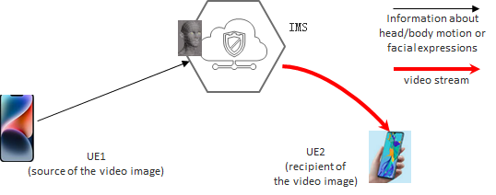

Figure 5.16.3-1: An example of avatar call functional flow (image rendering at the network)

NOTE: it is also possible for UE1 to send video stream to the network, with which the network can render the avatar (the dynamic 3D object). This is particularly useful for UEs with limited capability.

3.2 Mrs. Dursley downloads, from the network, one of her registered digital representations to be used for the XR communication. During the session, the rendering is done at the terminal side. An example of the functional flow from Mrs. Dursley to Humphrey is illustrated in figure 5.16.3-2. Note that in this option the required 3D avatar model needs to be made available at all the recipients (UE1 in this option).

1) The body motion or facial expressions of Mrs. Dursley are captured at UE2, which is transmitted to the recipient via the network.

2) With the received information about Mrs. Dursley’s motion or facial expressions, UE1 renders the avatar (the dynamic 3D object). The video image (with the rendered avatar) is displayed at the screen of Humphrey’s terminal.

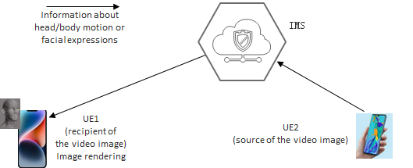

Figure 5.16.3-2: An example of avatar call functional flow (image rendering at the receiving side)

NOTE: this use case shows the example of rendering of the video-based avatar media to 3D avatar. It is also possible to render other media to 3D avatar.

### 5.16.4 Post-conditions

The 3GPP system with a combination of various technologies offers the users an immersive shopping experience equivalent to a face-to-face purchase in a crowded market.

### 5.16.5 Existing features partly or fully covering the use case functionality

The service requirements on IMS Multimedia Telephony Service and supplementary services are well documented in TS 22.173 since Rel-7, many of which have been implemented in stage-2 and stage-3 WGs. The requirements on 3GPP IMS Multimedia Telephony Service are captured in TS 22.261 [5] clause 6.39 as a result of Rel-18 work.

On the user identity related aspects, there are several features defined including:

- Support of Multi-device and Multi-Identity in IMS MMTEL service is captured in TS 22.173 clause 4.6 [3]:

The support of multiple devices is inherent in IMS. In addition, a service provider may allow a user to use any public user identities for its outgoing and incoming calls. The added identities can but do not have to belong to the served user. Identities may be part of different subscriptions and different operators.

- TS 22.101 [4] has specified in clause 26a a set of service requirements on User Identity:

*Identifying distinguished user identities of the user (provided by some external party or by the operator) in the operator network enables an operator to provide an enhanced user experience and optimized performance as well as to offer services to devices that are not part of a 3GPP network. The user to be identified could be an individual human user, using a UE with a certain subscription, or an application running on or connecting via a UE, or a device (“thing”) behind a gateway UE.*

*Network settings can be adapted and services offered to users according to their needs, independent of the subscription that is used to establish the connection. By acting as an identity provider, the operator can take additional information from the network into account to provide a higher level of security for the authentication of a user.*

*The 3GPP System shall support to authenticate a User Identity to a service with a User Identifier.*

- Clause 8 of TS 22.261 [5] specifies the security related requirements covering aspects such as authentication and authorization, identity management, and data security and privacy.

The functional requirement and performance KPIs in support of XR applications are mainly captured in TS 22.261 [5]:

- clause 7.6.1 AR/VR;

- clause 6.43 Tactile and multi-modal communication service;

- clause 7.11 KPIs for tactile and multi-modal communication service

In support of metaverse services, additional considerations need to be given on the following aspects:

- securely register and store the digital representations (e.g. avatars) for the users. The user could be an individual human user using a UE with a certain subscription, or an application running on or connecting via a UE, or a device behind a gateway UE. The user could also be a third party, which is typically an enterprise customer having service level agreement with the operator and interacting with the 3GPP network via an application server.

- assist the authorization of the use of third party’s digital assets (e.g. the digital representations (e.g. avatars) in the XR communication. The third party is also involved in the procedure to certify the user identity (e.g. an employee of the company).

- when required render the digital representations (e.g. avatars) based on the voice, facial expression or gesture in the live communication video

### 5.16.6 Potential New Requirements needed to support the use case

[PR 5.16.6.2-1] Subject to user’s consent, the 5G system shall support mechanisms to securely register, store and update the digital assets for a user.

NOTE 1: The user could be a human user using a UE with a certain subscription, or an application running on or connecting via a UE, or a device behind a gateway UE. The user could also be a third party, which is typically an enterprise customer having service level agreement with the operator and interacting with the 3GPP network via an application server.

[PR 5.16.6.2-2] Subject to regulatory requirements and operator’s policy, the 5G system shall provide suitable and secure means to allow trusted third-party to authorize the use of the digital assets (that belong to the third-party enterprise customer) by a user.

NOTE 2: In a typical example the user is an employee of the third-party enterprise customer.

[PR 5.16.6.2-3] The 5G system shall be able to collect charging information per UE for managing (e.g. register, store and update) the digital assets for an end user (e.g. typically a human user with a certain subscription).

[PR 5.16.6.2-4] The 5G system shall be able to collect charging information per application for managing (e.g. register, store and update) the digital assets for the third party (e.g. typically an enterprise customer having service level agreement with the operator).

[PR 5.11.6.2-5] Subject to regulatory requirements and user’s consent, the 5G system shall support real-time transmission, between a UE and the network, of the body movement information (e.g. body motion or facial expressions) of a human user in order to ensure immersive voice/audio and visual experience.

NOTE 3: The body movement information (e.g. body motion or facial expressions) of a human user is used for rendering of the avatar of this user.

[PR 5.11.6.2-6] Subject to regulatory requirements, user’s consent and operator’s policy, the IMS shall support the capabilities of rendering the avatar based on the body movement information (e.g. body motion or facial expression) of a human user.

## 5.17 Use Case on Work delegation to autonomous virtual alter ego

### 5.17.1 Description

Artificial Intelligence (AI) is becoming more and more popular in many areas where especially humans cannot handle complicated tasks well (e.g., factory, vehicle, robot, mobile). This trend is likely to continue, and AI will be applied to even more areas. In addition to the rapid expansion of AI, the AI technology itself is also improving. AI that can express emotions like humans and AI that can communicate naturally are now emerging. Given these trends, AI could one day be used not only for industrial use cases, but also as our personal partner and personal assistant to perform many of the tasks around us.

This use case proposes a communication with an autonomous virtual alter ego, which is an AI-based digital representation acting autonomously on behalf of a user herself/himself in the mobile metaverse services. For example, user's autonomous virtual alter ego autonomously sends a mail to clients on user’s behalf. Also, the alter ego can autonomously communicate with the user, other physical users, and other alter ego by using the network capabilities based on the user’s 3GPP subscription. Therefore, the use of network by the alter ego has to be captured correctly by the network from charging point of view.

NOTE: The term "autonomous virtual alter ego" means an AI-based digital representation behaving autonomously on behalf of a user herself/himself in the mobile metaverse services.

All the experience and knowledge performed both in physical world and metaverse will be shared between the alter ego and its user, thus creating more than double the opportunities to play multiple roles simultaneously. This autonomous virtual alter ego concept aims to improve emotional well–being, health, and life satisfaction by enabling users to perceive many opportunities in life, such as balancing work and family and participating in many communities simultaneously.

### 5.17.2 Pre-conditions

John has a UE which has connectivity to 5GS based on subscription to MNO and a contract with an autonomous virtual alter ego service provider. The service setting and parameters for this alter ego service are stored in the user’s subscription data.

John’s virtual alter ego has been trained by the autonomous virtual alter ego service provider, so he can enjoy the alter ego application via his UE.

There are two kinds of application servers. One is for alter ego application. The other is for other applications which the alter ego application connects for executing tasks.

The autonomous virtual alter ego service provider is trusted by MNO, and the alter ego can use the network capabilities autonomously based on user’s subscription to MNO.

NOTE: The autonomous virtual alter ego application server doesn’t always have connectivity to internet (e.g., the case that alter ego service is operated on edge servers). Therefore, there would be the case that alter ego application server connects to other application servers via 5GS not via internet.

The MNO offers a service enabler that allows John to request that the network limit how much resources his alter ego is able to consume on his behalf. The service enabler also provides John with storage space that he can use to store application specific data and information about himself in the network. John is able to configure the enabler to give the virtual alter ego limited access to John’s information.

### 5.17.3 Service Flows

1. John has a F2F appointment with his important client at client's office, so he cannot attend an internal web meeting scheduled on the same time. Then, he connects to the alter ego application via his UE and asks his alter ego to show up and participate in the internal web meeting on his behalf.

2. His virtual alter ego checks the network resources on 5GS and computing resources on the alter ego server. Then it judges whether the requested task is able to be process or not. The virtual alter ego checks with the enabler server to see what information about John it is able to access.

3. If the alter ego can complete the tasks, the information from the enabler server is used to train the alter ego and the alter ego starts the tasks. Otherwise, the alter ego proposes task examples it can do with current resources to him, so that John can reconsider the request. For example, the alter ego can only listen during the meeting and take some notes but can’t say anything. Once John and the alter ego agree on what task(s) the alter ego will perform, John silences, or turns his off his UE so that he can focus on the F2F meeting.

4. Before the alter ego attends the meeting, it accesses the web meeting server as John’s alter ego via internet or 5GS by receiving the permission from John and web meeting server. When the company internal information or some other information is needed for the meeting, the alter ego asks the enabler to permit access to the information or asks John to permit the access to them.

5. At the meeting, the alter ego explains something, makes some questions/comments to other attendees (including physical humans and other virtual alter egos).

6. After the meeting, the alter ego autonomously reports to John via 5GS by message or on call. He looks or listens to the report and returns feedback and new requests by message or on call if any.

7. When the alter ego communicates via 5GS, the charging information is collected and linked to user’s charging information to charge the user subscribing the alter ego service.

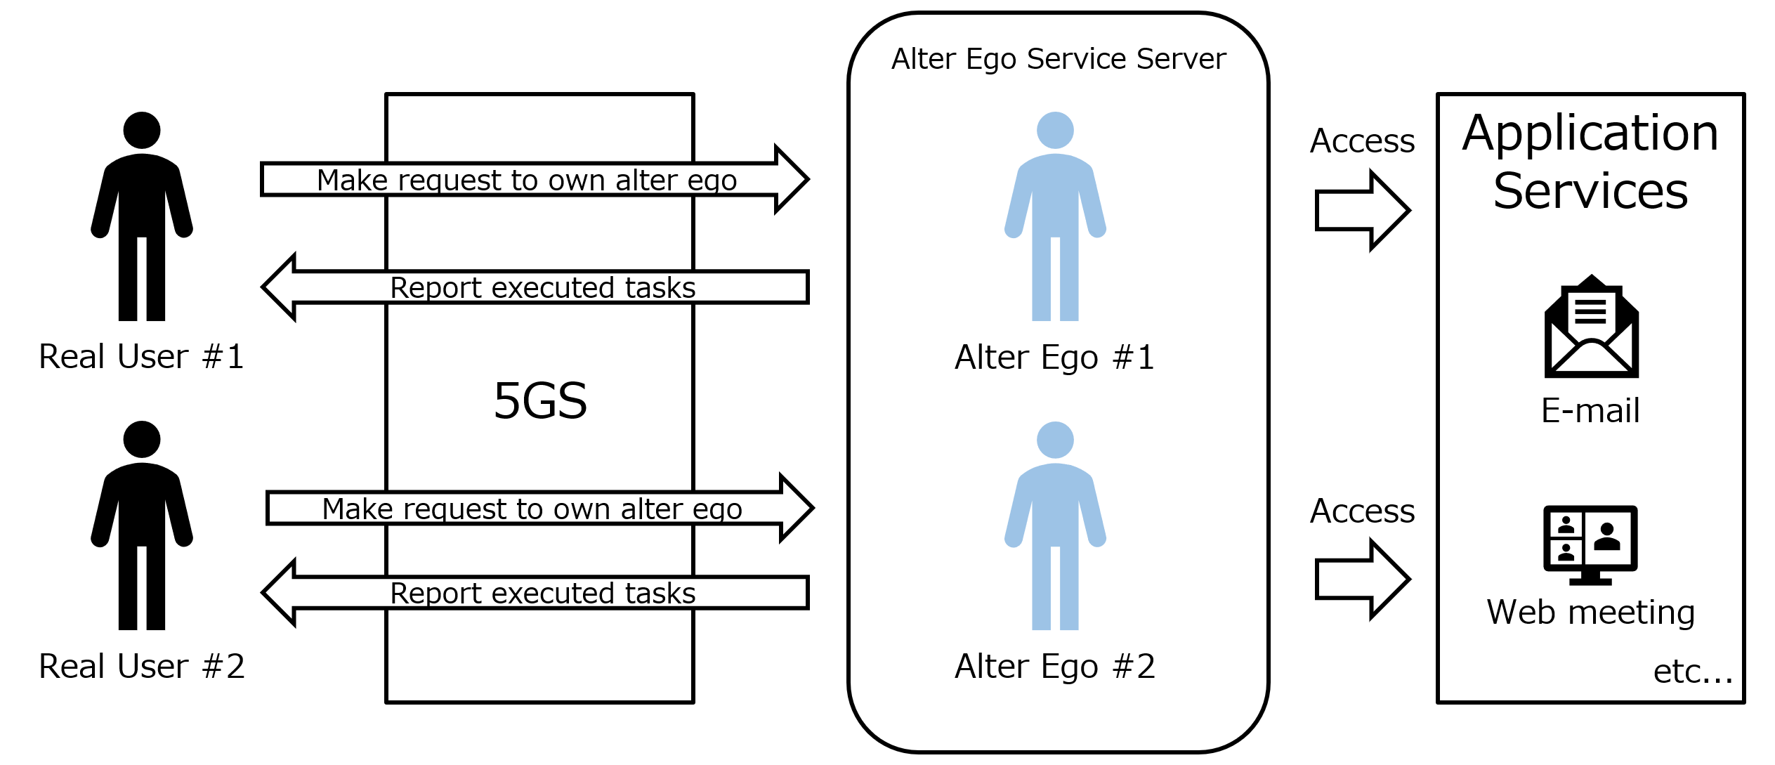

Figure 5.17.3-1: Alter Ego Service Flow

### 5.17.4 Post-conditions

After receiving the feedback from John, the alter ego is retrained. Then, the autonomous virtual alter ego becomes more accurate and finishes the tasks much more immediately. As a result, the time available to him in life is more than doubled.

### 5.17.5 Existing features partly or fully covering the use case functionality

AIML model transfer frameworks documented in TR 23.700-80 [51] can be applied to this use case.

IMS MMTEL services documented in TS 22.173 [3] can be applied to this use case.

### 5.17.6 Potential New Requirements needed to support the use case

[PR 5.17.6-1] The 5G system shall be able to provide a means for a subscriber to authorize a third party to use a subscriber’s digital representation (e.g., avatar) and to access multimedia communication services on behalf of the subscriber.

[PR 5.17.6-2] The 5G system shall be able to collect charging information associated with communication involving a digital representation associated with the subscriber.

## 5.18 Use Case on virtual meeting room in financial services

### 5.18.1 Description

Meeting rooms in banks provide a private place for customers and financial manager to communicate, financial manager can provide customized information on the financial products that suitable for the customers. Customers may find a dedicated room for consulting and signing contact safer and the user experiences are better. While meeting rooms are limited resource in bank and customers need to go to bank by themselves for consulting, which will take more time and resources. A virtual bank meeting room offered by a mobile metaverse service can solve this limitation.

The virtual banking space can be designed by the consumers based on their user preference. Consumers can be represented by their digital representations (e.g. avatars) as they use these mobile metaverse services. Consumers can have eye contact or observe each others' body movements in a virtual environment, generating a friendly face-to-face service experience. With this service option, bank branches are freed from physical limitations of space and location.

### 5.18.2 Pre-conditions

Each user has a unique digital representation (e.g. avatar) in the mobile metaverse service. Bank R provides consumers a virtual bank as a mobile metaverse service as a location agnostic service experience. This service requires a high level of security in mobile communication as the content is sensitive. Users have their own digital representations (e.g. avatars) that they use to represent themselves when they use the mobile metaverse service, and these avatars are mapped with their real identification.

### 5.18.3 Service Flows

1. Frank is a very active user of mobile metaverse service X, he does his daily work and entertainment making use of this mobile metaverse service X using his avatar.

2. Bank R has a virtual branch offered as mobile metaverse service X, in which the bank provides financial services and can provides different financial products to consumers based on their individual preferences. Frank is a VIP customer of Bank R. Frank is considering to have some financial products and he needs to consult with a professional financial manager in the virtual bank.

3. Frank enters the virtual bank branch using his avatar, Bank R will identify the user Frank, represented by his digital representation (e.g. avatar,) and authorize these by means of the 5GS to make sure the real identification of this avatar is the same with Frank.

4. 5GS will inform Bank R that this avatar is authenticated and authorized to represent Frank, and this digital representations (e.g. avatar) is authorized to represent Frank to perform financial actions. Bank R receives this information and provides this digital representation (e.g. avatar) representing Frank access to a customized VIP consulting room. In this room, Bank R can provide consulting and financial services to Frank.

5. After the authorization, the 5GS will increase automatically update the security mechanisms (such as encryption algorithms) associated with the PDU session to guarantee the security of the communication services used to deliver this financial service.

### 5.18.4 Post-conditions

Frank had a safe and realistic experience using his digital representations (e.g. avatar) in the virtual meeting room.

### 5.18.5 Existing features partly or fully covering the use case functionality

None.

### 5.18.6 Potential New Requirements needed to support the use case

[PR 5.18.6-1] Subject to operator policy and national or regional regulation, the 5G system shall support identification of digital representations (e.g. avatars) associated with users, for mobile metaverse services.

[PR 5.18.6-2] Subject to operator policy and national or regional regulation, the 5G system shall support different communication security mechanisms according to the security requirements of different services.

## 5.19 Use Case on Privacy-Aware Dynamic Network Exposure in Immersive Interactive Experiences

### 5.19.1 Description

With the proliferation of APIs in existing mobile applications already creating an extensive market for application exposure, API integration in emerging Metaverse applications and features is likely to emerge as a major functionality for enhancing experiences across extended reality functions that builds upon already-existing API development. Given the importance of consistent, reliable network access and the low-latency connections necessary to generate and maintain immersive experiences in Metaverse immersive experiences, one could reasonably expect the development of APIs supporting network exposure for configuring and optimizing network features for a diverse array of emerging functions in extended reality interactions. As 5G begins to support VR, AR, and MR interactions through the cellular network, questions surrounding the efficiency and trustworthiness of network exposure to application developers abound.

In particular, the exposure of network characteristics through and the development of network-focused applications raises important questions around the privacy of user data with respect to the use of sensitive data around their internet usage, which could potentially reveal personally identifiable information about their location, environment, behaviour, or specific activities through such exposure. This concern extends beyond industry best practices and into emerging requirements from regulations such as the GDPR [52], CCPA [53], and other emerging national and international privacy regulation frameworks which specify the right of individuals to privacy across the lifecycle of data that could reveal personally identifiable information across a broad specification of contexts. It is thus incumbent on this body to proactively standardize the privacy features of the emerging 5GS in the context of APIs to ensure that such network exposure in application contexts does not expose providers or users to undue risks or liability.

### 5.19.2 Pre-conditions

The following pre-conditions and assumptions apply to this use case:

1. Jenna is developing an application that uses potentially personally identifiable information.

2. Jenna is aware of the existence and relevance of tuneable network characteristics to improve or augment an immersive experience, e.g., sufficient tools exist to modify characteristics like streaming bitrate in immersive contexts.

3. Jenna has access to exposed APIs allowing her to deploy these features in relevant experiences for immersive interaction.

### 5.19.3 Service Flows

1. Jenna develops an application that uses sensitive data, e.g., an application that uses the real-time location and/or environmental features of users’ appearance and surroundings to generate a personal digital representation (e.g. avatar) in a mobile metaverse service activity.

2. Jenna uses an API exposing tuneable network characteristics to carry out some function, e.g., dynamically adjust the streaming resolution of generated mobile metaverse media (e.g. avatar/hologram,) or the streaming bitrate of the mobile metaverse media (e.g. avatar) in motion, based on higher-level network characteristics accessible in real time through the API.

3. Jenna develops an application that sends user information through the application to the network provider. Jenna does so in a way that is compliant with existing privacy transmission, storage, and processing standards. This means that Jenna’s application considers relevant privacy-preserving features such as informed consent to process, transmit, store, and appropriately delete any personally identifiable information collected and ingested during the flow.

4. The application uses this information to optimize a network-level feature such as streaming bitrate corresponding to a tuneable knob through the API. The network provider also considers relevant privacy-preserving features ingested as part of the data exchanged during this process.

5. When ingesting potential personally identifiable information at the network and/or application level, application provider, user, and network provider receive transparent, verifiable guarantees that data has been processed, stored, and transited in compliance with existing regulations within the user’s jurisdiction

### 5.19.4 Post-conditions

1. Jenna’s digital representations (e.g. avatars) and other personally identifiable information generated through her application are able to safely exchange information through network exposure APIs without compromising the privacy of users or the network.

2. Network providers remain compliant with existing privacy regulations and best practices.

### 5.19.5 Existing feature partly or fully covering use case functionality

Not applicable.

### 5.19.6 Potential New Requirements needed to support the use case

[5.19.6-1] Subject to national/regional regulations, and user consent, the 5G System shall be able to process and expose information from UEs related to user’s location, user’s body, and user’s environment, e.g., user’s home, user’s immediate vicinity.

NOTE: This requirement does not affect the ability of regulatory services, e.g., legal intercept service, to access such information without consent of the user.

## 5.20 Use Case on Immersive Tele-Operated Driving in Hazardous Environment

### 5.20.1 Description

Operating vehicles, lifting devices, or machines in an industrial environment is hazardous when achieved manually and locally by a human. Depending on the environment, operators are exposed to dangerous material, toxic fumes, extreme temperatures, landslide risks, radioactivity, etc.

AGVs already exist, although it is expected that human operators can take remote control to remotely operate such moving vehicles.

In this use case, it is proposed to leverage 5G to provide an end-to-end system in which a remote user controls a moving device (vehicle, lifting device, robot, etc.) with an immersive cockpit displayed on a virtual reality head-mounted display and haptic gloves for control. Furthermore, the cockpit is complemented with information from the digital twin of the place in where the user operates (e.g., sensors in a factory, type of material around, other moving vehicles or persons).

The use case improves user safety and makes the operations even more accurate by merging additional information from a digital twin.

### 5.20.2 Pre-conditions

Bob works in a seaport; he operates a lifting device. The place in which he is operating is surrounded by cranes, machines, containers, pipes, and barrels containing hazardous substances.

A new mobile metaverse service is available: instead of locally controlling the device, Bob is installed in a safe remote location from which he is working. The surrounding information is available through a digital twin of the seaport and can come from various sources (IoT sensors, CCTV cameras, connected machines, and other vehicles).

In order to maximize Bob’s efficiency, the metaverse service experience delivered by the system is real-time with non-noticeable latency. This use case includes both location related and location agnostic service experience examples.

The mobile metaverse service Bob uses for teleoperation is running on a mobile metaverse server. In addition, Bob is equipped with a head-mounted display and haptic gloves to remotely control the vehicle.

### 5.20.3 Service Flows

1. This morning, Bob stayed home as his boss informed him about a potential hazard at the factory that was identified through some sensor on a pipe. Unfortunately, the exact nature and location of the hazard on the pipe are not known. So, Bob decides to remotely inspect the factory before his boss and local public authorities arrive to check.

2. He puts on his head-mounted display on which a cockpit environment is displayed from the mobile metaverse server: a virtual control panel appears in front of him. He can see his hands and the control panel in the cockpit. Bob’s application is connected to the mobile metaverse server which enables him to use the service.

3. Bob can tell the mobile metaverse server to configure which surrounding information from the digital twin he wants to monitor. He decides to focus on the 3D representation of the pipe and get real-time sensor information from it, as well as live data from the ambient temperature and gas sensors. The mobile metaverse media displays additional predicted data that temperature is growing, gas concentration is increasing, and that there is a high risk of explosion in less than 10min if this continues. This surrounding information is integrated with other display elements in the cockpit, but he can anchor it in his FOV.

4. While driving along the seaport by remotely controlling the lifting device via its digital twin in the metaverse server, Bob can also see the (hidden) content of other pipes.

### 5.20.4 Post-conditions

Thanks to the 5G mobile metaverse “Tele-operated Driving” service, Bob has been able to drive the vehicle remotely in a reactive way avoiding dangers and finding the leak with the help of the information provided via the digital twins.

### 5.20.5 Existing feature partly or fully covering use case functionality

The use case related to traffic flow simulation in clause 5.2 already provides requirements and KPIs related to the operation of a moving UE, similar to an AGV. However, that use case does not envision the use of remote control, e.g., using haptic devices and HMD, which trigger new requirements.

The use case related to critical healthcare services in clause 5.10 captures the usage of HMD and haptic devices with related requirements and KPIs, which can be generalized to industrial operations. However, this use case does not consider time-critical decisions based on surrounding moving objects in an open area. Neither it relies on real-time digital twin updates to track the characteristics of the environment (e.g., information about pipe content, etc.)

### 5.20.6 Potential New Requirements needed to support the use case

[PR 5.20.6-1] The 5G system shall be able to provide a means to associate data flows related to one or multiple UEs with a single digital twin maintained by the mobile metaverse service.

[PR 5.20.6-2] The 5G system shall be able to provide a means to support data flows from one or multiple UEs to update a digital twin maintained by the mobile metaverse service.

[PR 5.20.6-3] Subject to regulatory requirements and operator’s policy, the 5G system shall be able to support data flows directed towards one or multiple UEs as a result of a change in a digital twin maintained by the mobile metaverse service, so that physical objects could be affected via actuators.

NOTE 1: How an application actually operates on physical objects upon receiving a command via the mobile metaverse service, e.g. using actuators, changing environmental controls configuration, etc is out of scope of the 5G system. In addition, regulations and/or other standards could apply to remote operations (e.g. based on a specific industry).

[PR 5.20.6-4] The 5G system shall be able to support the following KPIs for remotely controlling physical objects via the mobile metaverse service.

| **Use Cases** | **Characteristic parameter (KPI)** | | | |  | **Influence quantity** | | | | |  |
| --- | --- | --- | --- | --- | --- | --- | --- | --- | --- | --- | --- |
| **Max allowed end-to-end latency** | **Service bit rate: user-experienced data rate** | **Reliability** | **Area Traffic capacity** | **Message Data Volume (bits)** | | **Transfer interval** | **Position accuracy** | **UE speed** | **Service Area** | **Remarks** |
| Metaverse-based Tele-Operated Driving | [100] ms [25] (NOTE 1) | [10~50 Mbit/s] [25] | 99%  [25] | [~360 Mbit/s/km2 ]  (NOTE 4) | ~8Mbps video stream. Four cameras per vehicle (one for each side): 4*8=32Mbps.  Sensor data (interpreted objects).  Assuming 1 kB/object/100 ms and 50 objects: 4 Mbps [25] | | 20~100 ms [25]  (NOTE 2) | [10] cm [25] | [10-50] km/h (vehicle) [25]  Stationary/Pedestrian (user) | Up to 10km radius [25]  (NOTE 3) | UL (NOTE 5) |
| [20] ms [25] | [0.1~0.4 Mbit/s] [25] | 99,999% [25] | [~4 Mbit/s/km2 ]  (NOTE 4) | Up to 8Kb  per message [25] | | 20 ms [25]  (NOTE 2) | [10] cm [25] | [10-50] km/h (vehicle) [25]  Stationary/Pedestrian (user) | Up to 10km radius [25]  (NOTE 3) | DL (NOTE 5) |
| 1-20ms  (NOTE 6) | 16 kbit/s -2 Mbit/s  (without haptic compression encoding);  0.8 - 200 kbit/s  (with haptic compression encoding)  (NOTE 6) | 99.999%  (NOTE 6) | [~20 Mbit/s/km2 ]  (NOTE 4) | 2-8 (1 DoF) (NOTE 6) | |  |  | Stationary/Pedestrian (user) | Up to 10km radius [25]  (NOTE 3) | Haptic feedback |
| NOTE 1: The end-to-end latency refers to the transmission delay between a UE and the mobile metaverse server or vice-versa, not including sensor acquisition or actuator control on the vehicle side, processing, and rendering on the user side (estimated additional 100ms total). Target e2e user experienced max delay depends on reaction time of the remote driver (e.g. at 50km/h, 20ms means 27cm of remote vehicle movement).  NOTE 2: UL data transfer interval around 20ms (video) to 100ms (sensor), DL data transfer interval (commands) around 20ms.  NOTE 3: The service area for teleoperation depends on the actual deployment; for example, it can be deployed for a warehouse, a factory, a transportation hub (seaport, airport etc.), or even a city district or city. In some cases, a local approach (e.g., the application servers are hosted at the network edge) is preferred to satisfy low latency and high-reliability requirements.  NOTE 4: The area traffic capacity is calculated for one 5G network, considering 4 cameras + sensors on each vehicle. Density is estimated to 10 vehicles/km2, each of the vehicles with one user controlling them. [25]  NOTE 5: Based on [25]. UL is real-time vehicle data (video streaming and/or sensor data), DL is control traffic (commands from the remote driver)  NOTE 6: KPI comes from [5] cl 7.11 “remote control robot” use case | | | | | | | | | | | |

Table-5.20.6-1: Key Performance Indicator (KPI) for mobile metaverse Tele-Operated Driving

## 5.21 Use Case on Virtual Emergency Drill over 5G Metaverse

### 5.21.1 Description

An Emergency Drill is a crucial activity for governments, local municipalities, and citizens to prepare for potential disasters such as earthquakes, fires, and floods. To make the drills more effective, it is important for a wide range of people, organizations, and government entities to participate and create simulations that are as close to real-life disaster scenarios as possible. The use of a metaverse environment is expected to significantly enhance the value of these drills. With the ability to provide a more realistic experience, the Emergency Drill in the metaverse is expected to not only improve response to direct damage from emergencies, but also provide valuable data on human thoughts, decisions, and actions in actual crisis situations.

It is also important for mobile operators to anticipate traffic patterns related to confirming people's safety or evacuation actions during an emergency, and take measures to address potential data traffic congestion, overload, or failure of base stations or network equipment. The mobile network operator should be prepared not only for disasters but also large-scale network failures. They has to be able to quickly and accurately assess the extent of damage and impact and take timely action to recover their networks.

### 5.21.2 Pre-conditions

City A, known for its beautiful beaches, attracts many visitors each year. However, it is located near the sea and is at risk of suffering significant tsunami damage in the event of a major earthquake. With the challenges of providing rapid evacuation guidance for residents, saving lives, and restoring infrastructure, City A holds an annual comprehensive emergency drill. Although the drill is typically held on a holiday, the number of participants has been decreasing in recent years due to work, leisure, or COVID-19. This year, City A has decided to conduct the emergency drill in the metaverse environment to address this issue.

### 5.21.3 Service Flows

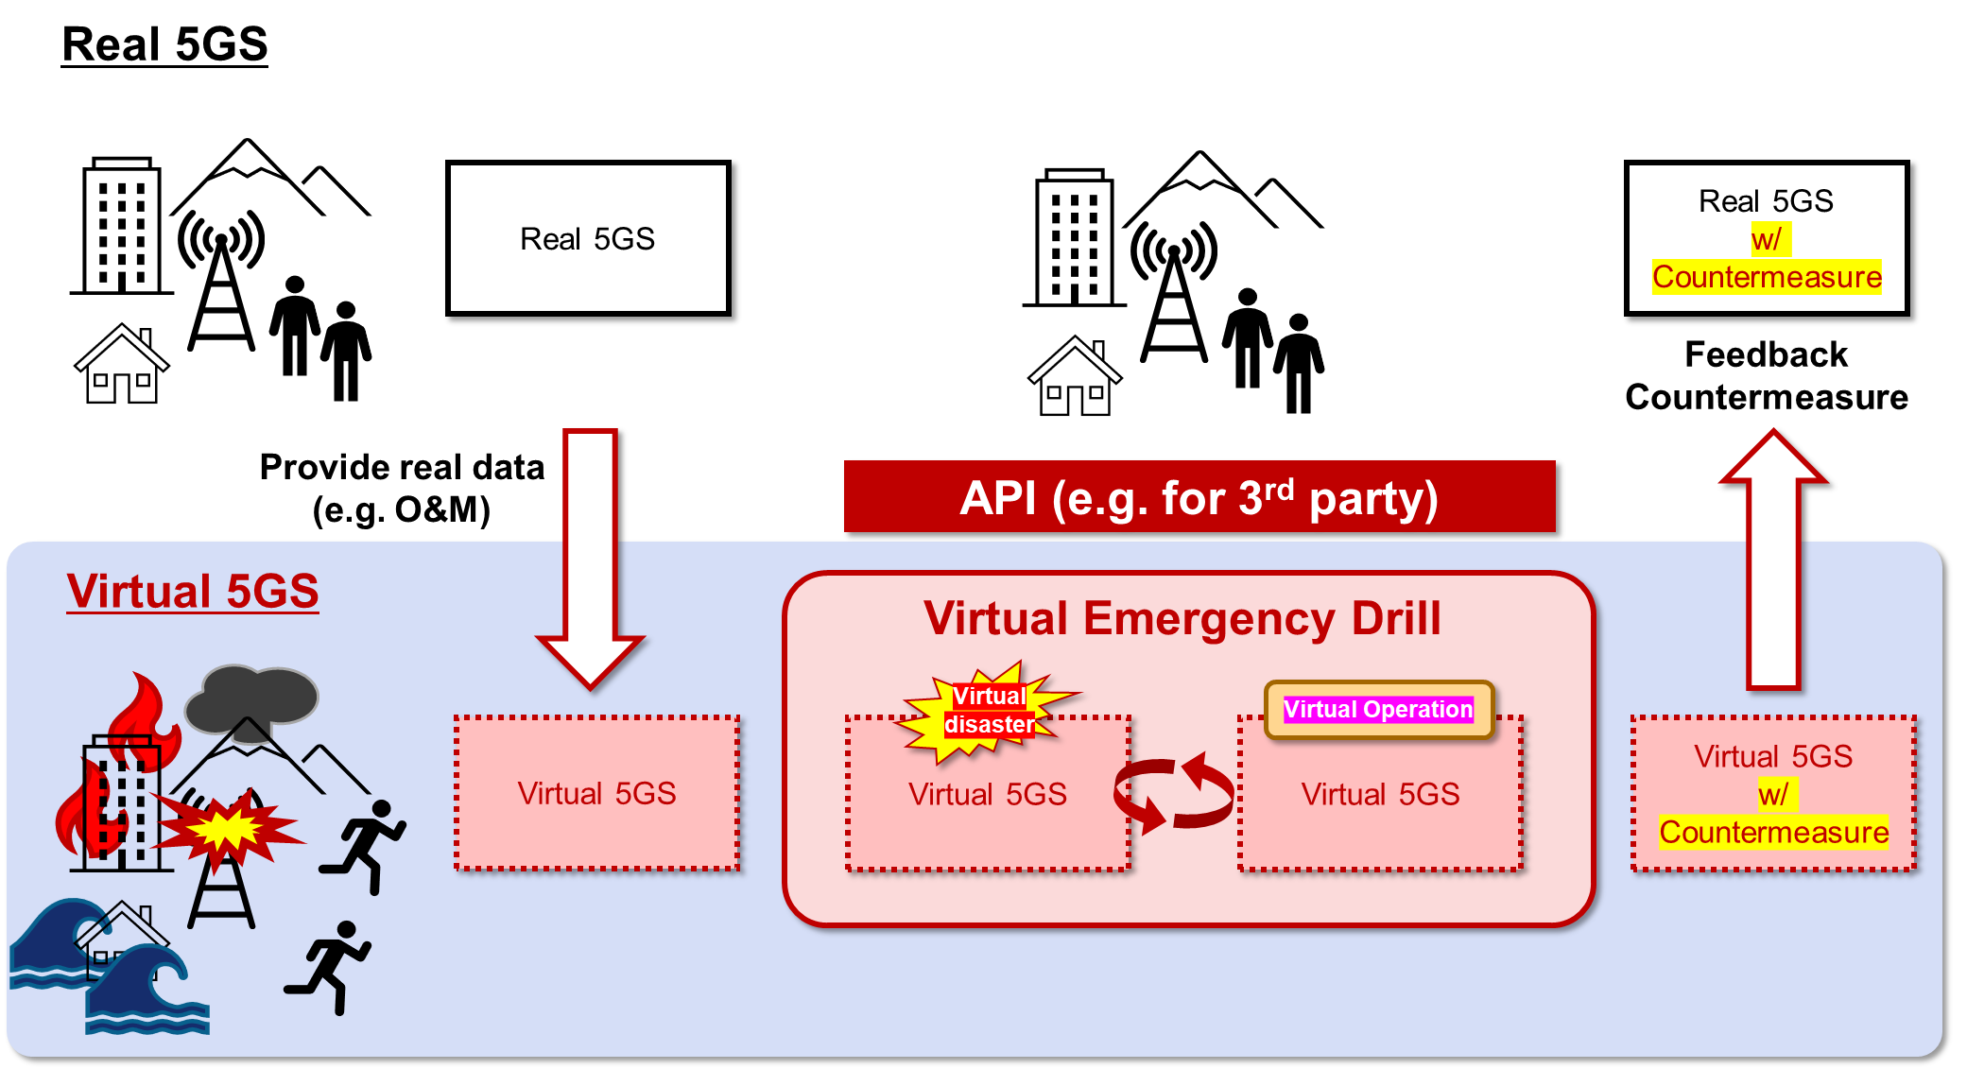

1. City A is planning a virtual emergency drill that participants can access from any location, such as their office, home, or even the beach.

2. Mobile operator B will provide the 5G system and anticipated operational and maintenance data for the emergency drill in the metaverse environment.

3. In the metaverse environment, a virtual disaster, such as an explosion of Mt. Fuji, is simulated, and participants, including citizens, organizations, and governments, will immediately respond by assessing the damage, conducting evacuation and rescue activities, and taking other necessary actions in the virtual space.

4. City A and designated organizations will collect various types of data during the emergency drill.

5. Additionally, Mobile operator A will collect data in the virtual network environment, taking into account actual operational and maintenance data from the real environment, such as UE mobility, overload, and out of coverage, to evaluate the impact of the network in the event of a disaster and implement necessary countermeasures in the virtual environment.

### 5.21.4 Post-conditions

By participating in emergency drills, citizens and organizations learn how to respond to disaster scenarios, such as evacuations and rescues, and this information can be incorporated into local government disaster preparedness plans. Additionally, mobile operators can take effective measures to counteract potential network failures and other adverse impacts.

### 5.21.5 Existing features partly or fully covering the use case functionality

Editor's Note: No existing features are identified.

### 5.21.6 Potential New Requirements needed to support the use case

[PR 5.21.6-1] Subject to the operator’s policy, 5G system shall be able to provide the means for the authorized third party to provide the input data about specific virtual event(s) e.g. failure of the NW equipment, burst traffic on the virtual 5G system(s) for the mobile Metaverse service.

## 5.22 Use case of Mobile Metaverse Live Concert

### 5.22.1 Description

Mobile metaverse services allow people to enjoy an online digital concert with their avatars beyond the limitation of time and space. In order to provide immersive interactive location agnostic service experience to mobile metaverse service customers, large amount of computing resouces is needed to perform real-time processing for audio, video, and interactive data, etc. The thing to realise here is that different customers will use terminals e.g. XR glasess with different brands and different processing capabilities, some of the glasses will not have enough computing resources to perform the real-time rendering. Through split rendering, most of the computing work task can offload to the network, the high speed and low latency transmission provided by 5G system can cooperate with the edge cloud side for real-time rendering, and combine with the local optimized rendering of the XR terminal side to provide the immersive and unbounded XR experience. In addition to this, similar to the real world, people are more likely to watch a concert together with their friends, further, the mobile metaverse live concert service is also provides private boxs for group of avatars to enjoy the concert privately, and different types of social authority can be provided in the private box on demand.

### 5.22.2 Pre-conditions

1) Alex, Bob and Carey are good friends live in different cities, they agree to watch the mobile metaverse live concert together.

2) Alex, Bob and Carey are equipment with XR glasses and tactile, the equipment can capture their voice, facial expression, pose information to generate avatars and interact with the whole live concert.

3) Enough computing resources can be provided to the mobile metaverse live concert service and the 5G network is capable of providing sufficiently high throughput and low latency network transmission.

### 5.22.3 Service Flows

1. Alex, Bob and Carey’s subscribe to the mobile metaverse live concert services and order a “private box” which can only be used by themselves. Alex, Bob and Carey will be represented at the virtual concert event by their avatars.

2. Due to extensive computing resource requirement for image rendering in the interactive live concert, and Alex and Carey’s glasses are not strong enough to perform this processing, the UEs negotiate with the mobile network operator to offload the rendering service to the edge cloud. Carey's glasses can only receive the rendered image and show it in the field of view. Bob’s glass is more advanced, which can render the image itself.

3. The concert begins and the three friends access the mobile metaverse service. The live singer is presented to the audience as her own avatar. During the show, the singer and all the audience will be represented by their own avatars in the virtual space. Alex, Bob and Carey can adjust their own visual perspective, such as panoramic view, close range or even backstage. At the same time, they can also view the singer's voice and movement, and immerse themselves in the concert.

4. At the same time, extra VIP services can be provided in the “private box”, e.g. to chat with other audience members in the private box without being overheard. The virtual singer may also enter the "private box" to hold a personal meeting with her selected fans.

### 5.22.4 Post-conditions

The consumers in the mobile metaverse live concert service enjoy a great immersive experience and socialize with their friends.

The 5G system is capable of supporting the communication required by the immersive mobile metaverse live concert service. Some extra edge computing services are also provided to some consumers whose equipment has insufficient computing capacity.

### 5.22.5 Existing feature partly or fully covering use case functionality

The functional and performance requirements for AR/VR services have been captured in TS 22.261 clause 7.6.

### 5.22.6 Potential New Requirements needed to support the use case

[PR 5.22.6-1] Subject to operator policy, the 5G system shall be able to support avatar-based multiparty communication in mobile metaverse service.

## 5.23 Use Case on cooperation between metaverse and network using interactive XR

### 5.23.1 Description

The mobile metaverse allows users to access an endless virtual world at anytime and anywhere through their terminals. The mobile metaverse are expected to behave as the real world, which means in addition to rendering a virtual environment like the physical world, the perceived spatial-temporal consistency is also the key point to achieve an immersive location agnostic service experience.

In mobile metaverse, spatial-temporal consistency for single user could mean, for example, dropping a virtual pen and seeing this pen fall subsequently. While for multiple players, this consistency could mean, for example, that one person cuts down a tree and other people see the tree falling down. This user experience requires the motion-to-photon latency in the range of 7 ms to 15ms [5] at least for a single user viewing the consequence of her own actions. Immersive VR requires the delivery of massive amount of data (in the order of Gigabyte) at ultra-low latency (less than 20 ms) [54].

NOTE: For location agnostic service experience involving multiple users who are not in the same location, the requirements above do not apply, since the service can impose ordering and timing of representations of virtual events in an arbitrary manner.

It should be noted that the computation resources for rendering involved in the mobile metaverse is different from the cloud gaming and traditional VR. For example, running a typical massively multiplayer online game today requires multiple tera FLOPS of graphics horsepower, and the demand is expected to grow by two orders of magnitude to create fully immersive mobile metaverse experiences. [55]

For the mobile metaverse world, distributed computation is an inevitable processing mode, so the selection of proper servers and data centers should consider the requirements of network delay, processing delay, storage and computation resource. The goal is to minimize the user's perception of delay.

Therefore, in order to obtain consistent experience in mobile metaverse service anytime and anywhere, deep collaboration between mobile metaverse and 5G network is needed. The potential collaboration aspects may include caching location, computation location, communication path, traffic scheduling and resource allocation in network. For example, when a service request emerges, the network control policy needs to coordinate the selection of (i) caching locations to provide digital objects, (ii) computation locations to execute service functions, and (iii) communication paths to route all associated data streams, jointly optimized with dynamic decisions on (iv) traffic scheduling and (v) resource allocation at all network locations. [55]

### 5.23.2 Pre-conditions

There are about 12,000 players sign up for a popular game and appear simultaneously in a specific setting, such as Eve Online in 2021. Due to the limitations of the existing server processing, it is not possible to support such a large number of high concurrency, so the network and application server need to cooperate to support the distribution of visitors to other servers while ensuring low latency requirement by XR applications.

### 5.23.3 Service Flows

1. Bob is a player who attends a popular AR interactive game and gathers with others in a shared environment, they are aware of each other’s action so that they need high synchronization.

2. The service provider will provide deployment information of each server to the 5G network, and request the Bob’s physical location and transmission delay in 5G network.

3. According to the cooperation agreement with application, 5G network will expose information to service providers, including the physical location and network delay of specific terminals or a group of terminals. The network delay includes the delay inside 5G system (UE to PSA UPF) and the latency information between PSA UPF and some potential servers.

4. The new server is selected by the service provider according to the UE location, network delay, business requirements, computation resource and storage resource of application servers. The decision result will be sent back to 5G network. Then the 5G network can then formulate corresponding policies for the service flows.

5. The content information will be synchronized to the new server in real time. 5G network should support the ultra-low latency data transmission, potentially among multiple operators.

### 5.23.4 Post-conditions

Bob will have a good experience in this interactive AR game.

### 5.23.5 Existing features partly or fully covering the use case functionality

3GPP started the work of edge computing from R15 to R18. In R15, AF influence mechanism is introduced to inform the 5G network of the application deployment information to assist UPF selection. In R16, 5G system supports QoS monitoring mechanism for end-to-end delay monitoring for URLLC services. In R17, 5GS supports to solve the problem of edge DNS selection and service migration between different edge platforms. In R18, the work focuses on the edge computing platform access from other operator network, and the distribution of network policies for a group of local UEs.

### 5.23.6 Potential New Requirements needed to support the use case

No potential new requirements have been identified.

## 5.24 Use Case on Authorization of Avatar Usage rights

### 5.24.1 Description

In metaverse, digital humans (avatars) are widely used in business activities, such as advertising, news reporting, live shows. With the maturity of digital human technologies and the continuous growth of market demands, lifelike avatars have become reality in recent years. In the future, more and more people are expected to use their own avatar to participate in business activities in the virtual world. Especially, celebrities, famous professors and other people with special social positions have influences also in the virtual world. In some scenarios, authorization of avatar usage rights is needed for commercial or other purposes. If there were no proper management of avatar usage rights, it could cause the spread of false information, even result in chaos in virtual world.

Therefore, the 5G system needs to support management and authorization of avatar usage rights. The owner of the avatar is expected to be responsible for the speech and behavior of his/her avatar. An individual or an enterprise has to be authorized by the owner of an avatar before using the avatar especially in business activities.

### 5.24.2 Pre-conditions

Singer J has her own lifelike avatar, which is used for her live concerts in metaverse. Her touching voice has won hundreds of millions of fans. Company A is a clothing manufacturer. Seeing the commercial value of Singer J, the company invited her to be the company’s brand ambassador, who helps to increase brand awareness and attends product promotion activities. Singer J has signed one-year business contract with Company A. Subject to the contract, Singer J’s avatar is the brand ambassador for Company A in metaverse.

MNO B provides management services (including authorizing and deauthorizing) for the use of avatars in the mobile metaverse services. Each avatar has been assigned a unique identification code in MNO B’s management system. MNO B also provides avatar storage services.

Singer J is one of the subscribers of MNO B, and Company A is also served by MNO B.

### 5.24.3 Service Flows

1. Company A registers with the MNO B as an enterprise customer, while Singer J registers as an individual customer of MNO B. MNO B assigns IDs for Company A and Singer J respectively.

2. Singer J registers her personal avatar with MNO B. The avatar is lifelike and mapped to Singer J’s ID in real world. So MNO B identifies and stores the avatar and its ID, also associates with the avatar’s owner, Singer J’s ID.

3. Company A sends a request for the usage rights of Singer J’s avatar that is managed by MNO B.

4. MNO B sends a request to Singer J to ask for authorization of the avatar to be used in the mobile metaverse services.

5. After being confirmed by Singer J, Company A’s usage rights of avatar has been authorized. MNO B updates the system with the information that Company A has the usage rights of Sing J’s avatar.

### 5.24.4 Post-conditions

Upon authorization, Singer J has granted the usage rights of her avatar to Company A for one year to be used in mobile metaverse services. During this year, Company A is authorized to use Singer J’s avatar for business purposes. When Company A wants to use Singer J’s avatar in a mobile metaverse service, the 5GS searches the avatar by its ID, and pushes the requested avatar to company A. At the end of the year, Company A’s usage rights of Singer J’s avatar will be duly terminated.

### 5.24.5 Existing features partly or fully covering the use case functionality

None.

### 5.24.6 Potential New Requirements needed to support the use case

[PR 5.24.6-1] Subject to regulatory requirements, user’s consent and operator’s policy, the 5G system shall support mechanisms to identify an avatar and associate the avatar with a subscriber (i.e. the owner of the avatar).

[PR 5.24.6-2] Subject to regulatory requirements, user’s consent and operator’s policy, the 5G system shall be able to authorize the avatar to be used in mobile metaverse services.

[PR 5.24.6-3] Subject to regulatory requirements, user’s consent and operator’s policy, the 5G system shall provide time-bound authorization services for an avatar to be used in mobile metaverse services.

[PR 5.24.6-4] Subject to regulatory requirements, user consent and operator’s policy, the 5G system shall be able to support mechanisms to manage the authorization information about the use of an avatar in mobile metaverse services (e.g. the applied time-bound authorization services, the authorized users).

[PR 5.24.6-5] Subject to regulatory requirements, user consent and operator’s policy, the 5G system shall be able to identify the subscriber who has the right to use an avatar in mobile metaverse services.

## 5.25 Use Case on Enabling Metaverse services to users via multiple access connections

### 5.25.1 Description

The metaverse enables immersive virtual media, 3D avatar and holographic communications for realizing use cases such as interactive gaming, virtualized shared workspaces, and immersive conference rooms for remote collaboration, etc. The goal is to create a virtual world we can work in, interact with, and even escape to. Many mobile metaverse use cases are applicable to indoor and/or localized areas such as home, offices, stadiums, shopping malls, movie theatres, theme parks, hospitals, universities, concert halls, etc. Even though metaverse services go beyond virtual reality media presenting virtual worlds that seem to be distant, the scenarios that this use case focusses on are tied to a single physical location which is mostly indoors and serving a localized area. Such physical locations may prefer non-3GPP (trusted, untrusted or wireline) access.

Some mobile metaverse services require more bandwidth and lower latencies which can be challenging to meet. Major improvements to satisfy these requirements of uninterrupted, lag-free, immersive mobile metaverse service experience using non-3GPP access have been made such as:

- incorporation of 1200 MHz of new spectrum in the 6 GHz band with Wi-Fi 6E enabling bigger channel sizes up to 160 MHz

- support up to 1024 QAM with Wi-Fi 6 and 6E and Wi-Fi 7 aiming to support up to 4096 QAM

- doubling maximum channel bandwidth available to each device to 320MHz in the 6GHz band with Wi-Fi 7

- incorporation of High Band Simultaneous (HBS) Multi-Link Operation (MLO) in 802.11be that aggregates two simultaneous 160 MHz channels (four streams) in 5 GHz and 6 GHz bands reducing latency to < 2msec

In case of converged or hybrid network architecture, a single mobile metaverse user can access mobile metaverse services via 5GS using both 3GPP and non-3GPP accesses simultaneously. In such scenario, the metaverse traffic would need to be synchronized as it may be subject to varying latencies when routed over both 3GPP and non-3GPP access. Alternatively, a single mobile metaverse service can be accessed by multiple users across multiple access networks from a network operator.

### 5.25.2 Pre-conditions

Two friends and neighbors Mark and Bob want to enjoy their weekend using a Metaverse application for immersive gaming. Mark is using his home residential broadband (non-3GPP) while Bob is using the 3GPP access network from the same network operator. Both the 3GPP and non-3GPP access network are connected to the network operators 5GC.

### 5.25.3 Service Flows

1. Mark starts the immersive gaming via an authorized 3rd party metaverse application using the network operators broadband access network (non-3GPP access).

2. Bob joins the immersive gaming to play along with Mark via the same authorized 3rd party mobile metaverse services using the same network operator but connecting to the 3GPP access network.

3. Both Mark and Bob experience different network conditions, e.g., bitrate, reliability, latency across the access networks.

4. 5GS exposes varying network condition changes across the two access networks to an authorized 3rd party mobile metaverse service.

5. Based on the real-time network condition information shared by 5GS, the authorized 3rd party mobile metaverse service adjusts the requested QoS for both users for coordinated user experience.

6. Based on the requested QoS from the authorized 3rd party mobile metaverse service, the 5GS performs dynamic policy updates for the users to meet the desired QoS levels for the metaverse traffic and synchronizes the metaverse application data streams for both users using different access networks.

### 5.25.4 Post-conditions

Both Mark and Bob accessing the same mobile metaverse service across different access networks from the same operator can get the same coordinated user experience even when experiencing different network conditions.

### 5.25.5 Existing features partly or fully covering the use case functionality

The 5G system supports non-3GPP access concurrent with 3GPP access and traffic steering already. The traffic steering aspects are covered in TS 24.193.

It is already possible to expose QoS monitoring information to third parties, when using 3GPP access.

Dynamic QoS policy updates are also possible in the 5GS in the HPLMN and VPLMN.

In clause 6.43.2 of 3GPP TS 22.261, there are the following requirements:

The 5G system shall enable an authorized 3rd party to provide policy(ies) for flows associated with an application.

The policy may contain e.g., the set of UEs and data flows, the expected QoS handling and associated triggering events, and other coordination information.

The 5G system shall support means to apply 3rd party provided policy(ies) for flows associated with an application. The policy may contain e.g., the set of UEs and data flows, the expected QoS handling and associated triggering events, and other coordination information.

NOTE: The policy can be used by a 3rd party application for the coordination of the transmission of multiple UEs’ flows (e.g., haptic, audio, and video) of a multi-modal communication session.

### 5.25.6 Potential New Requirements

[P.R.-5.25.6-1] Subject to operator policy and user consent, 5G system shall be able to provide means to expose network performance information (e.g., bitrate, latency) to an authorized 3rd party metaverse application.

NOTE: The network performance information can be per UE and take into account all available 5G access network types with the aim of improving user experience.

[P.R.-5.25.6-2] 5G system shall be able to provide means to enable authorized 3rd party to synchronize the metaverse traffic which is routed or steered over available 5G access networks.

## 5.26 Use Case on IMS-based 3D Avatar Call Support for Accessibility Use Case

### 5.26.1 Description

3GPP has long standardized functionality to support availability of communication for users with disabilities. Global Text Telephony [56] provides a character-by-character text conversation to enable Global Text for those who rely on it, even for emergency service access. With the advent of speech recognition, it is possible to encode audio calls into text and text can be converted to speech. This kind of conversion goes a long way to achieve ITU-T SG16's Total Conversation vision: "Total Conversation is an ITU-T defined concept that encompasses voice telephony, video telephony and text telephony. The idea is that it gives everyone the chance to communicate with one another regardless of whether they are hearing, hearing impaired or deaf." [57]

There are a number of additional valuable scenarios that could be enabled through the use of IMS 3D Avatar Call, as described in 5.11.

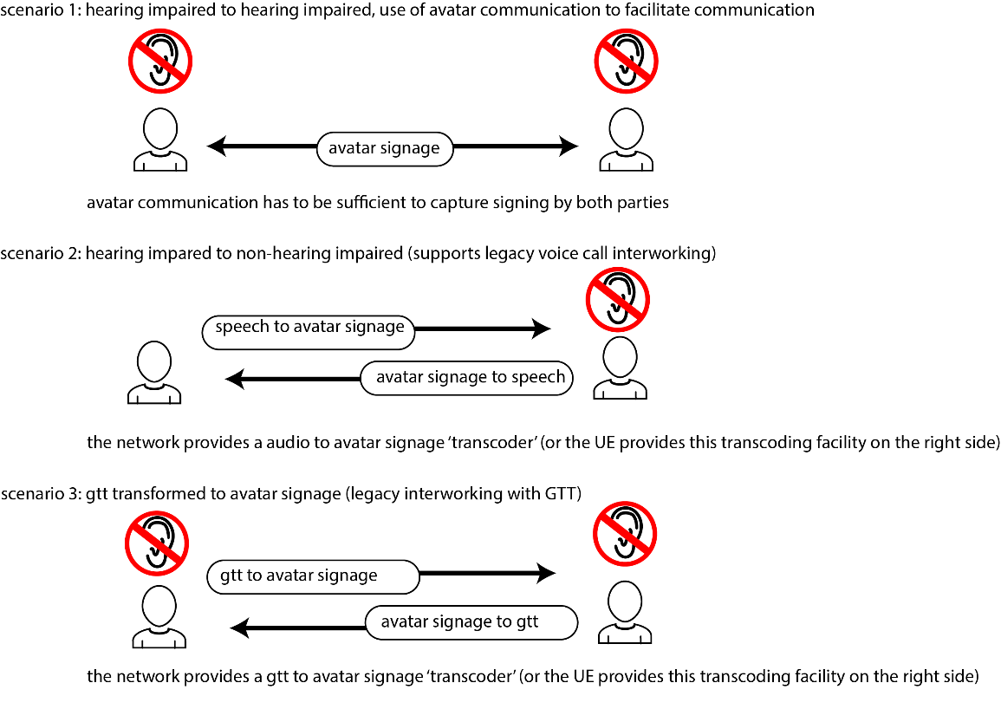

Figure 5.26.1-1: Accessibility Scenarios for IMS 3D Avatar Call

In scenario 1, above, a hearing-impaired user communicates with another using signage. Each user's gestures as well as facial expression and movements are captured by sensors (e.g. these sensors could be part of the terminal equipment) and transformed into an avatar encoding before transmission to the conversational partner. The experience of both parties is natural, and the user experience should resemble that of a video call, albeit with 'idealized lighting and contrast' due to the animation.

In scenario 2, one person speaks while the other signs. The signage of the person on the right is captured as described in scenario 1, but in addition it is analyzed. Research results indicate the likelihood that it will soon be possible to reliably use AI-based programs to capture signage to generate text. [57] It is clear that text to speech is possible. Thus for the user on the left, they can see the person on the right signing and receive an audio rendering of the text they generate.

The speech of the user on the left can be converted to text by means of voice recognition. There is extensive research into text to signage as well as some commercial products already available in this area. It is therefore possible for the user on the right to both see the user on the left speaking, as well as an avatar providing signage, or even an avatar rendering of the user on the left *performing* signage.

In scenario 3, one of the users may not be able to use IMS 3D Avatar call, e.g. they use terminal equipment without this support. In this case, the user on the left enters text and this is rendered as an avatar signing for the user on the right, if this is desired. The user on the right can express herself using signing, which is captured as text (as described for scenario 2) and sent as GTT text media to the user on the left.

One element is currently not possible with text conversion to other media, be it speech or generated avatar media of signage: the timing and emotions expressed in the communication. As part of scenario 3, we consider the possibility of capturing specific text conventions to indicate speech pauses or emotions.

An additional consideration is that the display equipment used to present the IMS 3D Avatar call may either be a UE itself or a separate monitor that the UE is able to use or is available through the display connected another UE, as by Inter-Device Connectivity (a feature of IMS.)

Finally, the possibility to support a communicating user that is 'software generated' is supported well by this use case. In this case, a variant of scenario 2 could be used where the user on the left is in fact an automated customer support centre representative. The computer generated speech is rendered as signage to the user on the right, and the signage of the user on the right is rendered as speech to the software-based customer service party.

### 5.26.2 Pre-conditions

Both communicating parties AeCha, Bharathi and Carlos have a mobile subscription with PLMNs Absolute Telecom (PLMN A) and Benefit Wireless (PLMN B) and Celestial Cellular (PLMN C).

Both Arndt and Berndt have UEs that support sensors capable of capturing their facial expressions and movements as well as gestures sufficiently for this use case. They also are able to set their terminal equipment down so they have free hands (either on a tripod or table, etc.) Carl has a UE that is only capable of voice calls.

### 5.26.3 Service Flows

**Scenario 1: IMS 3D Avatar Call between two callers employing accessibility features and translation**

AeCha calls Bharati. AeCha and Bharati use IMS 3D Avatar Call to communicate through sign language.

AeCha signs using Korean sign language. Bharathi signs using Hindi sign language. There are many forms of sign language in the world that are not mutually comprehensible internationally, and we assume that AeCha and Bharathi would not be able to understand each other's signage directly.

There are a set of services available in the communication channel between AeCha and Bharathi that enable the two of them can communicate.

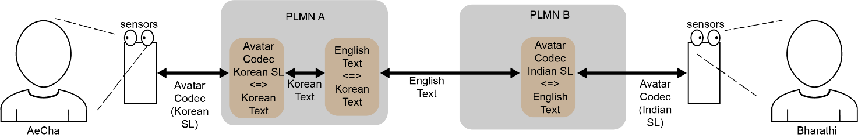

Figure 5.26.3-1: IMS Avatar Call with Services for Signage to Text and Text Translation

AeCha's signing is captured by the sensors and encoded as Avatar Codec, capturing her use of Korean sign language. In the network, the signage is transcoded into Korean text. The Korean text can be translated into English text. This text can then be used to generate Indian Sign Language (shown in the transcoding function in PLMN B).

It is acknowledged that the translation services included in this use case are not exact, however the possibility to communicate directly using signage, and even with the avatar of the corresponding party could be quite valuable.

The avatars seen by AeCha and Bharathi are a representation of the other party, as sufficient information is exchanged by the 5G system to enable the transcoders that produce the avatar codec in PLMN A and PLMN B to do so.

**Scenario 2: IMS 3D Avatar Call and Audio between two callers, with accessibility enhancements**

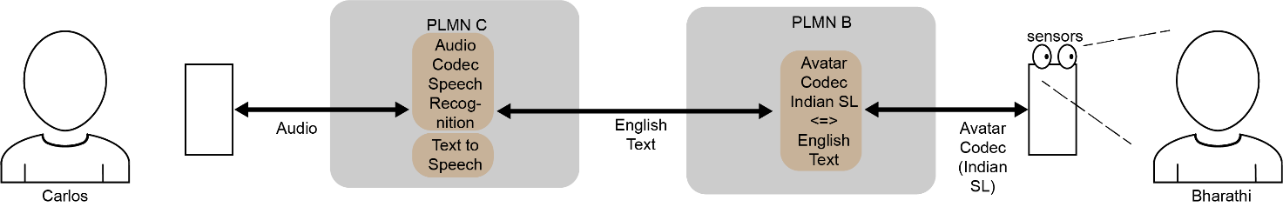

Figure 5.26.3-2: IMS Avatar Call with Services for Signage to Text and Text to Voice

Carlos speaks. His speech is recognized (in a transcoder in PLMN C) and encoded as English Text. This text is transported as media. The text is transcoded (in PLMN B) to Indian sign language encoded in an avatar codec. Bharathi views an avatar signing, using Indian sign language to represent Carlos' speech. The avatar is not a representation of Carlos as there are no sensors capturing Carlos, unless there is a means to configure the transcoder in PLMN B with the avatar information corresponding to Carlos' appearance. This is out of scope of this use case.

Bharathi signs, and this is captured in an Avatar codec that identifies her gestures, facial expression and movements. This is converted to English text in a transcoder function in PLMN B. The English text is sent as media to PLMN C, where a transcoder converts the text to speech. This speech is transported as audio media to Carlos, who hears a synthesized voice expressing the communication that Bharathi signed.

**Scenario 3: IMS 3D Avatar Call and GTT between two callers, with accessibility enhancements**

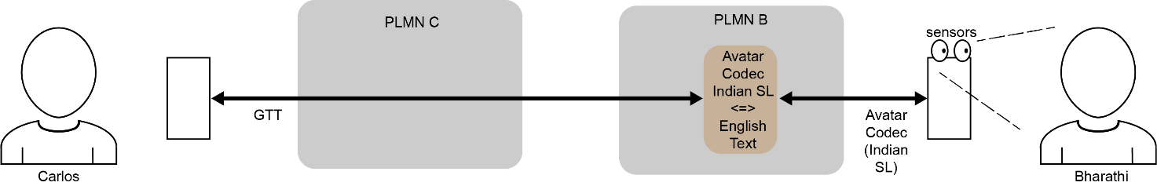

Figure 5.26.3-3: IMS Avatar Call with Services for Signage to Text and Text to Voice

In this scenario, Carlos uses a GTT terminal to supply GTT media uplink. This media is converted in a transcoder to avatar codec representing signing in Indian sign language to Bharathi. The avatar is not a representation of Carlos as there are no sensors capturing Carlos, unless there is a means to configure the transcoder in PLMN B with the avatar information corresponding to Carlos' appearance. This is out of scope of this use case.

Bharathi signs, and this is captured in an Avatar codec that identifies her gestures, facial expression and movements. This is converted to GTT text in a transcoder function in PLMN B. The GTT media is delivered to Carlos, who reads text expressing the communication that Bharathi signed.

### 5.26.4 Post-conditions

In each of three scenarios one or both parties are able to sign and see signage in their native sign language in order to communicate with the other party. The possibility to interwork with legacy GTT terminals and legacy audio terminals is also supported.

### 5.26.5 Existing feature partially or fully covering use case functionality

The 5G system supports IMS which is able to handle diverse media, establish calls and support media codec transcoding services.

The 5G system supports GTT.

### 5.26.6 Potential New Requirements

[P.R.-5.26.6-1] The 5G system shall support the encoding of sensor data capturing the facial expression and movement and gestures of a person, in a standard form, such that as part of the avatar encoding.

[P.R.-5.26.6-2] The 5G system shall support a set of transcoders from and to avatar representations e.g. between text, speech and avatar encoding.

[P.R-5.26.6-3] The 5G system shall support the avatar transcoding functionality to control the appearance of the avatar based on the preferences of its associated user. Examples of the controlled appearance could be for the avatar to express behavior, movement, affect, emotions, etc.

[P.R.-5.26.6-4] The 5G system shall support a set of transcoders to facilitate accessibility of avatar representation from and to GTT to control the appearance of the encoded avatar.

[P.R.-5.26.6-5] The 5G system shall be able to collect charging information for transcoding services associated with IMS-based avatar call.

## 5.27 Use Case on Localized Mobile Metaverse Overload

### 5.27.1 Description

The mobile metaverse offering a location related service experience may reach its limits, as significant resource intensive communication is required to support uplink sensor data and downlink media for each user. In a crowded environment, such as an amusement park, users may want to experience augmented reality in their local environment.

In this use case, Dream Park is a huge theme park in a city. This theme park has been in operation for several decades. The attractions (roller coasters, etc.) are no longer 'new' or 'state of the art.' In order to increase interest for visitors without upgrading the attractions, the owners now provide extensive virtual content for each location in the park. This allows customers to enjoy and experience the theme park’s thrilling rides in exciting new ways and to share the park with all sorts of animated characters and decoration.

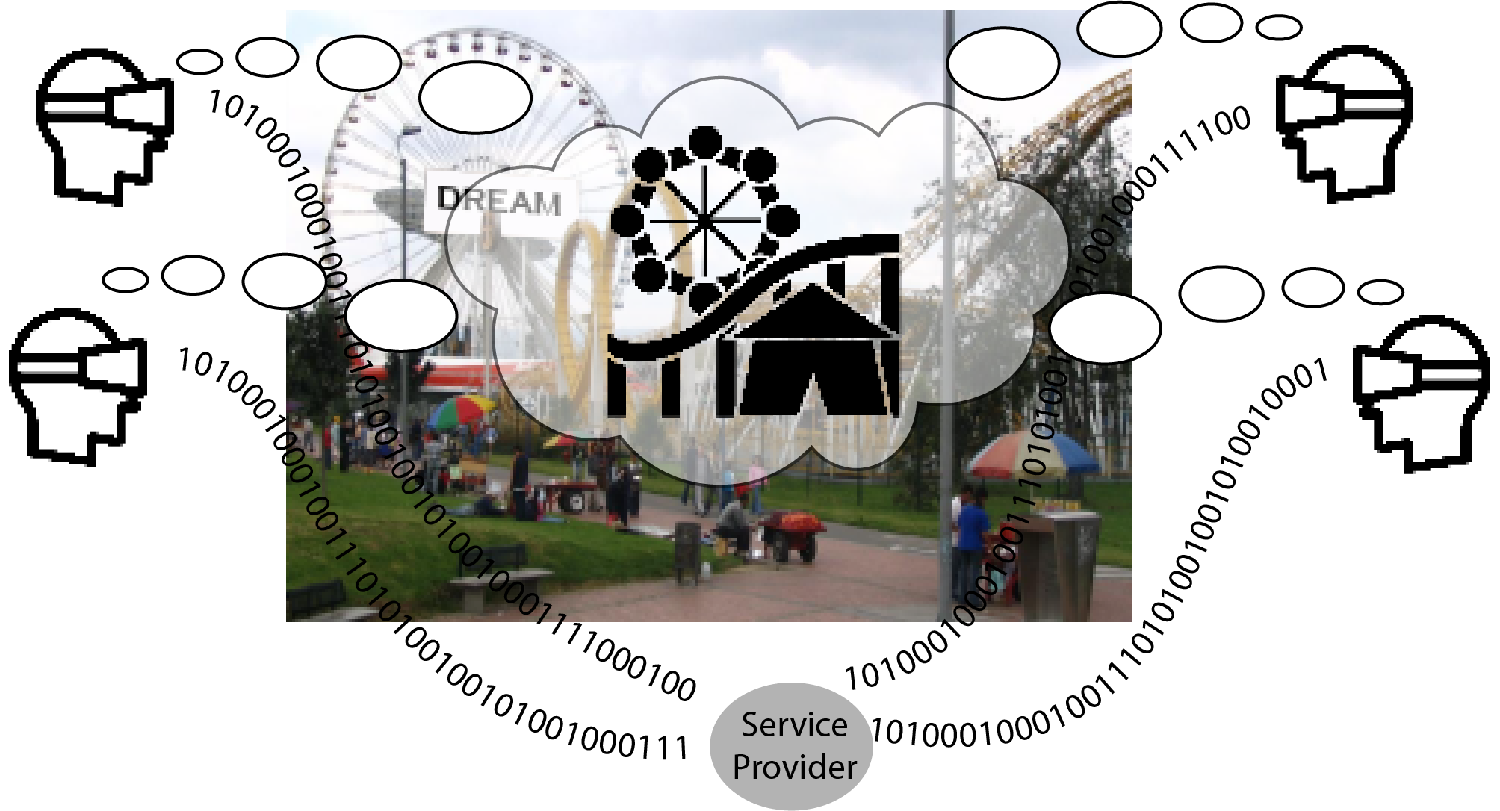

Figure 5.27.1-1: A theme park that offers localized metaverse services

Visitors can select the type of experience they wish. If they do not buy the **premium** **content** they can still enjoy the 'brick and mortar' rides, and *conditionally* (that is, if there is no congestion,) also the premium content. Paid premium users (i.e. users who have purchased tickets to experience special augmented content) can enjoy the premium content *at any time*, even if there is congestion.

NOTE: This aspect of the use case is not further developed. It is assumed that the support of premium content can be supported in different ways using existing mechanisms.

There is **general content** that is provided to all visitors, for example, AR public safety messages and announcements. This class of content needs to be delivered very efficiently so it does not produce congestion, but it is not highly interactive or personalized for the specific viewer. This content still perfectly fits the context in which it is displayed, e.g. at the entrance to buildings or along a pathway.

In a major amusement park in 2019, there were an average of 119,000 visitors a day. The park has 2.023 km2 surface area. The resulting user density is 58,824 visitors per km2.

This use case considers how the 5GS can reasonably provide localized mobile metaverse services (AR that fits the location) even in high user density conditions. We will consider three aspects.

- Support for AR content communicated by mass distribution

Attributions for Figure 5.27.1-1.

|  |
| --- |
| The amusement park icon is available given creative commons license from thenounproject.com:  Amusement park - Created by Lars Meiertoberens from Noun Project AR User, per creative commons.  The amusement park image is available at:  Amusement park image - [Parque Salitre - Amusement park - Wikipedia](https://en.wikipedia.org/wiki/Amusement_park#/media/File:Parque_Salitre.JPG): https://en.wikipedia.org/wiki/Amusement_park#/media/File:Parque_Salitre.JPG as per creative commons license. |

### 5.27.2 Pre-conditions

Ajay and Vijay also have subscriptions with the operator to receive XR multimedia communication service. They both have a mobile subscription to the local operator, Salvo Net.

Ajay has a premium ticket to the amusement park. Vijay has a normal ticket.

Dream Park offers mobile metaverse services to the park visitors by means of communication services from Salvo Net. They have arranged a specific network slice to suit their localized mobile metaverse services.

In this use case we do not assume that all content is 'all or nothing', that is, either one buys a premium ticket and gets the content, or one does not get any premium content at all. If there is *sufficient* *capacity* in the theme park, anyone can access the premium content. This ensure that the park will fill up every day! The availability of 'premium experiences' after a waiting interval gives an incentive to those who visit on weekdays, when there is bad weather, etc.

### 5.27.3 Service Flows

**Support for mass distribution of AR content**

3.1 The amusement park network slice is 'congested' and there is limited access to premium content. Still, in any case there is 'general content' that has to be delivered to all visitors. This includes public safety announcement, so Dream Park considers the delivery of general content to park visitors crucial to support at all times.

3.2 The amusement park's mobile metaverse service requests exposed functionality of Salvo Net to deliver AR content to all visitors by means of efficient multicast or broadcast transmission, even though the density of visitors is very high (e.g. 60,000 per km2).

3.3 Salvo Net distributes the AR content as requested efficiently and avoiding as much as possible further congestion of the amusement park network slice.

### 5.27.4 Post-conditions

As a result of support for mass distribution of AR content is delivered to all users in the park efficiently, even though there is very high user density.

Different mobile metaverse services are delivered to the user simultaneously, i.e. it is not necessary to deliver only one XR content at the same time. It is therefore necessary to ensure that different mobile metaverse servers can synchronize their delivery of content to prevent clashes in the presentation to the user. This is even more important if there are different mobile metaverse servers that produce different components of multi-modal media that has to be delivered to one or more users.

### 5.27.5 Existing features partly or fully covering the use case functionality

The 5G system provides extensive support for mobile broadband communication and multicast and broadcast services.

The 5G system provides a means by which resources can be dedicated to multicast and broadcast services, so that these resources are dedicated, and do not diminish when the network is congested.

The 5G system supports network slices to provide services according to the requirements of customers who deliver services to mobile users.

The 5G system supports a means to support differentiated QoS policy for different subscribers who are using a particular service. The ARP parameter and other mechanisms for response to congestion in the 5G system cannot be set or otherwise influenced by a third party. There is no way for an AF to request a specific ARP be applied to the session.

### 5.27.6 Potential New Requirements needed to support the use case

[PR 5.27.6-1] Subject to operator policy, the 5G system shall support mechanisms to expose functionality to a trusted third party to be able to select subscribers to whom mobile metaverse media can be distributed in a resource efficient manner.

[PR 5.27.6-2] Subject to operator policy, subject to user consent, the 5G system shall support efficient mechanisms to provide resource efficient communication of third party mobile metaverse media to one or more subscribers.

[PR 5.27.6-3] Subject to operator policy, the 5G system shall support a mechanism to enable multiple authorized third parties to synchronize media communications from multiple service data flows delivered to one or more UEs.

[PR 5.27.6.4] The 5G system shall be able to collect charging information associated with distribution of third party mobile metaverse media to one or more subscribers.

[PR 5.27.6.5] Subject to operator policy and regulatory requirements, the 5G system shall support a means by which an authorized third party service provider can request differentiated handling of specific subscribers using the third party's service during network congestion.

## 5.28 Use Case on user identities in a digital asset container

### 5.28.1 Description

To ensure a seamless user experience across metaverse services, network operators offer digital asset management services that allow users to certify certain information, such as IDs. These services support multiple user identities, each representing different aspects of the user's life, such as their professional role and private life. As a result, each user identity may have its own set of information stored in the associated digital asset container, and this information can be managed differently based on the security requirements of the service. For example, the information associated with virtual banking requires a higher level of security in mobile communication due to the sensitive nature of the information, compared to that associated with virtual gaming.

### 5.28.2 Pre-conditions

Bank B offers virtual financial services, e.g. avatar-based calls with financial managers, and the deposit and withdrawal of digital money through its virtual banks.

Mobile Operator T has established service level agreements with Bank B to provide multimedia communication services for virtual banking. Moreover, T provides digital asset management services for its subscribers, and some of this information is associated with the user's activities in Bank B.

Shaun, a senior employee at Bank B, has stored work-related digital assets in his digital asset container, which is supported by Mobile Operator T. This information includes his work ID, which is used to access Bank B's confidential database, and professional-looking avatar (dressed in a suit with Bank B’s watermark). Additionally, Shaun's digital asset container holds other digital assets for his private life, such as a cartoon avatar. Recognizing the importance of data security, Shaun restricts his access to work-related information in selected locations, such as when he is physically in the office.

### 5.28.3 Service Flows

1) Shaun registers with T by a UE that has a subscription with T. During his commute, he buys some digital clothes for his avatars in a virtual shop, which are then stored in his digital asset container.

2) Shaun arrives at his office. Having been authenticated by T and bank B, he initials a multimedia session with a customer. During the session, he uses his work ID to access the customer’s digital safe deposit box managed by B.

3) B assigns Shaun a new work ID as he obtains permission to highly sensitive business information of B.

4) Shaun requests to update his work ID in the digital asset container.

5) With T confirming his presence in the office building, Shaun is able to successfully update his work ID.

### 5.28.4 Post-conditions

Shaun is able to access highly confidential information using his updated work ID when he is in the office.

### 5.28.5 Existing features partly or fully covering the use case functionality

The functional requirements for user identity are captured in TS 22.101 clause 26a [4].

### 5.28.6 Potential New Requirements needed to support the use case

[PR 5.28.6-1] The 5G system shall be able to associate information with user identities in the digital asset container for a user.

[PR 5.28.6-2] Subject to operator policy, the 5G system shall be able to support users to define conditions (e.g. based on user location information) to restrict the access to, and management of, digital assets associated with user identities.

# 6 Considerations

The task of determining impacts on regulatory services is difficult, as work on metaverse services is still being defined. Furthermore, regulations and policies related to metaverse services are still being defined in various regions. It is expected that the 5G system will meet regional/national regulatory rules and operator policy when supporting the use of metaverse services.

# 7 Consolidated potential requirements and KPIs

## 7.1 Consolidated potential requirements

### 7.1.1 Localized Mobile Metaverse Service Functionality

Table 7.1.1-1 – Localized Mobile Metaverse Service Functionality Consolidated Requirements

|  |  |  |  |
| --- | --- | --- | --- |
| CPR # | Consolidated Potential Requirement | Original PR # | Comment |
| [CPR 1.1] | Subject to operator policy, the 5G system shall provide a means to define and expose to a third party a spatial anchor, i.e. an association between a physical location (a point or volume in three dimensional space) and service information.  NOTE: Service information can include information to enable users to discover and access services, e.g. type of service, URLs, configuration data, the distance between the user and the spatial anchor, etc. | [PR 5.1.6-1]  [PR 5.1.6.2]  [PR 5.1.6.3]  [PR 5.4.6-2] |  |
| [CPR 1.2] | Subject to operator policy, the 5G system shall enable an authorized third party to request the information associated with a specific spatial anchor.  NOTE: How the service and location information is used by the third party to access a mobile metaverse server and the AR media itself is out of scope of this requirement. | [PR 5.4.6-4] |  |
| [CPR 1.3] | Subject to operator policy, the 5G system shall provide an authorized third party a means to define authorization to access spatial anchor information and to manage the spatial anchor(s), e.g. add, remove or modify spatial anchors. | [PR 5.4.6-5] |  |
| [CPR 1.4] | Subject to operator policy, user consent and regulatory requirements, the 5GS shall provide a means for a UE to provide sensor data, (e.g. from UE sensors, cameras, etc.) to the UE's serving network in order to derive localization information, e.g. to produce or modify a spatial map or discover or find localized mobile metaverse services. | [PR 5.5.6.1-1]  [PR 5.5.6.1-2]  [PR 5.5.6.2-2]  [PR 5.5.6.2-3] |  |
| [CPR 1.5] | Subject to operator policy and regulatory requirements, the 5GS shall support mechanisms to expose a spatial map or derived localization information to authorized third parties. | [PR 5.5.6.1-3] |  |

### 7.1.2 Digital representation of users and avatar functionality

Table 7.1.2-1 – Digital representation of users and avatar functionality Consolidated Requirements

|  |  |  |  |
| --- | --- | --- | --- |
| CPR # | Consolidated Potential Requirement | Original PR # | Comment |
| [CPR 2.1] | The 5G system shall support 5G CN to provide real-time feedback in support of conversational XR communication among multiple users simultaneously.  NOTE: The feedback can include information such as network condition, achieved QoS. Such information can be used by the IMS, for example, to trigger the codec negotiation. | [PR 5.3.6.2-1] |  |
| [CPR 2.2] | Subject to user consent, the 5G system (including IMS) shall support multimedia conversational communications between two or more users including transfer of real time avatar media and audio media.  NOTE 1: Avatar media can be transmitted on both uplink and downlink.  NOTE 2: Confidentiality of the data used to produce the avatar (e.g. from the UE cameras, etc.) is assumed. | [PR 5.11.6-1]  [PR 5.22.6-1]  [PR 5.11.6-2]  [PR 5.11.6-3] |  |
| [CPR 2.3] | Subject to user consent, the 5G system (including IMS) shall support change of media types between video and avatar media for parties of a multimedia conversational communication. | [PR 5.11.6-4] |  |
| [CPR 2.4] | The 5G system (including IMS) shall support transcoding between media such as text, GTT, video and avatar media in multimedia conversational communications.  NOTE 1: Text, video or other media could allow a party to control the appearance of its avatar, e.g. to express behaviour, movement, affect, emotions, etc.  NOTE 2: The transcoding of media enables avatar communication, e.g. in scenarios in which UE participating in an IMS call or other service does not support e.g. FACS, encoding avatar media, generating avatar media, etc. | [PR 5.11.6-5]  [PR 5.26.6-2]  [PR 5.26.6-3]  [PR 5.26.6-4] |  |
| [CPR 2.5] | Subject to regulatory requirements, user consent and operator policy, the 5G system (including IMS) shall support the capabilities of rendering the avatar based on the body movement information (e.g. body motion or facial expression) of a human user. | [PR 5.16.6.2-6] |  |
| [CPR 2.6] | The 5G system (including IMS) shall support the encoding of sensor data capturing the facial expression and movement and gestures of a person, in a standard form.  NOTE: The actual transmission and rendering of facial expression and movement and gestures of a person within a multimedia conversational communication is subject to that person’s consent. | [PR 5.26.6-1]  [PR 5.16.6.2-5]  [PR 5.16.6.2-6] |  |

### 7.1.3 Operational efficiency, exposure, and coordination of mobile metaverse services

Table 7.1.3-1 – Operational efficiency, exposure, and coordination of mobile metaverse services Consolidated Requirements

| CPR # | Consolidated Potential Requirement | Original PR # | Comment |
| --- | --- | --- | --- |
| [CPR 3.1] | Subject to operator policy, the 5G system shall support a mechanism that enables flexible adjustment of communication services based on e.g. the type of devices (e.g., wearables), or communication duration (e.g. more than one hour), such that the services can be operated with reduced energy utilization.  NOTE: Metaverse service experience over an extended period of time (e.g. 2h) requires significant power consumption by the UE. In some cases, a device with no external power supply cannot sustain downloading and rendering of media over a long interval, e.g. for the duration of an entire feature film or athletic event. | [PR 5.7.6-1]  [PR 5.7.6-2] |  |
| [CPR 3.2] | The 5G system shall be able to provide a means to associate and coordinate data flows related to one or multiple UEs e.g. associated with the same object in digital twin applications provided by the mobile metaverse service. | [PR 5.20.6-1]  [PR 5.20.6-2]  [PR 5.20.6-3] |  |
| [CPR 3.3] | Subject to operator policy, regulatory requirements and user consent, the 5G system shall be able to expose network performance information (e.g., observed or predicted bitrate, latency or packet loss) related to one or more users to an authorized third party metaverse application.  NOTE: The network performance information can be per UE and take into account all available access network types, i.e. 3GPP and non-3GPP. | [PR 5.25.6-1]  [PR 5.9.6.2] |  |
| [CPR 3.4] | Subject to operator policy, the 5G system shall support a mechanism to enable one or more authorized third party(ies) to coordinate multiple service data flows delivered to/from one or more UE(s). Multiple UEs may be associated with one user/location or different users at different locations potentially using different access networks, i.e. 3GPP and non-3GPP.  NOTE 1: Coordination refers to the ability to provide an acceptable level of user experience for a given service, e.g. based on latency and synchronization constraints (due to multiple sources or long distance between UEs/users).  NOTE 2: It is not assumed that it is always possible to coordinate and provide the same capabilities regardless of whether 3GPP or non-3GPP access is used. | [PR 5.27.6-3]  [PR 5.9.6.1]  [PR 5.3.6.2-4]  [PR 5.25.6-2]  [PR 5.10.6-2] |  |
| [CPR 3.5] | The 5G system shall enable the coordination of diverse media, transmitted to a UE from one or more mobile metaverse services associated with a physical location, to be combined to form a localized service experience. | [PR 5.1.6-4]  [PR 5.4.6-1] |  |
| [CPR 3.6] | Subject to operator policy, the 5G system shall support exposure mechanisms enabling an authorized third party to determine one or more subscribers to whom mobile metaverse media can be distributed in a resource efficient manner. | [PR 5.27.6-1] |  |
| [CPR 3.7] | Subject to operator policy, subject to user consent, the 5G system shall support a means to provide resource efficient communication of third party mobile metaverse media to one or more subscribers. | [PR 5.27.6-2] |  |

### 7.1.4 Security and Privacy aspects of mobile metaverse services

Table 7.1.4-1 – Security and Privacy aspects of mobile metaverse services Consolidated Requirements

|  |  |  |  |
| --- | --- | --- | --- |
| CPR # | Consolidated Potential Requirement | Original PR # | Comment |
| [CPR 4.1] | Subject to regulatory requirements, operator policies and user consent, the 5G system shall be able to support mechanisms to expose to a trusted third party (e.g. the conference focus) the result of the UE authenticating the user.  NOTE: How a UE authenticates the user's identity at the terminal equipment, e.g. using biometrics, is out of 3GPP scope. | [PR 5.3.6.2-2] |  |
| [CPR 4.2] | Subject to operator policy, user consent and regulatory requirements, the 5GS shall support mechanisms to authorize Spatial Localization Service. | [PR 5.5.6.2-1] |  |
| [CPR 4.3] | Subject to regulatory requirements, user consent and operator policy, the 5G system shall be able to authorize the avatar to be used in mobile metaverse services. | [PR 5.24.6-2] |  |
| [CPR 4.4] | Subject to regulatory requirements, user consent and operator policy, the 5G system shall provide time-bound authorization services for an avatar to be used in mobile metaverse services. | [PR 5.24.6-3] |  |

### 7.1.5 Digital Asset Management

Table 7.1.5-1 – Digital Asset Management Consolidated Requirements

|  |  |  |  |
| --- | --- | --- | --- |
| CPR # | Consolidated Potential Requirement | Original PR # | Comment |
| [CPR 5.1] | Subject to user consent, operator policy, and regulatory requirements, the 5G system shall be able to provide functionality to store digital assets associated with a user, and to remove such digital assets associated with a user. | [PR 5.13.6-1]  [PR 5.15.6-1]  [PR 5.16.6.2-1]  [PR 5.14.6-2] |  |
| [CPR 5.2] | Subject to user consent, operator policy, and regulatory requirements, the 5G system shall provide a means to allow a user to securely access and update their digital assets. | [PR 5.13.6-1]  [PR 5.15.6-1]  [PR 5.16.6.2-1] |  |
| [CPR 5.3] | Subject to user consent, the 5G system shall be able to allow a trusted third party to retrieve the digital asset(s) associated with a user, e.g. when the user accesses a specific application.  NOTE: When a user accesses an immersive mobile metaverse service, the authorized third party (service provider) could obtain relevant digital assets of a user associated with that service. | [PR 5.13.6-2]  [PR 5.15.6-3]  [PR 5.14.6-1]  [PR 5.15.6-2] |  |
| [CPR 5.4] | Subject to regulatory requirements and operator policy, the 5G system shall provide secure means to authorize the use of digital assets associated with a user (e.g. digital assets belonging to a third party customer). | [PR 5.16.6.2-2]  [PR 5.13.6.5] |  |
| [CPR 5.5] | The 5G system shall provide mechanisms to certify the authenticity of the digital assets associated with a user. | [PR 5.13.6-4] |  |

### 7.1.6 Charging requirements for mobile metaverse services

Table 7.1.6-1 – Consolidated Requirements on charging for mobile metaverse services

|  |  |  |  |
| --- | --- | --- | --- |
| CPR # | Consolidated Potential Requirement | Original PR # | Comment |
| [CPR 6.1] | The 5G system shall be able to collect charging information for the actions related to spatial anchors, where a third party creates, deletes or modifies a spatial anchor or associated service information.  NOTE: It is assumed that exposure of network anchors and associated service information can be a service provided by a network operator to third parties. | [PR 5.4.6-6]  [PR 5.4.6-7] |  |
| [CPR 6.2] | The 5G system shall support the collection of charging information associated with the exposure of a spatial map or derived localization information to authorized third parties. | [PR 5.5.6.1-4] |  |
| [CPR 6.3] | The 5G system shall support the collection of charging information associated with the production or modification of a spatial map on behalf of an authorized third party. | [PR 5.5.6.1-5] |  |
| [CPR 6.4] | The 5G system shall support the collection of charging information associated with exposing spatial location service information to authorized third parties. | [PR 5.5.6.2-4] |  |
| [CPR 6.5] | The 5G system shall support collection of charging information associated with initiating and terminating avatar call. | [PR 5.11.6-6] |  |
| [CPR 6.6] | The 5G system shall be able to collect charging information for transcoding services associated with avatar call. | [PR 5.26.6-5] |  |
| [CPR 6.7] | The 5G system shall be able to collect charging information associated with distribution of third party mobile metaverse media to one or more subscribers. | [PR 5.27.6.4] |  |
| [CPR 6.8] | The 5G system shall be able to collect charging information per UE or per application, related to the use of digital assets associated with a user (e.g. typically a human user with a certain subscription). | [PR 5.16.6.2-3]  [PR 5.16.6.2-4] |  |
| [CPR 6.9] | The 5G system shall be able to collect charging information per UE for managing the digital assets associated with a user (e.g. typically a human user with a certain subscription) or a third party.  NOTE: A third party who has digital assets could be an enterprise customer having service level agreement with the operator. | [PR 5.16.6.2-3] |  |

## 7.2 Consolidated potential KPIs

|  |  |  |  |  |  |  |  |  |  |  |
| --- | --- | --- | --- | --- | --- | --- | --- | --- | --- | --- |
| Use Cases | Characteristic parameter (KPI) | | | | Influence quantity | | | | | Remarks |
| Max allowed end-to-end latency | Service bit rate: user-experienced data rate | Reliability | Area Traffic capacity | Message size (byte) | Transfer Interval | Positioning accuracy | UE Speed | Service Area |
| 5G-enabled Traffic Flow Simulation and Situational Awareness  (NOTE 2) | [5-20] ms (NOTE 1) | [10~100 Mbit/s]  [25]  (NOTE 6) | > 99.9% | [~39.6 Tbit/s/km2 ]  (NOTE 5) | - | 20~100 ms  (NOTE 3) | - | < 250 km/h | City or Country wide  (NOTE 4) | UL |
| Collaborative and concurrent engineering | [≤10] ms  [14]  (NOTE 7) | [1-100] Mbit/s  [14] | [> 99.9%]  [14] | [1.55] Tbit/s/km2  (NOTE 8) | Video: 1500  Audio: 100  [14] | - | - | Stationary or Pedestrian | typically  < 100 km2  (NOTE 9) | UL and DL audio/video |
| [5] ms UL  [1-50] ms DL  [14]  (NOTE 7) | [<1] Mbit/s  [14] | [> 99.9%] (without compression)  [> 99.999%] (with compression (NOTE 10))  [26] | [2.25] Tbit/s/km2  (NOTE 8) | 1 DoF: 2-8  3 DoFs: 6-24  6 DoFs: 12-48  [14] | 0.25-10 ms  [14] |  |  |  | UL and DL haptic feedback |
| Metaverse-based Tele-Operated Driving  (NOTE 16) | [100] ms [25] (NOTE 11) | [10~50 Mbit/s] [25] | 99% [25] | [~360 Mbit/s/km2 ]  (NOTE 14) | - | 20~100 ms [25]  (NOTE 12) | [10] cm [25] | [10-50] km/h (vehicle) [25]  Stationary/Pedestrian (user) | Up to 10km radius [25]  (NOTE 13) | UL real-time vehicle data (video streaming and/or sensor data) [25] |
| [20] ms [25] | [0.1~0.4 Mbit/s] [25] | 99,999% [25] | [~4 Mbit/s/km2 ]  (NOTE 14) | Up to 8Kb  [25] | 20 ms [25]  (NOTE 12) | [10] cm [25] | [10-50] km/h (vehicle) [25]  Stationary/Pedestrian (user) | Up to 10km radius [25]  (NOTE 13) | DL control traffic (commands from the remote driver) [25]. |
| 1-20ms  (NOTE 15) | 16 kbit/s -2 Mbit/s  (without haptic compression encoding);  0.8 - 200 kbit/s  (with haptic compression encoding)  (NOTE 15) | 99.999%  (NOTE 15) | [~20 Mbit/s/km2 ]  (NOTE 14) | 2-8 (1 DoF) (NOTE 15) |  |  | Stationary/Pedestrian (user) | Up to 10km radius [25]  (NOTE 13) | Haptic feedback |
| NOTE 1: The mobile metaverse server receives the data from various sensors, performs data processing, rendering and provide feedback to the vehicles and users. The end-to-end latency refers to the transmission delay between a UE and the mobile metaverse server.  NOTE 2: Examples of typical data volume including 1) camera: 10 Mbit/s per sensor (unstructured), 2) LiDAR: 90 Mbit/s per sensor (unstructured), 3) radar: 10 Mbit/s per sensor (unstructured), and 4) real-time Status information including Telemetry data: [< 50 kbit/s] per sensor/vehicle/VRU (structured). This is to support at least 80 vehicles and 1600 users present at the same location (e.g. in an area of 40m*250m) to actively enjoy immersive metaverse services for traffic simulation and traffic awareness, the area traffic capacity is calculated considering 2 cameras, 2 Radars, 2 LiDARs on road side, 1600 user’s smart phones and 80 vehicles with 7 cameras, 4 radar and 2 LiDAR for each vehicle.  NOTE 3: The frequency considers different sensor types such as Radar/LiDAR (10Hz) and camera (10~50Hz).  NOTE 4: The service area for traffic flow simulation and situational awareness depends on the actual deployment, for example, it can be deployed for a city or a district within a city or even countrywide. In some cases a local approach (e.g. the application servers are hosted at the network edge) is preferred in order to satisfy the requirements of low latency and high reliability.  NOTE 5: The calculation is this table is done per one 5G network, in case of N 5G networks to be involved for such use case in the same area, this value can be divided by N.  NOTE 6: User experienced data rate refers to the data rate needed for the vehicle or human, the value is observed from industrial practice.  NOTE 7: The network based conference focus is assumed, which receives data from all the participants, performs rendering (image synthesis), and then distributes the results to all participants. The latency refers to the transmission delay between a UE and the application server. As rendering and hardware introduce some delay, the communication delay for haptic feedback is typically less than 5ms.  NOTE 8: To support at least 15 users present at the same location (e.g. in an area of 20m*20m) to actively enjoy immersive Metaverse service concurrently, the area traffic capacity is calculated considering per user consuming non-haptic XR media (e.g. for video per stream up to 40000 kbit/s) and concurrently 60 haptic sensors (per haptic sensor generates data up to 1024 kbit/s).  NOTE 9: In practice, the service area depends on the actual deployment. In some cases a local approach (e.g. the application servers are hosted at the network edge) is preferred in order to satisfy the requirements of low latency and high reliability.  NOTE 10: The arrival interval of compressed haptic data usually follow some statistical distributions, such as generalized Pareto distribution, and Exponential distribution [26].  NOTE 11: The end-to-end latency refers to the transmission delay between a UE and the mobile metaverse server or vice-versa, not including sensor acquisition or actuator control on the vehicle side, processing, and rendering on the user side (estimated additional 100ms total). Target e2e user experienced max delay depends on reaction time of the remote driver (e.g. at 50km/h, 20ms means 27cm of remote vehicle movement).  NOTE 12: UL data transfer interval around 20ms (video) to 100ms (sensor), DL data transfer interval (commands) around 20ms.  NOTE 13: The service area for teleoperation depends on the actual deployment; for example, it can be deployed for a warehouse, a factory, a transportation hub (seaport, airport etc.), or even a city district or city. In some cases, a local approach (e.g., the application servers are hosted at the network edge) is preferred to satisfy low latency and high-reliability requirements.  NOTE 14: The area traffic capacity is calculated for one 5G network, considering 4 cameras + sensors on each vehicle. Density is estimated to 10 vehicles/km2, each of the vehicles with one user controlling them. [25]  NOTE 15: KPI comes from [5] clause 7.11 “remote control robot” use case.  NOTE 16: Examples of typical data volume including 1) ~8Mbps video stream. Four cameras per vehicle (one for each side): 4*8=32Mbps. 2) sensor data (interpreted objects), assuming 1 kB/object/100 ms and 50 objects: 4 Mbps [25]. | | | | | | | | | | |

# 

# 8 Conclusion and recommendations

The present document has analyzed a number of use cases for Mobile Metaverse Services enabled by the 5G system.

Clause 7 contains consolidated requirements and KPIs. It is recommended that these be specified in normative specifications.

Annex A (informative):  
Avatar Service Considerations

The term Avatar originated in writings associated with Hindu religion, referring to an incarnation of a divine being on Earth, significantly Vishnu.

In computing an avatar is a graphical representation of a user or user’s character or persona. [Wikipedia-Avatar] The term was used to describe the player’s character in a number of games in the late 1970s into the late 1980s. In 1992, Neal Stephenson used the term to describe virtual simulation of the human form in his novel Snow Crash, in which he also coined the term metaverse. [2]

Avatars are used in a number of ways today, besides as digital representations of characters in video games. The representation is often thought to be one to one (one person is represented by one digital representation), but this cannot be generalized. Some people are represented in multiple ways (especially over time), some groups use an avatar to represent them, sometimes programs or automated services are represented with an avatar (and these aren't human users at all.) In most applications, people can choose their own avatars and they may change these frequently, even adopting the avatars of other users if there is no policy to prevent this.

Avatars may serve as a digital representation of a user in Internet forums. These are often a kind of cartoon version of a person’s face or an image representing them, often. For example, this is an avatar on Boardgamearena.com, for a community member known as “tree mile.”



Figure A-1: Avatar as Iconic User Representation

This digital representation is static (that is, it is generally not animated,) and serves to provide a user with a memorable and unique personality in the on-line forum, but without divulging my actual appearance. This is a common use on social media platforms.

A social forum, in which avatars are remote controlled, animated. An early example of this was SecondLife. [Linden Lab] This is an example group of avatars in discussion.

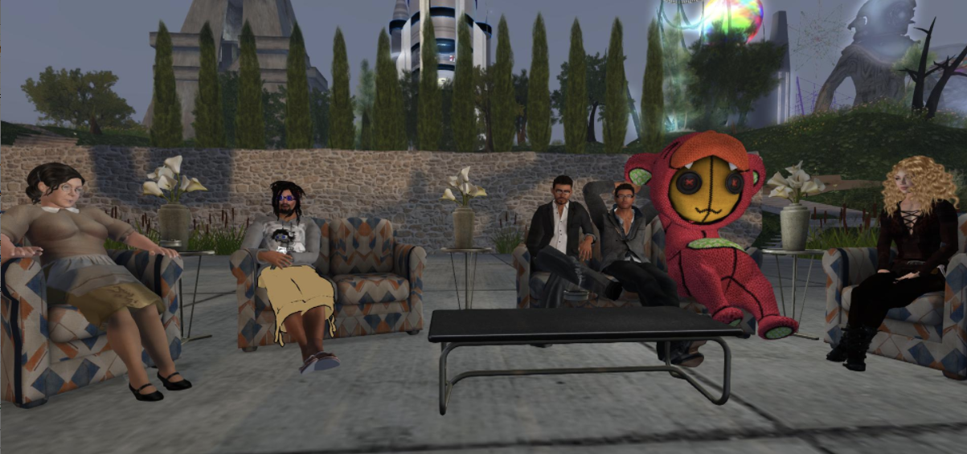

Figure A-2: Avatar as Animated User Representation

This platform does not feature a ‘game.’ Rather players interact, build things, share information, purchase virtual accoutrements. Some institutions built an on-line virtual presence, such as universities, private corporations even political parties to enable interaction between users represented as avatars.

Avatars have been used as a way to improve interaction between people using software or accessing on-line services and software. An example is “Clippy” a paperclip ‘help feature’ in Microsoft Office 97.

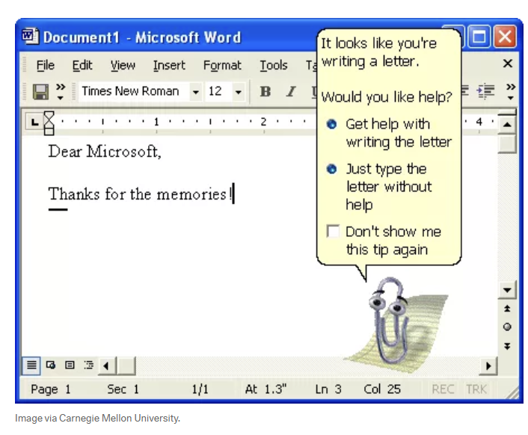

Figure A-3: Avatar as Animated Interactive Automaton

There are many other such digital representations that are used, e.g. for on-line chat services for service desks, etc.

Motion capture / animated avatars are used to stand in for a person. They model and reproduce or mimic the user’s movements, facial expressions and often represent specific facial animation for ‘talking’ in a way reminiscent of cartoons. One area where this has developed is a kind of content production by ‘vtuber’ contributors. Tools to create avatars (vtube animation software) can be coupled with motion capture software to allow contributors to generate video content in the form of animation. The creator is represented by media generated by means of a model and cameras. Sound can be added or recorded along with the video input.

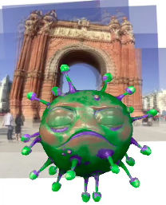

Figure A-4: Avatar Live Animation Generated from Camera and Microphone Input

A ‘live’ social media application can be designed around the techniques of animation and visual capture (as in the previous bullet) can provide an opportunity for users to communicate as cartoon digital representations of themselves with encoding and presentation in real-time. The communicating partner may be a human user or a ‘bot.’ Generally ‘chatbot’ services do not include such an animated figure – an icon or static image is used to represent the AI.  
  
A sophisticated ‘video capture,’ then transformation into a cartoon form with audio, and rendering this into media, is a very computationally intense task. There are many tools to create avatars and vtube video clips, however these are generally not ‘live.’ Figure A-5 presents ‘Kizuna AI’ a pioneering successful Vtuber personality. The media featuring these avatars is generated through tools that often involve animation editing and audio visual production operations. Pure animation techniques can be enhanced with motion capture and facial expression capture.



Figure A-5: Kizuna AI – an avatar celebrity

References

[Wikipedia-Avatar] <https://en.wikipedia.org/wiki/Avatar_(computing)>

[Stephenson] Stephenson, Neal “Snow Crash,” Bantam Books, New York, 1992.

[Linden Lab] https://secondlife.com/

Annex B (informative):  
The EU Digital Identity Wallet Initiative

**The European Commission** intends to establish a sovereign digital/digital identity as part of its digital transformation strategy[B.2].

This digital identity [[B.1](https://ec.europa.eu/info/strategy/priorities-2019-2024/europe-fit-digital-age/european-digital-identity_en)] will allow by 2030 the citizens of the union to authenticate themselves to the main public services (or to some services of non-public companies), using a "wallet". This wallet will be an application that will store (in a secure way) a certain number of data and certified documents (identity card, driving license, certificates of personal qualities - like the majority -) in order to share them with the relevant services (e.g. school registration) securely. These solutions shall be compatible in all European countries.

“Every time an App or website asks us to create a new digital identity or to easily log on via a big platform, we have no idea what happens to our data in reality. That is why the Commission will propose a secure European e-identity. One that we trust and that any citizen can use anywhere in Europe to do anything from paying your taxes to renting a bicycle. A technology where we can control ourselves what data is used and how."[B.1]

The EU Digital ID Wallet [B.1] is intended to allow European citizens to safely save their documents and personal information in a manner that complies with privacy regulations, as well as to give the data owners full control how the data is used (who can access it), and to track how it has been used.

The information stored in the wallet could have general utility in many circumstances, even outside of the country in which the information was issued. Examples given are driver's licenses, medical records or certification such as university degree titles.

It is acknowledged that people need to establish their identity in many ways. This process is currently complex, as each activity requires different credentials and as the form of credentials vary, identification requires different process. Having a single digital identity wallet will simplify these processes.

The goal of the program is to bring the following benefits:

- To support the ability of every person eligible for a national ID card to have a digital identity that is recognized anywhere in the EU;

- To provide a simple and safe way to control how much information you want to hsare with services that require the sharing of information;

- To allow mobile phone apps and other devices to support a means to

- provide identity services on- and off-line;

- store and exchange information provided by governments, e.g. name, surname, date of birth, nationality;

- to use information as confirmation ofthe right to reside, work, or study in a particular member state.

Today only 60% of the EU population in 14 Member States are abile to use their national electronic ID (eID) beyond their own country. Only 14% of key public service providers across all Member states allow cross-border authenticaiton with an eID system, e.g. to prove a person's identity as part of authentication with a service accessed by means of the Internet without the need of a password.There are many situations where such identity information is needed, mainly during interaction with the government. For example, filing tax returns, changing one's address. Many other activities require identification, e.g. opening a bank account, renting a car, checking into a hotel, applying for a bank loan, etc.

Various aspects of the intiative are of general interest for services offered over the internet, including:

- Qualification of web sites and services, to ensure they are trustworthy and reliable. This could (partially) address threats such as phishing and illegitimate services;

- An electronic signature framework, to express agreement to the content of a document;

- A means to demonstrate that a set of data existed at a specific time, e.g. that a bill or fine was paid on time;

- A 'seal of authenticity' that can be attached to digital content, such as football tickets, to avoid counterfeit in the digital domain.

While the digital wallet initiative is specific to Europe, the ideas behind it may be generally applicable. That is, to encourage and ease e-commerce, e-government and provide users with control over how their data is accessed, a digital wallet approach may have applicability and value in a broader international context.

Use Case Example: The use cases presented include identification on public websites, but also for banking or medical services, education, mobility, etc. It generally involves making life easier for citizens and businesses by producing a framework of trust in the exchange of identity papers without the need for verification by physical meeting.

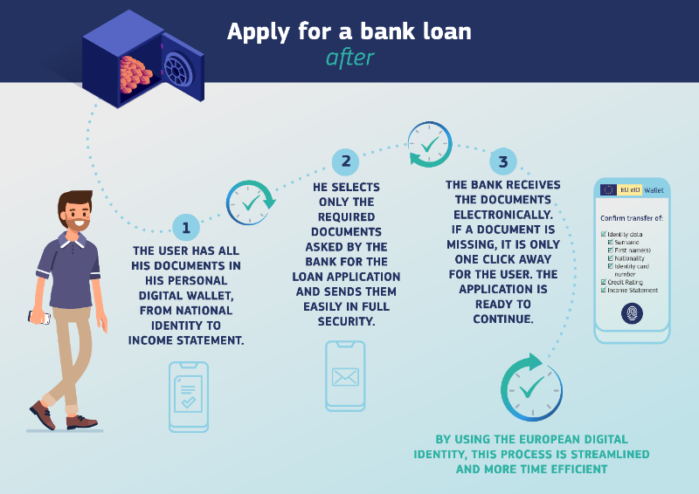

Figure Annex B-1: Example of use, applying for a bank loan [B.3]

Benefits for the citizen:

- Easy to identify itself

- Management of identity information storage and usage permissions

Benefits for businesses:

- User-friendliness and compliance with user identification legislation.

- Reduction in 'business integration requirements' for services, that currently has to contend with diverse documents and processes.

## References

In mid-February 2022, a call for projects for the implementation of solutions and experimentation was launched <https://ec.europa.eu/info/funding-tenders/opportunities/docs/2021-2027/digital/wp-call /2022/call-fiche_digital-2022-deploy-02_en.pdf>, accessed 24.10.22.

The "toolbox" defining the APIs and data schemas should be finalized by the end of 2022. The architecture of the technical solutions, such as the centralized or decentralized orientation, are not defined to date.

[B.1] Quote from Ursula von der Leyen, President of the European Commission, in her State of the Union address, 16 September 2020, <<https://ec.europa.eu/info/strategy/priorities-2019-2024/europe-fit-digital-age/european-digital-identity_en>>, accessed 24.10.22.

[B.2] <https://ec.europa.eu/info/strategy/priorities-2019-2024/europe-fit-digital-age/shaping-europe-digital-future_en>

[B.3] The figure is from <https://ec.europa.eu/info/strategy/priorities-2019-2024/europe-fit-digital-age/european-digital-identity_fr>, accessed 24.10.22.

Annex C (Informative):  
Traffic Characteristics of Metaverse Media Communication

|  |  |  |  |
| --- | --- | --- | --- |
| Use Cases | Device/Terminal Type Example | Data Rate | Traffic Characteristics |
| Localized Mobile Metaverse Service Use Case | AR capable glasses tethered to a UE | - | * Data transmission in short duration |
| Mobile Metaverse for 5G-enabled Traffic Flow Simulation and Situational Awareness | UE (different types, e.g., pedestrians, sensors) | [10-100Mbit/s] | * Data transmission in long duration * This use case motivates energy efficient content delivery to and from the UE, especially for pedestrians by using mobile phone |
| Collaborative and Concurrent Engineering in Product Design using Metaverse Services | XR devices, mobile phones, computers | [1-100Mbit/s] | * Data transmission in long duration * This use case motivates energy efficient content delivery to and from the UE |
| Spatial Anchor Enabler Use Case | AR glasses | - | * Data transmission in short duration |
| Spatial Mapping and Localization Service Enabler Use Case | UE | - | * Data transmission in short duration |
| Mobile Metaverse for Immersive Gaming and Live Shows | VR/AR/MR/Cloud Gaming mobile devices, such as mobile headsets or other haptic mobile devices, | [1-1000Mbit/s] | * Data transmission in long duration * This use case motivates energy efficient content delivery to and from the UE |
| AR Enabled Immersive Experience | AR glasses | [200-2000Mbit/s] | * Data transmission in long duration * This use case motivates energy efficient content delivery to and from the UE * Detailed discussion on energy utilization may be needed |
| Supporting Multi-service Coordination in One Metaverse | VR glasses, Tactile gloves | - | * Sustained diverse data transmission in long duration * This use case may motivate energy efficient content delivery support depending on the data transmission (uplink and downlink). |
| Synchronized predictive avatars | Metaverse devices | - | * Data transmission in long duration * This use case may motivate energy efficiency content delivery to and from the UE |
| Use Case on Metaverse for Critical HealthCare Services | Head mount device, tactile glove | [1-100Mbit/s] | * No requirement because it is life critical, it is assumed that a sufficient power supply exists to support an adequately long service life. |
| IMS-based 3D Avatar Communication | UE | - | * Data transmission in long duration with low data volume. |
| Virtual humans in metaverse | Head mount device, tactile glove | - | * Data transmission in long duration with low data volume. |
| Work delegation to autonomous virtual alter ego | UE | - | * Data transmission in short duration. |
| Immersive Tele-Operated Driving in Hazardous Environment | Head mount device | [10~50 Mbit/s] | * Data transmission in long duration. * This use case may motivate energy efficiency content delivery to and from the UE |
| Virtual Emergency Drill over 5G Metaverse | - | - | * Data transmission in short duration. |
| Mobile Metaverse Live Concert | Head mount device, tactile glove | - | * Data transmission in long duration * This use case motivates energy efficient content delivery to and from the UE * Detailed discussion on energy utilization may be needed |
| IMS-based 3D Avatar Call Support for Accessibility Use Case | UE | - | * Data transmission in long duration with low data volume. |
| Localized Mobile Metaverse Overload | - | - | * Data transmission in long duration. * This use case may motivate energy efficiency content delivery to and from the UE |

Table-C-1: Analysis of energy efficiency of content delivery in metaverse services

Annex D (informative):  
Change history

|  |  |  |  |  |  |  |  |
| --- | --- | --- | --- | --- | --- | --- | --- |
| **Change history** | | | | | | | |
| **Date** | **Meeting** | **TDoc** | **CR** | **Rev** | **Cat** | **Subject/Comment** | **New version** |
| 5.2022 | SA1#98e | S1-221264 | - | - | - | Initial Skeleton | 0.0.0 |
| 5.2022 | SA1#98e |  | - | - | - | Incorporation of approved pCRs: S1-221265; S1-221266; S1-221267; S1-221268; S1-221269. | 0.1.0 |
| 9.2022 | SA1#99e |  | - | - | - | Incorporation of approved pCRs: S1-222032; S1-222381; S1-222382; S1-222383; S1-222384; S1-222385; S1-222386; S1-222387; S1-222388; S1-222389; S1-222390; S1-222391 | 0.2.0 |
| 11.2022 | SA1#100 |  | - | - | - | Incorporation of approved pCRs: S1-223054; S1-223249; S1-223440; S1-223442; S1-223464; S1-223465; S1-223609; S1-223611; S1-223612; S1-223613; ; S1-223614; S1-223615; S1-223617; S1-223622; ; S1-223677; S1-223709; S1-223710; S1-223711; ; S1-223712 | 0.3.0 |
| 02-2023 | SA1#101 |  |  |  |  | Incorporation of approved pCRs: S1-230182; S1-230774; S1-230743; ; S1-230766; S1-230491; S1-230492; S1-230767; ; S1-230769; ; S1-230796; ; S1-230771; S1-230498; S1-230682; S1-230568; ; S1-230570; S1-230572; ; S1-230433; S1-230573; ; S1-230574; ; S1-230436; S1-230575; ; S1-230775; S1-230578; S1-230768 | 0.4.0 |
| 03-2023 | SA#99 | SP-230223 |  |  |  | MCC clean-up for presentation to SA | 1.0.0 |
| 05-2023 | SA1#102 |  |  |  |  | Incorporation of approved pCRs: S1-231232; S1-231767 S1-231173; S1-231690; S1-231727; S1-231585; S1-231013; S1-231598; S1-231581; S1-231592; S1-231597; S1-231599; S1-231692; S1-231784; S1-231696; S1-231594 | 1.1.0 |
| 06-2023 | SA#100 | SP-230508 |  |  |  | MCC clean-up for approval by SA | 2.0.0 |
| 06-2023 | SA#100 | SP-230508 |  |  |  | Raised to v.19.0.0 by MCC following approval by SA | 19.0.0 |